

SCALING BEHAVIOR IN BIPOLAR MEMBRANE ELECTRODIALYSIS: FROM MECHANISTIC ANALYSIS TO OPERATIONAL OPTIMIZATION WITH ION SELECTIVITY AND CONCENTRATION LIMITS

## **YUQIN NI**

**SCHOOL OF CIVIL AND ENVIRONMENTAL ENGINEERING**

**2025**

SCALING BEHAVIOR IN BIPOLAR MEMBRANE ELECTRODIALYSIS: FROM MECHANISTIC ANALYSIS TO OPERATIONAL OPTIMIZATION WITH ION SELECTIVITY AND CONCENTRATION LIMITS

**Yuqin Ni**

School of Civil and Environmental Engineering

A thesis submitted to the Nanyang Technological University in partial fulfilment of the requirement for the degree of

Master of Engineering

**2025**

Statement of Originality

I hereby certify that the work embodied in this thesis is the result of original research, is free of plagiarized materials, and has not been submitted for a higher degree to any other University or Institution.



. . . . . . . . . . . . . . . . . . . . . . . . . . . . . . . . . . . . . . . . . . . .

Date Ni Yuqin

Supervisor Declaration Statement

I have reviewed the content and presentation style of this thesis and declare it is free of plagiarism and of sufficient grammatical clarity to be examined. To the best of my knowledge, the research and writing are those of the candidate except as acknowledged in the Author Attribution Statement. I confirm that the investigations were conducted in accord with the ethics policies and integrity standards of Nanyang Technological University and that the research data are presented honestly and without prejudice.



. . . . . . . . . . . . . . . . . . . . . . . . . . . . . . . . . . . . . . . . . . . .

Date She Qianhong

Authorship Attribution Statement

This thesis **does not** contain any materials from papers published in peer-reviewed journals or from papers accepted at conferences in which I am listed as an author.



. . . . . . . . . . . . . . . . . . . . . . . . . . . . . . . . . . . . . . . . . . . .

Date Ni Yuqin

ACKNOWLEDGEMENTS

I would like to express my deepest gratitude to all those who supported me throughout the journal to pursue this master’s degree.

First and foremost, I would also like to thank Nanyang Technological University, the School of Civil and Environmental Engineering and Nanyang Environment & Water Research Institute (NEWRI) for providing the academic environment, research facilities and opportunities that enable me to finish this study

I am sincerely thankful to my supervisor, Prof. She Qianhong, for his invaluable guidance, encouragement, and insightful feedback. His expertise and dedication have been instrumental in shaping the direction of my entire research in these two years and quality of this work.

To my colleagues in the research group, thank you for the inspiring discussions, technical support, and collaborative spirit that enriched this journey. Special thanks to my friends for their companionship and encouragement, which made the challenging moments more manageable.

Finally, I am profoundly grateful to my parents for their unwavering love, patience, and belief in me. Their support has been my greatest source of strength throughout this endeavor.

TABLE OF CONTENTS

ACKNOWLEDGEMENTS i

TABLE OF CONTENTS ii

SUMMARY v

LIST OF TABLES viii

LIST OF FIGURES ix

LIST OF ABBREVIATIONS xv

Chapter 1 Introduction 1

1.1 Research Background 1

1.2 Problem Statement 3

1.3 Research Objectives 5

1.4 Thesis Outline 6

Chapter 2 Review of Theory and Previous Work 8

2.1 The principles of ED and BMED 8

2.1.1 Working Principles of ED 8

2.1.2 Working Principles of BMED 10

2.1.3 Ion Exchange Membranes 12

2.1.4 The Applications of ED and BMED 15

2.2 Scaling in ED and BMED 19

2.2.1 Basic Mechanism of Scaling 19

2.2.2 The Influence of Scaling on ED and BMED Performance 22

2.2.3 Factors Affecting Scaling Behavior 24

2.3 Summary 29

Chapter 3 Impact of Ion Transport on Membrane Scaling in Bipolar Membrane Electrodialysis 31

3.1 Introduction 31

3.2 Material and Methods 34

3.2.1 Lab-scale BMED Stack and Membranes 34

3.2.2 Experimental Testing Protocol 34

3.2.3 Scaling Characterization and BMED Performance Analysis 35

3.3 Results and Discussion 37

3.3.1 Scaling Occurs on Multiple Locations across the Entire BMED Stack 37

3.3.2 Mechanisms of Ion Transport Dependent Scaling in BMED 40

3.3.3 Scaling Significantly Reduces BMED Performance 48

3.3.4 Selective Cation Exchange Membrane Reduced Scaling 53

3.3.5 Reduce Current Density to Further Limit Ion Transport-Dependent Scaling 60

3.4 Implication 65

Chapter 4 Determination of Critical Ca2+ and Mg2+ Concentrations for Scaling Prevention in BMED 67

4.1 Introduction 67

4.2 Material and methods 68

4.2.1 BMED Experimental Process 68

4.2.2 BMED Performance Analysis 69

4.3 Results and Discussion 70

4.3.1 Influence of Ca2+ on Acid-Base Production and System Performance 70

4.3.2 Influence of Mg2+ on Acid-base Production and System Performance 72

4.3.3 Influence of Mixed Mg2+ and Ca2+ on Acid-base Production and System Performance 74

4.3.3 The BMED Performance in a Long-term Test 76

4.4 Conclusions 78

Chapter 5 Conclusions and Recommendations 80

5.1 Overall Conclusions 80

5.2 Recommendations for Future Research 82

Reference 83

Appendix A Supporting Information for Impact of Ion Transport on Membrane Scaling in Bipolar Membrane Electrodialysis 92

Section A1. Bipolar membrane electrodialysis (BMED) setup 92

Section A2. The composition of model seawater brine 93

Section A3. The quantification of scaling in BMED 94

Section A4. Stack resistance calculation 95

Section A5. Characterization of IEMs after NaCl tests 97

Section A6 Scaling formation in chambers 98

Section A7. Characterization of Pristine IEMs 99

Section A8. The composition of scaling 100

Section A9 The quantification of scaling 101

Section A10. The calculation of transport numbers 102

Section A11 The voltage change across the BMED stack 104

Section A12. Specific energy consumption during BMED tests 105

Appendix B Supporting Information for Determination of Critical Ca2+ and Mg2+ Concentrations for Scaling Prevention in BMED 108

Section B1 The composition of salt solutions in tests 108

Section B2 The characterization of SCEM 109

SUMMARY

Bipolar membrane electrodialysis (BMED) is an advanced electrochemical technology that can simultaneously dilute salt solution and produce high-value acid and base products. Despite its wide application in chemical manufacturing, agriculture and pharmaceutical industry, scaling is an essential challenge that requires to be solved to ensure the process efficiency. The presence of scaling will decrease the product concentration and purity, increase energy consumption, and even result in membrane rapture. In that case, it is a necessity to explore the scaling mechanism in the entire BMED stack and work out efficient methods to mitigate the scaling.

In this work, we investigated the scaling mechanism at different locations in the BMED stack. Under the electric field, divalent cation (i.e., Mg2+ and Ca2+) transport through the CEM from SC to BC. When they reach the BC, they react with excess OH- near the membrane surface and form heterogeneous deposits on CEM facing BC. And homogeneous deposits in the BC When the deposits cover the membrane surface, the effective membrane area decreases. As the current remains constant in the tests, the local current density increased to maintain the ion transport. Once the local current continuously increases to be higher than the limiting current density, water splitting is triggered to generate additional OH-. OH- leaks to the SC and reacts with residual divalent cations, causing further scaling on CEM facing SC and in the SC. The deposits on CEM facing SC will trigger water splitting as well to aggravate the scaling formation. Additionally, when the divalent cations migrate to the interface of BPM/BC, where high-pH environment facilitates heterogenous scaling formation. In that case, the scaling is observed on membranes (both sides of CEM and BPM facing BC) and in chambers (BC and SC). The mechanism of scaling formation based on ion transport provides essential implications for scaling mitigation in the following work.

Based on the scaling mechanism, divalent cations transport from the SC to BC initiate the scaling formation, and water splitting aggravates scaling. In order to limit the transport of cations, SIEMs are applied in the BMED stack to represent traditional CEMs. With the selectivity to enable monovalent cations to pass through while preventing the transport of multivalent cations, scaling is reduced effectively. In addition, current density is closely related to the splitting of water. So, we change different current densities and find scaling does decrease with decreasing current density. However, the longer process time required due to lower ion transport kinetics needs to be considered in the determination of process parameters in the future work.

Furthermore, the composition of cations in the feed solution is essential as well. With the critical concentration of Mg2+ and Ca2+ that will not trigger scaling in BMED, BMED can be run in long-term with stable efficiency. Individual tests revealed that 10 ppm Ca2+ and 0.01 ppm Mg2+ are sufficient to reduce acid-base production due to slight scaling formation. Mixed-ion and long-term tests confirm these thresholds. In particular, long-term exposure to high OH- environment leads to the degradation of SCEM, evidenced by a persistent decline in the base concentration and increased OH- leakage.

In conclusion, this thesis elucidates the mechanism of scaling formation at different locations during the treatment of seawater brine. Based on the ion transport-induced mechanisms, this research also presents that the application of SCEM and lower current densities can facilitate reducing scaling in BMED system. Moreover, the critical concentration of Ca and Mg is determined to eliminate the effect of scaling on the BMED performance. This research contributes to a comprehensive understanding of scaling behavior based on ion transport in BMED system and explore methods to reduce scaling to improve BMED performance.

LIST OF TABLES

Table A 1 The composition of model SWB in BMED system 92

Table A 2 The turbidity [NTU] of solution in SWB and base chamber 97

Table B 1 The composition of model SWB in BMED system 107

LIST OF FIGURES

Figure 2-1 Ion transport in various ED systems. (a) Two-compartment cell with CEM; (b) Two-compartment cell with AEM; (c) Three-compartment cell; (d) Four-compartment cell; (e) Five-compartment cell; (f) Five-compartment cell with SCEM; (g) Seven-compartment cell 10

Figure 2-2 The BMED stack configuration: (a) two-chamber BMED (BPM-CEM-BPM); (b) two chamber BMED (BPM-AEM-BPM); (c) three-chamber BMED (BPM-AEM-CEM-BPM). 11

Figure 2-3 Schematic diagrams of ion exchange membranes. (a) Anion exchange membrane (AEM); (b) Cation exchange membrane (CEM). (c) Bipolar membrane (BPM). AEL: anion exchange later. CEL: cation exchange layer; + and – represents the positive and negative fixed charge in the membranes, respectively. X+ and Y- represents the cations and anions in the solutions, respectively. 13

Figure 3-1 FE-SEM images and EDX elemental analysis of membrane surfaces. (a) AEM facing SC: Photograph after tests in (a1) NaCl and (a2) SWB; (a3) SEM diagram; EDX elemental mapping image of (a4) Mg and (a5) Ca; (a6) EDX map spectrum. (b) CEM facing SC: Photograph after tests in (b1) NaCl and (b2) SWB; (b3) SEM diagram; EDX elemental mapping image of (b4) Mg and (b5) Ca; (b6) EDX map spectrum. (c) CEM facing BC: Photograph after tests in (c1) NaCl and (c2) SWB; (c3) SEM diagram; EDX elemental mapping image of (c4) Mg and (c5) Ca; (c6) EDX map spectrum. (d) BPM facing BC: Photograph after tests in (d1) NaCl and (d2) SWB; (d3) SEM diagram; EDX elemental mapping image of (d4) Mg and (d5) Ca; (d6) EDX map spectrum. (AC: acid chamber; SC: salt chamber; BC: base chamber; SWB, seawater brine). 39

Figure 3-2 The concentration changes of Mg2+ and Ca2+ in (a) SC, (b) BC and (c) AC, and pH changes in (d) SC, (e) BC and (f) AC. (g) The loss of divalent ions and the total loss with time; (h) The reduction ratio of Mg2+ and Ca2+ with time. (AC, acid chamber; BC, base chamber; SC, salt chamber) 40

Figure 3-3 Scaling mechanism on (a) CEM facing BC and (b) CEM facing SC (The black arrow represents the transport of cations, the red arrow represents the generation and transport of OH-; the red dotted box represents precipitation occurs). (c) The transport number of different CEMs. (CEM in Mg or Ca form means the fixed charge group within the CEMs were combined with Mg or Ca, representatively). 43

Figure 3-4 Schematic diagram of scaling formation on BPM facing BC (The black arrow represents the transport of cations; the red arrow represents the transport of OH-; the red dotted box represents precipitation occurs). 46

Figure 3-5 BMED performance change during treating NaCl and seawater brine (SWB). (a) Concentration of produced acid; (b) Concentration of produced base; (c) Purity of produced acid; (d) Purity of produced base; (e) Variation of stack resistance, chamber resistance and membrane resistance during BMED treating different solutions; (f) Current efficiency for acid and base production when treating different solutions. 49

Figure 3-6 The cyclic tests of BMED with unused membranes, cleaned membrane after treating NaCl and cleaned membrane after treating SWB. (a) The concentration of produced acid; (b) The concentration of produced base; (c) pH change in the SC. 52

Figure 3-7 SEM images and EDX elemental analysis of membrane surfaces. (a) AEM facing SC: Photograph after tests in (a1) SWB; (a2) SEM diagram; EDX elemental mapping image of (a3) Mg and (a4) Ca; (a5) EDX map spectrum. (b) SCEM facing SC: Photograph after tests in (b1) SWB; (b2) SEM diagram; EDX elemental mapping image of (b3) Mg and (b4) Ca; (b5) EDX map spectrum. (c) SCEM facing BC: Photograph after tests in (c1) SWB; (c2) SEM diagram; EDX elemental mapping image of (c3) Mg and (c4) Ca; (c5) EDX map spectrum. (d) BPM facing BC: Photograph after tests in (d1) SWB; (d2) SEM diagram; EDX elemental mapping image of (d3) Mg and (d4) Ca; (d5) EDX map spectrum. (AC: acid chamber; SC: salt chamber; BC: base chamber; SWB, seawater brine). 54

Figure 3-8 The concentration changes of Mg2+ and Ca2+ in (a) AC, (b) BC and (c) SC. (d) pH changes in SC. (e) The loss of Mg or Ca and the total loss with time. (f) The reduction ratio change of Mg and Ca with time (AC, acid chamber; BC, base chamber; SC, salt chamber). 56

Figure 3-9 BMED performance change when using CEM and SCEM. (a) Concentration of produced acid; (b) Concentration of produced base; (c) Conductivity change in the SC. (d) Variation of stack resistance, chamber resistance and membrane resistance during BMED using CEM and SCEM. (e) Specific energy consumption of produced acid and base with CEM and SCEM. 58

Figure 3-10 The concentration changes of Mg2+ and Ca2+ in (a) AC, (b) BC and (c) SC. (d) pH changes in SC. (e) The loss of Mg or Ca and the total loss with time. (f) The reduction ratio change of Mg and Ca with time (AC, acid chamber; BC, base chamber; SC, salt chamber) under different current density. 61

Figure 3-11 BMED performance change under different current densities. (a) Concentration of produced acid; (b) Concentration of produced base; (c) Conductivity change in the SC. (d) Variation of stack resistance, chamber resistance and membrane resistance during BMED. (e) Specific energy consumption of produced acid and base. 63

Figure 4-1 The BMED performance changes with different concentrations of Ca2+. The concentration of produced (a) acid and (b) base. (c) The pH change in the salt chamber. (d) The membrane resistance changes with time. 73

Figure 4-2 Effect of Ca2+ concentration on (a) acid and (b) base production in BMED (The x-axis represents the logarithmic concentration of Ca2+ in the feed solution (ppm)). 75

Figure 4-3 The BMED performance changes with different concentrations of Mg2+. The concentration of produced (a) acid and (b) base. (c) The pH change in the salt chamber. (d) The membrane resistance changes with time. 76

Figure 4-4 Effect of Mg2+ concentration on (a) acid and (b) base production in BMED (The x-axis represents the logarithmic concentration of Mg2+ in the feed solution (ppm)). 77

Figure 4-5 The BMED performance changes with mixed Mg2+ and Ca2+. The concentration of produced (a) acid and (b) base. (c) The pH changes in the salt chamber. (d) The membrane resistance changes with time. 78

Figure 4- 6 The BMED performance changes in a long-term test. The concentration of produced (a) acid and (b) base. (c) The pH changes in the salt chamber. (d) Conductivity changes in the salt chamber with time. (e) The voltage changes across BMED stack. 80

Figure A1 The configuration of lab-scale experimental BMED stack. 91

Figure A2 Schematic experimental setup for determining the electrode resistance. (Conditions: electrode solution = 0.3 M Na2SO4, current density = 5~20 mA/cm2) 94

Figure A3 Voltage drop of the electrode compartments as a function of direct current. 95

Figure A4 Characterization of IEMs after BMED tests treating NaCl. AEM facing SWBC: (a1) SEM image; (a2) EDS map spectrum. CEM facing SWBC: (b1) SEM image; (b2) EDS map spectrum. CEM facing BC: (c1) SEM image; (c2) EDS map spectrum. BPM facing BC: (d1) SEM image 96

Figure A5 Photos of solution at the (a1) beginning and end (a2) of BMED treating NaCl. Photos of solution at the (a1) beginning and end (a2) of BMED treating SWB. 97

Figure A6 Characterization of pristine IEMs. AEM: (a1) SEM image; (a2) EDS map spectrum. CEM: (b1) SEM image; (b2) EDS map spectrum. BPM (AEL): (c1) SEM image; (c2) EDS map spectrum 98

Figure A7 X-ray diffraction spectra for the precipitates collected in the stack. 99

Figure A8 The loss of Mg or Ca and the total loss in the BMED stack 100

Figure A9 The schematic diagram of a two-cell mode measurement module for transport number 101

Figure A10 The voltage change across the BMED system. 103

Figure A11 The specific energy consumption (SEC) of the entire process to produce acid and base. 104

Figure A12 The conductivity change of acid chamber and base chamber (AC: acid chamber; BC: base chamber). 105

Figure B1 The SEM diagram of SCEM after treating solution containing 1 ppm Ca: (a) SCEM facing SC; (b) SCEM facing BC. The SEM diagram of SCEM after treating solution containing 10 ppm Ca: (c) SCEM facing SC; (d) SCEM facing BC. 108

Figure B2 The SEM diagram of SCEM after treating solution containing 1 ppb Mg: (a) SCEM facing SC; (b) SCEM facing BC. The SEM diagram of SCEM after treating solution containing 0.01 ppm Mg: (c) SCEM facing SC; (d) SCEM facing BC. 109

Figure B3 The SEM diagram of SCEM after treating solution containing 1 ppb Mg and 1 ppm Ca: (a) SCEM facing SC; (b) SCEM facing BC. The SEM diagram of SCEM after treating solution containing 0.01 ppm Mg and 100 ppm Ca: (c) SCEM facing SC; (d) SCEM facing BC. 110

LIST OF ABBREVIATIONS

**Abbreviation Description**

AC Acid chamber

AEL Anion exchange layer

AEM Anion exchange membrane

BC Base chamber

BMED Bipolar membrane electrodialysis

BMSED Bipolar membrane selective electrodialysis

BPM Bipolar membrane

CEL Cation exchange layer

CEM Cation exchange membrane

EC Electrode chamber

ED Electrodialysis

EDX Energy-dispersive X-ray spectroscopy

FESEM Field-emission scanning electron microscopy

ICP-OES Inductively coupled plasma optical emission spectroscopy

IEM Ion exchange membrane

RO Reverse osmosis

SAEM Selective anion exchange membrane

SC Salt chamber

SCEM Selective cation exchange membrane

SEC Specific energy consumption

SED Selective electrodialysis

SIEM Selective ion exchange membrane

SWB Seawater brine

XRD X-ray diffraction

**Nomenclature Description**

$μ_{i,m}$ Electrochemical potential of ion i in the membrane

$μ_{i,s}$ Electrochemical potential of ion i in the solution

R Universal gas constant

T Temperature

F Faraday constant

Zi Valence of ion i

$a_{i,m}$ Activity of ion i in the membrane

$a_{i,s}$ Activity of ion i in the solution

$φ_{Don}$ Donnan potential

$φ_{m}$ Membrane potential

$φ_{s}$ Solution potential

$Ksp$ Solubility product constant

${Purity}_{i}$ Purity of produced acid or base

$m_{i}$ Concentration of acid or base

$m_{imputies}$ Concentration of impurities in acid or base

$R_{stack}$ Stack resistance

$R_{chamber}$ Chamber resistance

$R_{membrane}$ Membrane resistance

$R_{ele}$ Electrode resistance

$R_{AEM}$ Anion exchange membrane resistance

$R_{CEM}$ Cation exchange membrane resistance

$R_{BPM}$ Bipolar membrane resistance

$U_{t}$ Voltage at time t

$I_{t}$ Current at time t

$U_{ele}$ Voltage of electrode chamber at time t

$I_{ele}$ Current of electrode chamber at time t

$N$ Number of repeating units

$A$ Effective area of each membrane

$d_{AC}$ Thickness of acid chamber

$d_{BC}$ Thickness of base chamber

$d_{SC}$ Thickness of salt chamber

$σ_{AC}$ Conductivity of solution in acid chamber

$σ_{BC}$ Conductivity of solution in base chamber

$σ_{SC}$ Conductivity of solution in salt chamber

$C_{0,S}^{i}$ Concentration of Ca2+ or Mg2+ at time 0

Concentration of Ca2+ or Mg2+ at time t

$V_{0,S}$ Volume of each chambers at time 0

$V_{t,S}$ Volume of each chambers at time t

$R_{Ca}$ Reduction ratio of Ca2+

Reduction ratio of Mg2+

Membrane potential

$\overline{t_{+}}$ Transport number of cations

$\overline{t_{-}}$ Transport number of anions

$M^{i}$ Molar weight of base or acid

Chapter 1 Introduction

* 1. **Research Background**

Global freshwater scarcity remains a problem that needs to be solved (Shemer, Wald et al. 2023). Seawater desalination has become an essential solution to address this problem, especially in coastal areas (Elimelech and Phillip 2011). Seawater brine (SWB) is produced during desalination as the concentrate waste stream in membrane integrated processes like reverse osmosis (RO) (Herrero-Gonzalez, Admon et al. 2020, Zhang, Zhao et al. 2021). It contains nearly double the salinity of the original seawater, rich in dissolved salts (Ortiz-Albo, Torres-Ortega et al. 2019, Zhang, Zhao et al. 2021). The direct discharge of SWB into open water might cause serious environmental problems (Chen, Wang et al. 2021). In that case, it is necessary to work out methods to recover the resource from SWB. Efficient utilization of SWB can not only mitigate the environmental negative effect, but also obtain valuable products, which meets the requirement of green chemistry and sustainability (Tu, Zhao et al. 2024).

Among the emerging technologies that can be used to recover resources in SWB, membrane technology stands at the forefront because it could take advantage of selective permeability for ions, giving more possibilities to solve problems (Arana Juve, Christensen et al. 2022). This technology involves the use of membranes to separate, purify, and concentrate substances across different applications. It can be applied in wastewater treatment, resource recovery, chemistry, biology, pharmaceuticals, food, and metallurgy (Nagarale, Gohil et al. 2006, Saleh and Gupta 2016, Ran, Wu et al. 2017). In various membrane technologies, electrodialysis (ED) and bipolar membrane electrodialysis (BMED) have exhibited potential in further treating SWB (Herrero-Gonzalez, Admon et al. 2020, Chen, Wang et al. 2021). In ED, SWB is further desalinated, which is sent into the dilute chamber. Under the electric field, ions in SWB transport though ion exchange membranes (IEMs) and concentrate in the concentrate chambers, leaving desalinated SWB. Although ED shows potential in further concentrating the SWB, the treatment of a concentrated solution remains a problem. BMED extends this capability by converting salt into acid and base, accompanied by further desalinating the SWB (Luo, Liu et al. 2022). BMED combines ED and bipolar membranes (BPMs) (Zhang, Lu et al. 2008). Water dissociation happens on the BPM surface to generate hydrogen ion (H+) and hydroxide ion (OH-), which combines with anions and cations respectively. After the BMED process, three streams are obtained, which are acid, base and desalinated SWB. This novel approach enables the production of acids and bases from salt solutions, providing a more efficient and sustainable alternative to conventional chemical methods.

In a typical a three-chamber BMED stack, cation exchange membranes (CEMs), anion exchange membranes (AEMs), and BPMs are placed between two electrodes (Chen, Jiang et al. 2018). When the electric field is applied, ions in salt solution will pass through respective CEMs or AEMs. Simultaneously, water dissociation happens at BPMs to generate H⁺ and OH⁻ ions (Zhang, Lu et al. 2008, Yan, Li et al. 2020). The process results in the generation of acid and base. A two-chamber stack can only produce one acid or base according to the membrane type (Paleologou, Thibault et al. 1997).

BMED has attracted considerable attention for its ability to sustainably and efficiently produce chemicals, without the need for conventional neutralization processes. It has been applied in biological and chemical industries to recover different kinds of acids and alkali (Reig, Valderrama et al. 2016). Inorganic acids and bases such as NaOH, LiOH, HCl, HNO3, H3PO4 have been produced from NaCl, LiCl, NaNO3 and Na3PO4 salt solutions (Cherif, Molenat et al. 1997, Trivedi, Shah et al. 1999, Huang and Xu 2006, Wei, Li et al. 2012, Qiu, Yao et al. 2019). BMED can also produce organic acid such as acetic acid, propionic acid, amino acid, citric acid (Trivedi, Shah et al. 1997, Tongwen and Weihua 2002, Ren, Wang et al. 2008, Wang, Yang et al. 2011).

The efficiency and performance of BMED systems are influenced by various factors, including the characteristics of the ion exchange membranes, operational parameters such as current density and flow rate, and the composition of the feed solution (Chen, Jiang et al. 2018, Gonzalez, Grageda et al. 2021).

* 1. **Problem Statement**

One of the challenges that hinder the widespread application of BMED is the scaling on IEMs (Ren, Wang et al. 2008). In acid and base production, the generation of scaling primarily result from the precipitation of slightly soluble salt such as calcium carbonate (CaCO3) and magnesium hydroxide (Mg(OH)2) (Bazinet, Montpetit et al. 2001, Ren, Wang et al. 2008, Wang, Yang et al. 2011). Some salt solutions contain such multivalent ions (Ca2+ and Mg2+). They will react with OH- in chambers and form scaling when the concentration exceeds solubility. Scaling will reduce efficiency of system, increase energy cost, and shorten the lifespan of membranes (Andreeva, Gil et al. 2018). In that case, the reduction of membrane scaling in BMED system has received much research attention.

To mitigate membrane scaling in BMED, various pretreatment processes are commonly employed, including filtration and chemical treatments aimed at removing multivalent ions that contribute to scaling (Reig, Casas et al. 2016, Qiu, Yao et al. 2019). While these processes are effective, they have notable disadvantages. Filtration can be costly, and chemical treatments often involve reagents that introduce additional environmental concerns and operational complexities. Apart from pretreatment, membrane cleaning is also a method to maintain BMED process (Wang, Yang et al. 2011). The cleaning techniques contain physical cleaning and chemical cleaning. Physical cleaning is not suitable for IEMs because IEMs cannot transport water molecules (Wang, Yang et al. 2011). Chemical methods involving rinsing with strong acids or bases are more widely used (Wang, Yang et al. 2011). Strong acids or bases could react with the scaled substances to remove them from membrane surfaces (Wang, Yang et al. 2011). Although this method is convenient and costs less, the wastewater needs further treatment as well.

To address these issues, a promising approach involves replacing IEMs with selective ion exchange membranes (SIEMs) to create bipolar membrane selective electrodialysis. SIEMs have been applied in ED systems to separate monovalent and multivalent ions (Sata, Sata et al. 2002, Matos, Velizarov et al. 2006, Luo, Abdu et al. 2018, DuChanois, Porter et al. 2021). SIEMs could not only reduce membrane scaling, but also requires no additional pretreatment before BMED, reducing the energy consumption and cost. Additionally, the permselectivity of SIEMs also makes BMED a sustainable solution for producing high-purity acids and bases (Zhang, Ghyselbrecht et al. 2012).

Despite the advancements in the field of BMED, several critical research gaps remain. Firstly, there is a lack of studies investigating the application of BMED to treat seawater brine. Seawater brine is the waste byproduct of desalination processes, rich in dissolved salts and minerals. There exists significant potential to produce acids and bases from seawater brine in BMED system. Much research focused on applying BMED in salt solution with single salt (Mazrou, Kerdjoudj et al. 1997, Qiu, Yao et al. 2019). Secondly, few studies paid attention to exploring the scaling mechanism across the BMED stack (Reig, Casas et al. 2016, Qiu, Yao et al. 2019). Many researchers only pointed out that scaling was observed on certain membrane (Bazinet, Montpetit et al. 2001, Ren, Wang et al. 2008, Mehran Aliaskari 2025). Thirdly, among the research that mentioned membrane scaling, pretreatment was applied to solve the scaling on IEMs. There is few research concentrating on applying SIEMs in BMED to reduce scaling and further eliminate scaling in this system. Given the economic value of seawater brine, the use of SIEMs to reduce membrane scaling in BMED is promising. Addressing these gaps could significantly advance the field, leading to more efficient and sustainable desalination technologies.

* 1. **Research Objectives**

The main objective of this thesis is to investigate the scaling behavior in BMED from mechanistic analysis to operational optimization with ion selectivity and concentration limits.

In the first work, the scaling mechanism in the entire BMED stack is explored, including in the chambers and on the membranes. After the BMED process with SWB, the solution was collected and tested for turbidity to reflect the degree of scaling in the chambers. The stack was teased apart, and the membranes were extracted for characterization to assess the presence of scaling. Besides the surface observation, elemental analysis was performed to confirm the scaling composition. Finally, the relationship between ion transport in the solution and the generation and aggravation of scaling was analyzed in combination with the system parameters (i.e., pH, voltage) of BMED operation. Based on the scaling mechanism, SCEMs were applied in the BMED stack to enhance ion selectivity and potentially reduced the transport of scaling-prone multivalent ions. Moreover, the current density was changed to ensure the influence of electrical driving force on scaling formation. In this chapter, a comprehensive understanding of scaling behavior in BMED is exhibited, which facilitates the future study in mitigating scaling in BMED.

In the second work, the critical concentration of Ca2+ and Mg2+ in the SWB was determined to prevent scaling in BMED. To evaluate whether scaling had a significant impact on BMED system performance, the acid and base production was compared under different concentrations of Ca2+ and Mg2+ in the feeding solution. The single ion solution (i.e., only Ca2+ or only Mg2+) was tested first to determine at which concentration the performance began to decline. Afterwards, the performance with the mixed solution was tested and finally the long-term run was performed. This chapter aims at determining the critical concentration of scaling-prone divalent ions in the feeding solution for long-term BMED process without loss of efficiency.

* 1. **Thesis Outline**

This thesis comprises five chapters. The main content in each chapter is briefly summarized below:

**Chapter 1: Introduction** – This chapter introduces the significance to recover resources from seawater brine and the background of ED and BMED. It also highlights that scaling is an essential challenge in BMED and necessity to investigate it.

**Chapter 2: Review of Theory and Previous Work** – This chapter shows the previous research in ED and BMED, including the working principles, applications. Afterwards, the scaling mechanisms in ED and BMED, its influence and elemental impacts are reviewed.

**Chapter 3: Impact of Ion Transport on Membrane Scaling in Bipolar Membrane Electrodialysis** – This chapter explores the scaling mechanism in the entire BMED stack including the chambers and on the membranes when treating SWB. It first identified all the locations where scaling occurred and analyzed the scaling mechanism based on the parameter changes. The application of SIEMs and different current densities are also discussed.

**Chapter 4: Determination of critical Ca2+ and Mg2+ concentrations for scaling prevention in BMED** – This chapter confirmed at which concentration (i.e., Ca2+ and Mg2+) the BMED system performance will not be affected by the presence of scaling.

**Chapter 5: Conclusions and Recommendations** – This chapter summarizes the conclusion of Chapter 3 and 4 and give the recommendations for future work.

Chapter 2 Review of Theory and Previous Work

**2.1 The principles of ED and BMED**

**2.1.1 Working Principles of ED**

ED is a process to separate ions that has been widely used in various fields including desalination and purification (Valero, Barceló et al. 2011). The charge imbalance caused by the reactions forms an electric field (Tekinalp, Zimmermann et al. 2023). Under its influence, cations tend to move toward the cathode and anions tend to move toward the anode. Moreover, the migration of ions will be influenced because of the presence of IEMs in the stack. These membranes are loaded with fixed charge groups, enabling ions with the same charge to pass through (Strathmann 2010, Jiang, Sun et al. 2021). Cations are allowed to pass through CEMs, and anions can pass through AEMs. As a result, ions are removed from the dilute streams and accumulate in adjacent concentrate chambers, leading to the formation of two separate streams. This is the principle for ED to concentrate in the solution, making it a functional technique applied to desalination, wastewater treatment.

The basic stack of an ED system is composed of a series of CEMs and AEMs that are alternatively placed between the cathode and anode (Strathmann 2010, Sedighi, Behvand Usefi et al. 2023). IEMs divide the stack into dilute chambers and concentrate chambers, which exist in turn. After assembling the system, the solution will be introduced into dilute chambers, and the solution typically contains ions that need to be separated or concentrated. In ED stack, ions are removed from the feed solution to generate diluted solution and concentrated solution. Actually, the arrangement of CEMs and AEMs plays an important role in determining the outcome of separation process. The combination of CEMs and AEMs can be varied to separate ions, remove unwanted substances and concentrate target product (Song, Sun et al. 2019). In current application, two-chamber, three-chamber, four-chamber and five-chamber cells are widely used, resulting in different products (Gherasim, Křivčík et al. 2014, Song, Sun et al. 2019). In a two-chamber cell, individual CEM or AEM is applied for basic ion separation as is shown in **Fig. 2-1 a b**. The concentrate solution contains cations or anions, and the outlet of feed solution contains the other one. An additional membrane is introduced to the three-chamber cell in **Fig. 2-1 c**. With the existence of both AEM and CEM, it enables the simultaneous concentration of cations and anions. The four-chamber cell and five-chamber cell further improve the precision in ion separation, and they no longer use concentrate solution as anolyte or catholyte (**Fig. 2-1 d e**). Apart from the application of normal IEMs in ED, an innovative approach emerges with the five-chamber dell, where the addition of a selective IEM enhances the selectivity of multiple cations and anion (**Fig. 2-1 f**) (Zhang, Paepen et al. 2012). The selective IEM allows an extra layer of control to permit monovalent ions to pass through. In **Fig. 2-1 g**, an ED cell with both selective CEM (SCEM) and selective AEM (SAEM) can separate monovalent ions and multivalent ions, making it more effective to concentrate targeted ions and remove others. Such diverse configuration showcases exhibit the diversity of ED in tailoring ion transport and concentration.

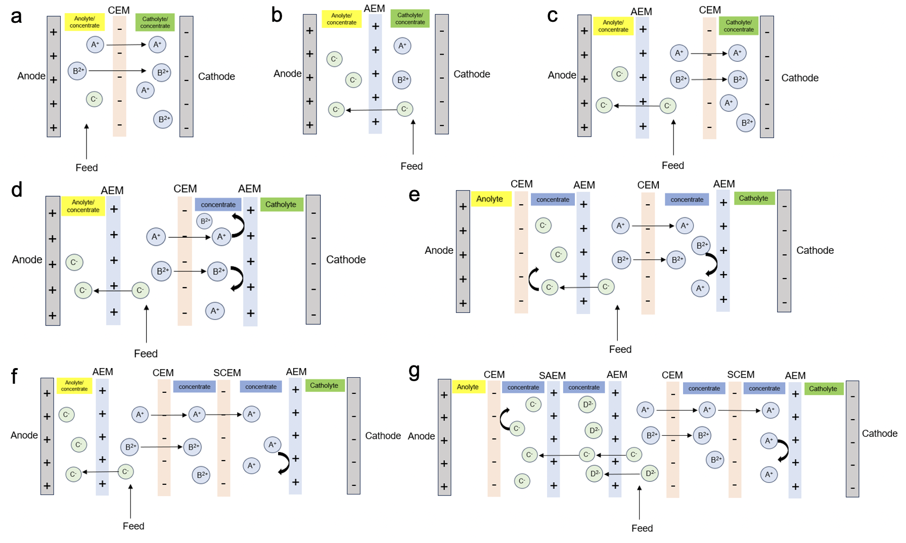

Figure 2-1 Ion transport in various ED systems. (a) Two-chamber cell with CEM; (b) Two-chamber cell with AEM; (c) Three-chamber cell; (d) Four-chamber cell; (e) Five-chamber cell; (f) Five-chamber cell with SCEM; (g) Seven-chamber cell.

**2.1.2 Working Principles of BMED**

BMED is an electrochemical separation process that combines ED and BPMs to convert salt solutions into acid and base products (Strathmann 2004, Chen, Bi et al. 2022). Upon application of a direct current, water molecules dissociate into H+ and OH- at the interface of BPMs (**Eq. 2-1**) (Giesbrecht and Freund 2020, Pärnamäe, Mareev et al. 2021). Cations in the salt chamber move toward the cathode and penetrate CEMs. They reach the base chamber and form base with OH- generated by BPM (**Eq. 2-2**). Similarly, anions migrate to the anode and penetrate the AEMs. Anions combine with H+ and form acid in the acid chamber (**Eq. 2-3**).

$$\begin{aligned}2H_{2}O→H_{3}O^{+}+{OH}^{-}\#\left(2-1\right)\end{aligned}$$

$$\begin{aligned}X^{+}+{OH}^{-}→XOH\#\left(2-2\right)\end{aligned}$$

$$\begin{aligned}Y^{-}+H^{+}→HY\#\left(2-3\right)\end{aligned}$$

where $X^{+}$ represents the cations and $Y^{-}$ represents the anions in the solution.

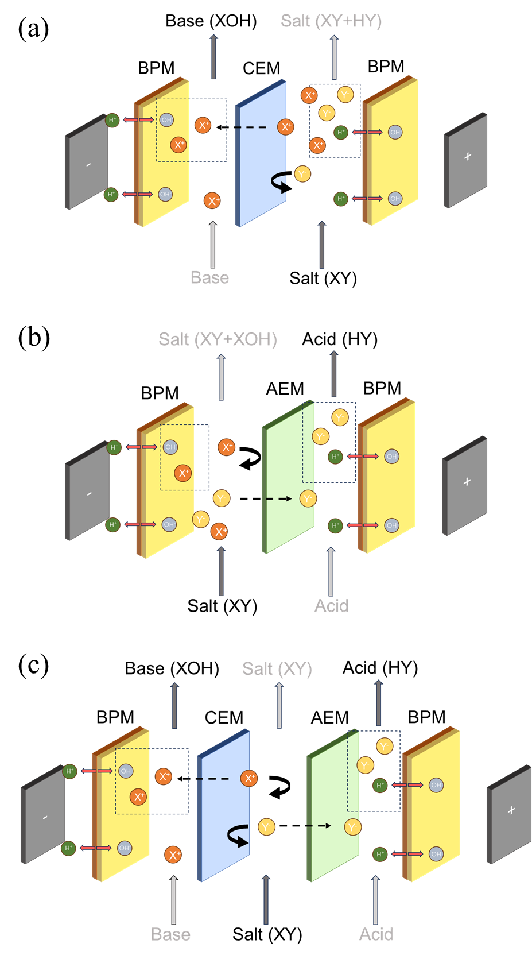

Figure 2-2 The BMED stack configuration: (a) two-chamber BMED (BPM/CEM/BPM); (b) two chamber BMED (BPM/AEM/BPM); (c) three-chamber BMED (BPM/AEM/CEM/BPM).

In BMED stack, BPMs, AEMs and CEMs are arranged to form several chambers. Traditionally, there are three types of BMED stack as shown in **Figure 2-2** (Fu, Gao et al. 2014, Hülber-Beyer, Bélafi-Bakó et al. 2021). The first one is a two-chamber BMED with a CEM placed between two BPMs (BPM/CEM/BPM) (**Figure 2-2 a**). The second one is a two-chamber BMED with an AEM placed between two BPMs (BPM/AEM/BPM) (**Figure 2-2 b**). These two-chamber stacks can only produce acid or base. In the first stack, salt solution flows between BPM and CEM, and cations penetrate the CEM, finally forming base. In the second stack, acid is generated. However, OH- generated by BPM will penetrate AEM as well and decreases the acid production efficiency (Hülber-Beyer, Bélafi-Bakó et al. 2021). Due to the limited salt recovery, a three-chamber BMED stack is developed to ensure the simultaneous production of both acid and base (Mazrou, Kerdjoudj et al. 1997, Lei, Li et al. 2020). The three-chamber configuration – comprising a CEM, AEM and two BPMs- is the most commonly adopted design in BMED due to its ability to efficiently separate and recover acid, base and salt stream. In this configuration, the membranes are arranged as BPM, AEM, CEM and BPM (BPM/AEM/CEM/BPM) (**Figure 2-2 c**). Therefore, the three compartments are acid, salt and base chambers. Under the electric field, BPMs generate H+ and OH- through water dissociation, which are directed into acid and base chambers, respectively. CEM allows cations to transport from salt chamber to base chamber, while AEM allows anions to transport from salt chamber to acid chamber. Moreover, they prevent the back-diffusion of H+ and OH-.

**2.1.3 Ion Exchange Membranes**

AEMs, CEMs and BPMs are three IEMs that are used in a BMED stack (**Figure 2-3**). AEMs are composed of polymer matrices functionalized with positively charged groups (e.g. quaternary ammonium groups, imidazolium or pyridinium groups) (**Figure 2-3 a**) (Zhang, Zhang et al. 2011, Vöge, Deimede et al. 2014, Peltier, You et al. 2023). The fixed charge in AEMs is positive, so anions can penetrate the AEMs, while cations are excluded. On the other hand, the fixed charge groups in CEMs are negative (**Figure 2-3 b**), such as sulfonic acid groups, carboxylic acid groups and phosphonic acid groups (Kang, Choi et al. 2003, Nagarale, Gohil et al. 2004, Klaysom, Ladewig et al. 2011). BPMs consists of an anion selective layer (AEL) with fixed positive charge and a cation selective layer (CEL) with fixed negative charge (**Figure 2-3 c**) (Oener, Foster et al. 2020, Pärnamäe, Mareev et al. 2021). Unlike CEMs and AEMs, BPMs are not used for ion transport. Ions cannot penetrate both AEL and CEL, so they cannot carry the ionic current to pass through the BPMs (Filingeri, Lopez et al. 2023). It is water dissociation at the interface of BPM to carry the ionic current. The generated H+ move toward the cathode and OH- moves toward the anode.

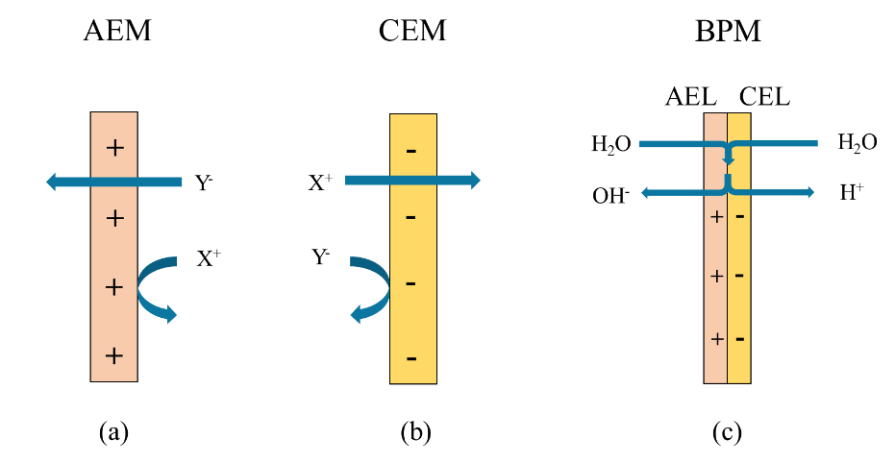

Figure 2- 3 Schematic diagrams of ion exchange membranes. (a) Anion exchange membrane (AEM); (b) Cation exchange membrane (CEM). (c) Bipolar membrane (BPM). AEL: anion exchange later. CEL: cation exchange layer; + and – represents the positive and negative fixed charge in the membranes, respectively. X+ and Y- represents the cations and anions in the solutions, respectively.

CEMs and AEMs are essential membranes in ED and BMED for their ability to transport specific ions. CEMs carry negative charge, so cations are counter-ions and anions are co-ions. Similarly, anions are counter-ions because they have the opposite charge as AEMs, while cations are co-ions. The working principal of CEMs and AEMs is selective penetration rather than ion exchange process (Jiang, Sun et al. 2021). Counter-ions are easier to penetrate the membrane. On the country, membranes will repulse co-ions, preventing them transporting across the membrane. The phenomenon that AEMs and CEMs repulse co-ions is called Donnan Repulsion (Donnan 1924, Glueckauf and Watts 1962). It depends on the characteristics of membranes and the feeding solution. If the density of charged group is high, it is more difficult for co-ions to transport across membranes, enhancing the Donnan effect. In the feeding solution, a higher concentration (higher ionic strength) will reduce the repulsion because it will screen the charged groups on IEMs, reducing the charge density perceived by ions approaching the membrane (Al-Sakaji, Husseini et al. 2023). In that case, the repulsion effect of co-ions will be weakened. Donnan Repulsion is attributed to the electrical potential at the interface of membrane and solution, and the potential is named as Donnan Potential (Luo, Abdu et al. 2018). It can be calculated if the equilibrium between membrane and solution is reached. When the equilibrium has achieved, the electrochemical potential is equal as is shown in **Eq. 2-4 and 2-5** (Aydogan Gokturk, Sujanani et al. 2022).

$$\begin{aligned}μ_{i,m}=μ_{i,s}\#\left(2-4\right)\end{aligned}$$

$$\begin{aligned}μ_{i,m}+RTlna_{i,m}+Z_{i}Fφ_{m}=μ_{i,s}+RTlna_{i,s}+Z_{i}Fφ_{s}\#\left(2-5\right)\end{aligned}$$

where $μ_{i,m}$ and $μ_{i,s}$ are electrochemical potential of ion i in the membrane and solution; R is the universal gas constant; T is the temperature; F is the Faraday constant; Zi is the valence of ion i; $a_{i,m}$ and $a_{i,s}$ refer to the activity of ion i in the membrane and solution.

As the state does not change, chemical potential is the same ( $μ_{i,m}$ = $μ_{i,s}$). Donnan potential ( $φ_{Don})$ is equal to the difference of potential between AEM or CEM and solution. From **Eq. 2-6**, it is obvious that Donnan Potential is generated because the activity of the same ion in the membrane deviates from that in the solution (Luo, Abdu et al. 2018).

$$\begin{aligned}φ_{Don}=φ_{m}-φ_{s}=\frac{RT}{Z_{i}F}\ln\left(\frac{a_{i,s}}{a_{i,m}}\right)\#\left(2-6\right)\end{aligned}$$

From **Eq. 2-6**, it can also be confirmed that the fixed charge groups of the membrane and the ionic strength of the solution mentioned above will affect Donnan Repulsion. R, T, Zi and F are constants to certain ion. If the density of charged group on membranes is high, $a_{i,m}$ of co-ions will decrease and $φ_{Don}$ increases, strengthening the ability to exclude co-ions. On the other side, when the concentration of feeding solution is high, $a_{i,s}$ will increase and the portion of co-ions in the membrane increases as well. In that case, it is essential to increase the fixed charge groups in the membrane and control the concentration of feeding solution to reach a better separation efficiency of co-ions and counter-ions.

**2.1.4 The Applications of ED and BMED**

**2.1.4.1 The Applications of ED**

ED has been used to treat wastewater containing concentrated salt solution (Paquay, Clarinval et al. 2000, Zhang, Ghyselbrecht et al. 2012, Jiang, Wang et al. 2014). The wastewater are generated from large heavy industries (e.g. oil and gas extraction, petrochemical industries, coal mining and power plant) (Hughes, Raubenheimer et al. 1992, McGovern and Zubair 2014, Gurreri, Tamburini et al. 2020). ED was efficient in removing salt from wastewater especially when the concentration was high. The energy consumption was lower compared to thermal desalination (Alawad, Mansour et al. 2023).

ED expanded to recover metal from wastewater. The wastewater from mining and chemical industries contain large amounts of valuable metals. Cu, Fe, Cd, Zn, Li and many other metals have been recovered through ED (Öğütveren, Koparal et al. 1997, Choi and Jeoung 2002, Marder, Sulzbach et al. 2003, Chekioua and Delimi 2015, Kim, Yoon et al. 2022). ED offered several advantages in metal recovery, including high efficiency, low energy consumption compared to traditional methods and the ability to treat complex solutions. In addition, the selective separation of specific metal ions increased the purity of the recovered metal when the solution contained different kinds of metals.

**2.1.4.2 The Applications of BMED**

In desalination, BMED can be used as a hybrid process to remove salts from brine while simultaneously generating useful chemicals. The brine is the effluent from the textile and desalination industries.

**2.1.4.2.1 Acid and Base Production**

BMED has emerged as a sustainable and multifunctional technology in acid and base production, desalination and resource recovery. It has been used to produce inorganic and organic acid and base.

BMED has been used to produce inorganic acid (e.g., HCl, H2SO4) and base (e.g. NaOH, LiOH). Ibáñez, Pérez-González et al. (2013) produced more than 1 M HCl and NaOH with current efficiency around 60 to 90 %. Leon, Abdullah Shah et al. (2022) used a new non-woven cloth IEMs in BMED to produce 0.8 M NaOH and HCl from 2 M NaCl under 300 A/m2. Melnikov, Mugtamov et al. (2020) used BMED to produce high concentration sulfuric acid from Na2SO4, and the concentration of sulfuric acid reaches 1.16 M. Kroupa, Kinčl et al. (2015) generated 65 g/L NaOH and around 50 g/L H2SO4 and the purity was 97 % to 98.3 % for base and 71.9 % to 83.3 % for acid. Because of the development of lithium battery, the demand for Li was high. Chen, Ruan et al. (2021) produced about 2 mol/L LiOH and 1 mol/L H2SO4 from Li2SO4.

BMED is also treated as a useful technology to produce organic acid and base. Conventional methods typically involve the production of large quantities of organic acids through fermentation, which necessitates additional downstream processing. (Huang and Xu 2006). The field and purity was low. BMED can produce high purity acid and base directly without additional treatment. Fu, Gao et al. (2014) used BMED to produce succinic acid. Luo, Cheng et al. (2017) produced around 0.44 M citric acid in the recirculation mode. Ferrer, Laborie et al. (2006) applied a current density of 500 A/m2 and the concentration of formic acid reached 7 M. Zhou, Yan et al. (2016) worked out an in-situ closed loop BMED stack to facilitate the production of phenylglycine. The feeding solution is Na2SO4. The base stream (NaOH) was used for the hydrolysis of phenylglycine, and the acid stream (H2SO4) acidified the solution. Finally, phenylglycine is received in solid after filtration and its field reached 94 %.

**2.1.4.2.2 Desalination**

In desalination, BMED can be used as a hybrid process to remove salts from brine water while simultaneously generating useful chemicals. The brine is the effluent from the textile and desalination industries. The produced acid and base can not only be used in washing or pretreatment but also be used as a by-product to increase economic benefits (Fernandez-Gonzalez, Dominguez-Ramos et al. 2015, Culcasi, Gurreri et al. 2022).

Reverse osmosis (RO) brine is the highly concentrated saline waste stream in RO desalination process. The brine typically contains high concentration of salt (i.e., NaCl, Ca2+, Mg2+. SO42-). Disposal of RO brine is a major environmental problem because the direct discharge will cause soil and water contamination. In that case, many studies focused on using BMED to treat RO brine. Ghyselbrecht, Silva et al. (2014) desalinated the high salinity NaCl solution (75 g/L) and the desalination ratio reached 99 %. 1.5 M HCl and 2 M NaOH was produced respectively. Gao and his team recover mixed acid and base (1 M) from acidic wastewater containing NaCl and RO concentrate through BMED (Gao, Yang et al. 2014, Yang, Gao et al. 2014). (Reig, Casas et al. 2016) applied BMED to treat RO brine without divalent ions (50 g/L NaCl) and produced 1 M NaOH and HCl with a current density of 77 %. Similarly, Herrero-Gonzalez, Diaz-Guridi et al. (2020) produced 3.3 M and 3.6 M HCl and NaOH from RO brine.

**2.1.4.2.3 Resource Recovery**

Moreover, BMED plays a growing role in resource recovery. It enables the extraction of metal ions from waste stream. It also recovers the ammonia and phosphate from agricultural and food waste. It combines separation, conversion and purification in a single system. It aligns with the goal of zero-waste and energy efficient treatment.

Kishida, Harato et al. (2017) used BMED to treat bauxite residue leachate that had been pre-neutralized with sulfuric acid. Bauxite residue leachate is a highly alkaline wastewater generated from the Bayer process during alumina production. It contains high concentration of NaOH and other heavy metal ions. To neutralize the wastewater, sulfuric acid was added. As a result, the effluent contained Na2SO4. They finally recovered 4.3 M NaOH and 1 M H2SO4. Liu, Zhu et al. (2018) applied BMED to recover Cr(III) and Cr(VI) from chromite processing residues as a form of Cr(OH)3 and Na2CrO4. Wu, Zhu et al. (2020) found that the recovery ratio of Cr(III) as Cr(OH)3 was low and it increased when Cr was recovered as Cr(VI). Based on this, they added H2O2 in BMED. Cr(III) was oxidized to Cr(VI) and transported to the product chamber and combined with Na+. The recovery ratio of Cr exceeded 87.8 %. Liu, Ke et al. (2020) used BMED to treat the raffinate from copper ore hydrometallurgical process. The heavy metal was concentrated in the base stream and SO42- recovered as H2SO4 as well. Similarly, Liu, Dai et al. (2022) also applied BMED to treat the same wastewater. They recovered arsenic as H3AsO4 and removed the metal cations as precipitates. Lithium recovery has gradually become an important requirement due to the high demand for lithium batteries and increasing waste rates. Bunani, Arda et al. (2017) applied BMED to the diluted acid solution, in which Li and B are separated and recovered. Jarma, Çermikli et al. (2021) recovered 50.2 % LiOH and 38.8%  H3BO3. To establish a recovery process for spent lithium-ion batteries, BMED is applied to recover LiOH and H2SO4 from Li2SO4 (Zhu, Asadi et al. 2025). The concentration of LiOH is 2.2 mol/L and that of sulfuric acid is 1.3 M.

**2.2 Scaling in ED and BMED**

**2.2.1 Basic Mechanism of Scaling**

Scaling is the precipitation and deposition of sparingly soluble inorganic salts. When treating solutions containing multivalent cations (e.g., Ca2+, Mg2+) and anions (e.g. CO32- and SO42-), the local environment in the ED or BMED stack will result in the formation of scaling. The existence of scaling ions play a crucial role in determining the scaling during the ED and BMED process. Multivalent ions such as Ca2+ and Mg2+ will form low-solubility precipitates with anions such as CO32-, SO42- and OH- as shown in **Eq. 2-7, 2-8, 2-9, 2-10, 2-11** (Johnston 1915, Andreeva, Gil et al. 2017).

Bicarbonate ions (HCO3-) is an essential element in scaling. It will convert to CO32 under alkaline conditions (Mikhaylin and Bazinet 2016). When Ca2+ and Mg2+ exists in the salt solution, it reacts to form insoluble salt CaCO3 and MgCO3 as shown in **Eq. 2-7 and 2-8** (MacAdam and Parsons 2004). The scaling of carbonate salt will pose additional pressure to the membrane and increase stack resistance (Sharifian, van der Wal et al. 2023).

The scaling of sulfate tends to arise when the salinity and concentration of salt is high. It will react with Ca2+ and Mg2+ to form less soluble salt (CaSO4 and MgSO4) in **Eq. 2-9**. This kind of scaling is found on the surface of IEMs and in the matrix of IEMs in ED process (Asraf-Snir, Gilron et al. 2018). In BMED, CaSO4 is less likely to precipitate in alkaline conditions due to high solubility (Mehran Aliaskari 2025). However, when the concentration of sulfate is high enough (3400 mg/L), the volume of scaling increases significantly (Mehran Aliaskari 2025).

Hydroxide scaling is the most common precipitation in ED and BMED. Ca2+ is likely to form Ca(OH)2 (**Eq. 2-10**), and Mg2+ is likely to form Mg(OH)2 (**Eq. 2-11**) under alkaline conditions, which is difficult to avoid in BMED. Studies have shown that Mg-scaling (Mg(OH)2) and Ca-scaling (CaCO3) interfered with each other: when the concentration of Mg is low, CaCO3 tended to precipitate on the IEM surface (Casademont, Farias et al. 2008, Sharifian, Boer et al. 2022, Sharifian, van der Wal et al. 2023, Mehran Aliaskari 2025). Otherwise, when the Mg concentration was high in the solution, it took priority to precipitate and suppressed the formation of CaCO3 (Mehran Aliaskari 2025).

$$\begin{aligned}{Ca}^{2+}+{CO_{3}}^{2-}⇌CaCO_{3} \left(s\right) Ksp=2.8×{10}^{-9}\#\left(2-7\right)\end{aligned}$$

$$\begin{aligned}{Mg}^{2+}+{CO_{3}}^{2-}⇌MgCO_{3} \left(s\right) Ksp=3.5×{10}^{-8}\#\left(2-8\right)\end{aligned}$$

$$\begin{aligned}{Ca}^{2+}+{SO_{4}}^{2-}⇌CaSO_{4} \left(s\right) Ksp=9.1×{10}^{-6}\#\left(2-9\right)\end{aligned}$$

$$\begin{aligned}{Ca}^{2+}+2{OH}^{-}⇌Ca{(OH) }_{2}\left(s\right) Ksp=5.5×{10}^{-6}\#\left(2-10\right)\end{aligned}$$

$$\begin{aligned}{Mg}^{2+}+2{OH}^{-}⇌Mg{(OH) }_{2}\left(s\right) Ksp=1.8×{10}^{-11}\#\left(2-11\right)\end{aligned}$$

According to the previous studies, scaling is commonly discovered on the membranes and in the bulk solution (Bazinet, Montpetit et al. 2001, Öner, Ata et al. 2023, Mehran Aliaskari 2025). Scaling might form in the solution or on the membrane surface according to the supersaturation location. The supersaturation location refers to the location where the solubility product exceeds the solubility product constant (Andreeva, Gil et al. 2018). If supersaturation occurs in the bulk solution, scaling tends to develop away from the membrane surface (Andreeva, Gil et al. 2018). In contrast, when supersaturation arises close to the membrane interface, the precipitation happens directly on the membrane. Additionally, scaling has been observed to form within the membrane flow channels as well (Asraf-Snir, Gilron et al. 2018).

In ED, scaling primarily occurs due to accumulation of scaling ions, resulting in local supersaturation. Under the applied electric field, cations migrate to the cathode, and tend to penetrate CEMs. In that case, concentration polarization, a ionic concentration gradient, occurs near the membrane surface. In these locations, the concentration of some salt may exceed the solubility product, and begin to precipitate and deposit as scaling on membrane surface. Moreover, water splitting at the depleted membrane surface is also a reason that trigger scaling in ED. When the ion in the dilute solution is too low to carry the ionic current, the system compensates by initiating water splitting at the interface of membrane and solution. Water splitting generates H+ and OH- to carry the current, increasing the pH near the membrane surface. As a result, OH- reacts with the divalent cations and form deposits like Ca(OH)2, Mg(OH)2 and CaCO3.

Scaling in BMED is more prone to occur due to the unique ion transport processes and localized pH shifts, particularly near membrane surfaces where water dissociation and ion accumulation take place. During the BMED process, water dissociates at the BPM interface to produce OH- in the base chamber. Simultaneously, cations transport through CEM from salt chamber to base chamber. When the solubility product of slightly soluble salt (i.e. Ca(OH)2, Mg(OH)2 and CaCO3) exceeds the solubility product constant, they will precipitate on the IEM surface or within the membrane matrix (Mikhaylin and Bazinet 2016).

**2.2.2 The Influence of Scaling on ED and BMED Performance**

The scaling on membranes will increase the membrane resistance, enhancing the energy consumption of the entire process. It will also prevent the transport of ions, further reducing the current efficiency and product purity. If scaling is attached to the membranes for long time, it may cause irreversible membrane pollution and even cause membrane rapture.

Öner, Ata et al. (2023) found the scaling will increase the desalination time and decrease the acid/base final concentration. Scaling on membranes covered the membrane and reduced the effective membrane area. With a lower effective membrane area, the ion mitigation rate across the membranes decreased, which extended the time for complete salt solution desalination. The longer process time also enhanced the co-ion leakage and back diffusion, which decreased the concentration of acid and base and the purity of products. Moreover, scaling in the base chamber consumed part of OH- as well. Ren, Wang et al. (2008) applied BMED to treat simulated wastewater effluent from glutamate fermentation and explored how Ca2+ and amino acid resulted in scaling. There was scaling on CEMs in the process, and the scaling was aggravated when both Ca2+ and amino acid existed. The scaling significantly reduced the removal rate of SO42-. In three consecutive batches, the latter group decreased by 1.22% and 1.21% compared with the previous group. Besides the removal rate, the energy consumption was affected by the scaling. The scaling increased the membrane resistance, which further increased the resistance of the stack. In that case, energy costs became higher when scaling existed. The same team did research on the scaling during the BMED processing with industrial glutamate production wastewater and found the scaling decreased the desalination rate (Wang, Yang et al. 2011).

All in all, scaling will decrease the BMED desalination efficiency and production efficiency. Under the electric field, OH- generated by BPM prefers to accumulate near CEMs, causing a high OH- environment. If divalent ions transport across the CEMs, the solubility product may exceed the solubility product constant and precipitates on CEMs. The scaling on membrane reduces the effective membrane area and slows down the subsequent ion transport. In that case, the desalination rate decreases. Besides the desalination rate, production of acid and base is a key element to evaluate a BMED process. Scaling has a definitely negative effect on production. Firstly, when divalent ions transport to the base chamber and react with OH-, OH- will be consumed. Scaling on BPM will prevent water dissociation and further decrease the generation of H+ and OH-. It is also mentioned above: the co-ion leakage and back diffusion will decrease the concentration and purity of acid and base.

**2.2.3 Factors Affecting Scaling Behavior**

**2.2.3.1 The Impact of Ion Composition on Scaling**

To mitigate the effects of scaling ions, the concentration of scaling ions especially Ca2+ and Mg2+ is adjusted in the salt solution before it is run in the BMED stack. Yang, Gao et al. (2014) added NaOH and CO2 to reduce Ca2+ from 714 ppm to 1.1 ppm and reduce Mg2+ from 2010 ppm to 0 ppm. During the process of BMED system, the voltage was relatively stable, indicating that scaling did not form on membranes. Moreover, the SEM diagrams showed that no crystals were observed on the surface of used CEM and AEM. Reig, Casas et al. (2016) used nanofiltration and chemical precipitation. The final concentration of Mg2+ and Ca2+ in the feeding solution was 9.3 ppm and 16.6 ppm. It is claimed that the concentration was low enough to avoid scaling when selective IEMs were applied.

* + - 1. **The Impact of IEMs on Scaling**

IEMs are core components in the BMED system. IEMs allow the ion transport under added electric field. The structure and chemical properties, such as fixed group charge density, hydrophobicity, surface roughness and heterogeneity, directly impact the process efficiency and the risk of membrane scaling.

Scaling behavior differs significantly between the homogeneous IEMs and heterogeneous IEM due to the structure. In homogeneous IEMs, the polymer matrix is dense and uniformly distributed (Strathmann 2004, Sata 2007). Ions drop from one fix-charge group to another to achieve ion transport across IEMs (Luo, Abdu et al. 2018). In contrast, heterogeneous IEMs contain imbedded conductive ion-exchange material and unconducive matrix, which creates ununiform microstructure and larger pore size in the membranes (Xu 2005, Ariono and Wenten 2017). Ions migrate mainly through the conductive pathway. Scaling is likely to form on the surface of homogeneous membrane because the membrane is dense. However, for heterogeneous membranes, scaling will form both on the IEM and within the IEM (Asraf-Snir, Gilron et al. 2018). In ED and BMED, homogeneous IEMs are used to avoid the scaling within the membrane matrix, which is seen as irreversible.

Surface roughness is a key physicochemical property of IEMs that are related to scaling formation kinetics. IEMs with rough surfaces are more susceptible to scaling formation compared to those with smoother surfaces (Andreeva, Gil et al. 2018). An IEM with rough surface has a concave-convex structure (Rolf, Cao et al. 2022), which facilitates the formation of scaling compared to IEMs with smooth surface. Firstly, rough surface offers nucleation sites for inorganic precipitates (Tong, Wallace et al. 2019, Dunn 2023). The concave points trap scaling ions, leading to local supersaturation. Moreover, scaling ions are difficult to diffuse from the concave point, so they tend to gather and begin to nucleate, finally forming scaling (Qian and Ma 2012).

The hydrophilicity of IEMs is also closely related to the scaling behavior. It is claimed that increasing hydrophilicity can inhibit scaling (Zhao, Chen et al. 2021). An IEM with higher hydrophilicity allows uniform ion distribution and avoid local supersaturation. Shi, Su et al. (2011) grafted amino acids of short chain to the IEM surface to increase the hydrophilicity and successfully resisted the protein fouling, Similarly, Zhao, Chen et al. (2021) prepared a CEM with smooth surface and higher hydrophilicity. Some IEMs adjusted the polymer ratio and increase the hydrophilicity to eliminate the flux of multivalent ions through IEMs (Tas, Zoetebier et al. 2016). With the increase of valence, the hydration energy will increase as well, making ions more difficult to shed their water to pass through the membrane (Yaminsky and Vogler 2001, Tekinalp, Zimmermann et al. 2023). In BMED, this kind of membrane could reduce the divalent ions transport to base chamber and avoid scaling in the base chamber.

Besides the properties of membranes, whether there is additional surface charge layer is essential to the scaling behavior as well. IEMs with fixed charge groups enables them to allow the migration of counter-ions and avoid that of co-ions. An IEM with opposite surface charge layer can prevent the accumulation of scaling ions or substances with the same charge. For example, Ma, Yi et al. (2020) and Mulyati, Takagi et al. (2013) prepared a membrane with negative surface charge to avoid the fouling of negatively charged pollutants like yeast and oil. Yang, Qiao et al. (2019) added a positive surface charge to resist the pollutants carrying positive charge through electrostatic repulsion. Moreover, an IEM with a positive surface charge layer can allow the transport of monovalent ions and reduce the flux of divalent ions, which is called selective IEMs (SIEMs). SIEMs can be used in ED and BMED because the scaling ions are divalent ions, and it is necessary to separate them from the monovalent ions in the feeding solution. The surface charge reach the propose through electrostatic repulsion and dielectric effect, which are two thermodynamic mechanisms. These two mechanisms are related to the study of thermodynamics involving ionic interactions and free energy changes in the system. Some IEMs imparted a layer of opposite charge on the top of the membrane, which depended on electrostatic repulsion to exclude multivalent ions (Farrokhzad, Moghbeli et al. 2015, Afsar, Shehzad et al. 2019, Pang, Tao et al. 2020). It is found that counter-ions with a higher charge will suffer higher repulsion (Sata, Sata et al. 2002, Pang, Tao et al. 2020, Tekinalp, Zimmermann et al. 2023).

The pore size of the IEMs is closely related to the scaling behavior. Some IEMs utilize steric hinderance or sieving to limit ions with a larger size or shape to transport through the channels in the membrane (Fan, Huang et al. 2022, Tekinalp, Zimmermann et al. 2023). Researchers cross-linked polymer to change the density or attached dense layer to the surface of the membranes (Ge, Wu et al. 2016, Liu, Jiang et al. 2017). The presence of dense layer will reduce the transport rate of larger ions, but not change the rate of smaller ones.

In ED and BMED, CEMs can be replaced with SCEMs to construct selective electrodialysis (SED) and bipolar membrane selective electrodialysis (BMSED). SIEMs can be added between BPMs and IEMs to produce multiple acids or bases as well. Yan, Li et al. (2020) explored the possibility of recovering resources from coal mining wastewater, which is abundant in chloride and sulfate. A selective anion exchange membrane was placed between a BPM and a normal AEM. BMSED had the capability to transform mixed salts into two acids (HCl and H2SO4) in one step. The concentration of acid and base reached the maximum when the current density was 50 mA/cm2 (Yan, Li et al. 2020). A higher current density generally enhances the ion transport rate across the membranes, leading to more efficient ion removal from the feed solution. The purity could reach 80 % under a low current density (Yan, Li et al. 2020). In the research of Chen, Jiang et al. (2018), BMSED could also applied to treat RO brine (70 – 105 g/L). In the long-term run, the final concentration of acid and base reached 1.9 M and 2.2 M, with a purity of more than 99% (Chen, Jiang et al. 2018). In these BMSED systems, Mg2+ and Ca2+ will be concentrated in the output of salt solution, which can also be collected for further usage. Chen, Wang et al. (2021) worked out a novel hybrid SED (HSED) and combined it with BMSED. This integrated system could not only produce acid and base, but also recover Ca2+, Mg2+ and SO42-. The concentration of HCl and NaOH reached 1.59 and 1.64 mol/L (Chen, Wang et al. 2021). BMSED simplifies the process and reduces the energy consumption. This integration contributes to the improvement of acid-base production and ion separation, providing a greater cost-effective method.

* + - 1. **The Impact of Process Parameters on Scaling**

Current density is closely related to the ion transport rate from the dilute chamber. Guo and Kim (2021) used ED to treat the high-strength wastewater and found there was a 50 % and 60.1 % of Ca2+ loss as calcium precipitates under a current density 5.1 and 7.6 mA/cm2 respectively. They also found the concentration of Mg decreased after 6 hours under 7.6 mA/cm2, which was observed under lower current density (Guo and Kim 2021). Asraf-Snir, Gilron et al. (2016) reflected the scaling growth on AEM in ED through membrane potential and found the increase of membrane potential occurred earlier as the current density increased. In BMED, current density is not only correlated with ion transport rate, but also the water dissociation at BPM. Higher current density accelerates the water dissociation, so the H+ and OH- accumulation speeds up (Gao, Yang et al. 2014). In the base chamber, scaling is more likely to form under a higher pH condition. Mehran Aliaskari (2025) monitored an increasing scaling height and coverage when they increase the current density.

The flow rate is another essential parameter that will directly influence the retention time of ions in the stack. The flow rate directly influences the residence time of ions within the membrane stack. At higher flow rates, ions have reduced contact time near the membrane surfaces, which helps avoid local supersaturation and thus delays the formation of scaling. Additionally, increased flow rate can help prevent heterogeneous scaling by flushing precipitates away from the membrane interface. Conversely, lower flow rates extend the interaction time between ions and membrane surfaces, increasing the likelihood of local supersaturation and accelerating scaling formation. Sharifian, Boer et al. (2022) observed a clear shape of aragonite under a low flow rate (30 ml/min), which was not observed under high flow rates. Similarly, Mehran Aliaskari (2025) monitored the height of scaling and membrane coverage under 3, 5 and 7 L/h and concluded that increasing flow rate decreased the scaling on BPM.

**2.3 Summary**

The literature shows the potential of ED and BMED in chemical production, resource recovery and desalination. However, there remain many problems that need to be resolved to further improve efficiency. Among these problems, scaling is an essential on because it not only decrease the system efficiency (e.g., desalination rate, acid/base production) but also destroy the membranes. In that case, a comprehensive understanding of scaling formation in ED and BMED is necessary for targeted solutions to scaling problems. Previous research have provided valuable insights into the scaling identification and mitigation, while comprehensive research in scaling in BMED is insufficient:

1. Extensive research has been conducted on scaling in ED, while comparatively little attention has been given to scaling in BMED.
2. Previous studies of scaling in BMED focused on the identification and characterization of scaling. The research on scaling mechanisms in the entire BMED stack, including chambers and membranes, has not been reported.
3. Changing the membranes, operating conditions and scaling ions in the solution according to the scaling mechanism require corresponding research.

Chapter 3 Impact of Ion Transport on Membrane Scaling in Bipolar Membrane Electrodialysis

**3.1 Introduction**

With the rapid expansion of seawater desalination to address global water scarcity, particularly through reverse osmosis, a huge amount of desalination brine is co-generated during freshwater production (Jones, Qadir et al. 2019, Shabib, Tatan et al. 2024). The desalination brine is generally regarded as a waste byproduct, discharging which poses negative environmental impact and incurs significant expense (Lattemann and Höpner 2008, Fernandez-Gonzalez, Dominguez-Ramos et al. 2015, Pramanik, Shu et al. 2017, Jones, Qadir et al. 2019, Mavukkandy, Chabib et al. 2019). On the other hand, the seawater brine (SWB) is a potentially valuable resource, as it is rich in dissolved salts which could be used as raw materials for producing various chemicals such as table salts (Reig, Casas et al. 2014), chlorine-based disinfectants (Abdul-Wahab and Al-Weshahi 2009), acid and base (Reig, Casas et al. 2016, Zhang, Zhao et al. 2021). In that case, recovering useful chemicals from SWB aligns with circular economy and improves the overall sustainability of desalination processes (Mavukkandy, Chabib et al. 2019, Zhang, Zhao et al. 2021, Ribeiro, Renfrew et al. 2025). Among the techniques to recover resources from SWB, bipolar membrane electrodialysis (BMED) has gained attention due to its ability not only to convert ionic species into high-value hydrochloric acid (HCl) and caustic soda (NaOH) but also dilute the brine for post discharge with reduced environmental impact (Mavrov, Chmiel et al. 1999, Fernandez-Gonzalez, Dominguez-Ramos et al. 2015, Filingeri, Lopez et al. 2023, Virruso, Cassaro et al. 2025). In that case, BMED is promising for integrated SWB management, enabling simultaneous desalination brine disposal and waste valorization (Fernandez-Gonzalez, Dominguez-Ramos et al. 2015, Kumar, Phillips et al. 2019, Herrero-Gonzalez, Admon et al. 2020).

In BMED, the stack is composed of alternating cation exchange membranes (CEMs), anion exchange membranes (AEMs) and bipolar membranes (BPMs) (Luo, Liu et al. 2022). Under the electric field, water dissociates into H+ and OH- at the interface of BPMs, enabling the generation of acid and base streams (Bunani, Yoshizuka et al. 2017, Hülber-Beyer, Bélafi-Bakó et al. 2021). CEMs and AEMs selectively transport cations and anion, respectively, removing salt ions from the brine stream and facilitating the brine dilution (Luo, Liu et al. 2022). Although BMED shows potential for treating SWB, scaling remains a major challenge. Scaling increases the membrane resistance (Chang, Ellis et al. 2010, Wang, Yang et al. 2011, Belashova, Mikhaylin et al. 2017, Öner, Ata et al. 2023), reduces the SWB dilution rate (Ren, Wang et al. 2008, Wang, Yang et al. 2011, Öner, Ata et al. 2023), elevates energy consumption (Ren, Wang et al. 2008, Öner, Ata et al. 2023), and reduces the concentration and purity of produced acid and base (Öner, Ata et al. 2023). Several studies have reported that scaling tends to form on the surface of CEMs and BPMs. Bazinet, Montpetit et al. (2001) specified the deposits on both sides of CEM as a mix of calcium carbonate and hydroxide after BMED was used to produce bovine milk casein isolates. Similarly, Ren, Wang et al. (2008) did morphological observation of CEM and identified the inorganic scaling as Ca(OH)2. Shee, Angers et al. (2008) applied BMED in dairy production and found the precipitation of Mg(OH)2 on the CEM facing base chamber. Wang, Yang et al. (2011) treated the glutamic acid wastewater and illustrated that a considerable amount of scaling was detected on CEM facing base chamber and few scaling was detected on CEM facing salt chamber. The scaling was a mixture of Ca(OH)2 and Mg(OH)2 and their carbonates. Öner, Ata et al. (2023) found insoluble Ca and Mg on CEM facing base chamber and spacers when treating simulated industrial saline water. Besides CEMs, Mehran Aliaskari (2025) monitored the scaling growth on BPM and identified Mg(OH)2 as the dominant scaling.

Previous research have primarily focused on the characterization of scaling on specific membranes and its influence on the overall performance (Bazinet, Montpetit et al. 2001, Ren, Wang et al. 2008, Shee, Angers et al. 2008, Wang, Yang et al. 2011, Filingeri, Lopez et al. 2023, Öner, Ata et al. 2023, Mehran Aliaskari 2025). The scaling mechanism proposed was relatively simplified: divalent ions (i.e. Ca2+ and Mg2+) migrated into base chambers and react with OH-, eventually forming scaling on membranes. Although these findings provide valuable insights, it shows a lack of comprehensive understanding of scaling behavior across different regions (i.e., membranes and chambers) of the BMED stack. Under the synergistic effect of water dissociation and ion transport, the scaling mechanism in different parts will be affected locally. A more comprehensive understanding is essential for developing targeted migration strategies and optimizing the BMED process.

The objective of this study is to systematically investigate the scaling behavior in BMED during the treatment of SWB, with a particular focus on understanding how scaling interacts with ion transport processes. To achieve this, scaling locations within the BMED stack were identified by characterizing deposits both in the chambers and on IEMs. The mechanism of scaling formation in each part were further elucidated accompanied by monitoring key operational parameters and analyzing ion changes. By developing a mechanistic framework, this study offers insights into future strategies aimed at effective scaling mitigation and process optimization.

**3.2 Material and Methods**

3.2.1 Lab-scale BMED Stack and Membranes

Commercial ion exchange membranes (IEMs) were used in this study. The bipolar membranes (BPMs) denoted as CJBPM-1 were provide by Kejia Polymer Materials Technology Co., China, while the CEMs and anion exchange membranes (AEMs) denoted as CSE and ASE, respectively, were provided by ASTOM Co., Japan. The effective area of each piece of membrane in the BMED stack was 7.065 cm2.

The configuration of the lab-scale BMED stack was illustrated in **Figure A1**. The stack contained three repeating units, each consisting of one BPM, one AEM, and one CEM. An additional BPM was placed adjacent to the cathode. Titanium electrodes coated with ruthenium served as the anode and cathode. The complete assembly comprised two electrode chambers (ECs), three acid chambers (ACs), three salt chambers (SCs), and three base chambers (BCs).

**3.2.2** **Experimental Testing Protocol**

A closed-loop circulation system was employed in the experiments.(Cassaro, Virruso et al. 2023) The setup consisted of four independent solution circuits: salt solution, base solution, acid solution, and electrode rinsing solution. A synthetic seawater brine (SWB) solution was prepared by doubling the concentration of major ions in seawater,(Liu and She 2024) with the detailed composition provided in **Table A1**. For comparison, a NaCl solution with equivalent conductivity to the SWB was used as a baseline system in the absence of scaling. The BC and AC were initially filled with 10 mM NaOH and 10 mM HCl, respectively. The electrode rinsing solution was 0.3 M Na2SO4. The volume of each solution was 0.4 L. Two peristaltic pumps, each with two pump heads (Lead Fluid, BT-600L-2 × YT15, China), were used to recirculate the solutions at a constant flow rate of 200 mL/min through the respective chambers. A constant current mode was adopted and the applied current density was maintained at 15 mA/cm² using a DC power supply (A-BF SS-L603SPD, China). Each experimental run lasted for 9 hours and was repeated at least three times to ensure reproducibility. Prior to applying the current, the system was operated for 10 minutes to remove air bubbles, ensuring complete wetting of the membrane surfaces and minimizing potential performance disturbances.

* + 1. **Scaling Characterization and BMED Performance Analysis**

**3.2.3.1 Scaling Characterization**

Field-emission scanning electron microscopy (FESEM; JEOL-7200F, Japan) and energy-dispersive X-ray spectroscopy (EDX; Oxford Instruments Aztec Standard X-max 50, UK) were employed to examine membrane surface morphology and elemental composition. Additionally, precipitated solids collected from CEMs after BMED operation were analyzed using X-ray diffraction (XRD; Bruker D8) to identify crystalline phases. To assess the extent of crystalization in the bulk salt solution within the SC and BC, turbidity measurements were performed for these solutions using a laboratory turbidimeter (2100N IS, HACH), with each sample analyzed in triplicate for accuracy. 30 mL of solutions were sampled from the SC and BC before and after each experiment. In addition to qualitative characterization, quantitative analysis was conducted to evaluate scaling severity. Ca²⁺ and Mg²⁺ concentrations in each solution were measured periodically during each testing using inductively coupled plasma optical emission spectroscopy (ICP-OES, Vio 550Max, PerkinElmer).The loss of Ca²⁺ and Mg²⁺ was calculated from the concentration change in each chambers as shown in **Appendix A Section 3**.

**3.2.3.2 BMED Performance Analysis**

Key operational parameters—including voltage, current, and pH—were continuously monitored to assess BMED performance and ensure system stability. Conductivity changes in AC, BC and SC were recorded every five minutes using conductivity meters (Orion Star A212, Thermo Scientific, USA). Current and voltage data were recorded every minute using Power DC software. The pH in the AC, BC, and SC was measured by portable pH meters (Seven2Go pH/Ion Meter S8, Mettler Toledo, Singapore). The purity of produced acid and base (%) was calculated via **Eq. 3-1**.

$$\begin{aligned}{Purity}_{i} = \frac{m_{i}}{m_{i}+m_{imputies}}\#\left(3-1\right)\end{aligned}$$

where $m_{i}$ is the concentration of acid or base (g/L) and $m_{imputies}$ is the concentration of impurities in acid or base (g/L).

The stack resistance ($R_{stack}$, Ω) was calculated according to Ohm’s Law with **Eq. 3-2**.

$$\begin{aligned}R_{stack}=\frac{U_{t}}{I_{t}}\#\left(3-2\right)\end{aligned}$$

where $U_{t}$ was the voltage (V) and $I_{t}$ was the current (A) at time $t$.

The stack resistance is the sum of electrode resistance, chamber resistance, and membrane resistance.(Dlugolecki, Nymeijer et al. 2008, Liu and She 2024) The chamber resistance ($R_{chamber}$, Ω) was calcualted by **Eq. 3-3**.(Dlugolecki, Nymeijer et al. 2008)

$$\begin{aligned}R_{chamber}=\frac{N}{A}\left(\frac{d_{AC}}{σ_{AC}}+\frac{d_{BC}}{σ_{BC}}+\frac{d_{SC}}{σ_{SC}}\right)\#\left(3-3\right)\end{aligned}$$

where $N$ is the number of repeating units, $A$ is the effective area of each membrane (m2). , , were the thickness of AC, BC and SC (m), $σ_{AC}$, $σ_{BC}$ and $σ_{SC}$ is the conductivity of AC, BC and SC (S/m).

The membrane resistance ($R_{membrane}$, Ω) was calculated by **Eq. 3-4**.

$$\begin{aligned}R_{membrane}=R_{stack}-R_{chamber}-R_{ele}\#\left(3-4\right)\end{aligned}$$

The electrode resistance ($R_{ele}$) was 43.11 Ω tested by the setup shown in **Figure A2** and calculated from **Figure A3** (details in **Appendix A A4**).

**3.2.3.3 Reversibility Tests of BMED**

To evaluate whether BMED performance declined with membranes after removing scaling, cyclic tests were performed after doing thorough cleaning at the end of treating SWB salt solution. The stack was disassembled, and the membrane was taken out for cleaning by rinsing with DI to eliminate any residual deposits. These cleaned membranes were then reassembled into the stack and tested with a NaCl solution to determine the BMED performance.

For comparison, a control test was also performed using membranes that had been operated only with NaCl solution. These membranes underwent the same cleaning procedure to ensure a fair comparison.

* 1. **Results and Discussion**
     1. **Scaling Occurs on Multiple Locations across the Entire BMED Stack**

After tests, IEMs and solutions were characterized by FESEM and turbidimeter to analyze the scaling formation and chemical composition at multiple locations of the BMED stack. When treating NaCl, the baseline salt solution, no precipitates was visually inspected using photographic evidence (**Figure 3-1 a1, b1, c1, d1**) and FESEM (**Figure A4 a1, b1, c1, d1**). In contrast, after BMED treating SWB, although no scaling was observed on the AEM facing SC **(Figure 3-1 a2, a3**), precipitates were observed on both sides of the CEM (**Figure 3-1 b2, b3 and c2, c3**) and the BPM facing BC (**Figure 3-1 d2, d3**), indicating the formation of scaling on the CEM and BPM. Moreover, SC and BC became visibly turbid when processing SWB **(Figure A5 b1 b2)** compared with tests for NaCl (**Figure A5 a1 a2**). The turbidity of solution in the SC increased from 0.137 to 45.233 NTU and that in the BC increased from 0.112 to 29.4 NTU (**Table A2**), which also proved that suspended solids were formed during the tests.

The EDX results, which revealed the elemental distribution on membranes after BMED treatment of NaCl and SWB, were consistent with the observed scaling during operation. Since no scaling was observed on the AEM after BMED of SWB, no Mg and Ca distribution was observed (**Figure 3-1 a4, a5**) and the atomic ratios of carbon and oxygen (**Figure 3-1 a6**) was similar as the pristine AEM (**Figure A6 a**). Compared to the pristine CEM (**Figure A6 b**), clear Ca and Mg distributions were observed on both sides of the CEM after BMED treating SWB (**Figure 3-1 b4, b5** and **c4, c5**). The atomic percentage of Mg and Ca increased from ~0 to ~9 % (**Figure 3-1 b6, c6**). In contrast, only Ca distribution was observed on the surface of BPM (**Figure 3-1 d4-d5**). 1.8% Ca was detected on the BPM facing BC while the composition of Mg remained zero (**Figure 3-1 d6**) compared to the pristine BPM (**Figure A6 c**), which will be discussed in detail in the next section.

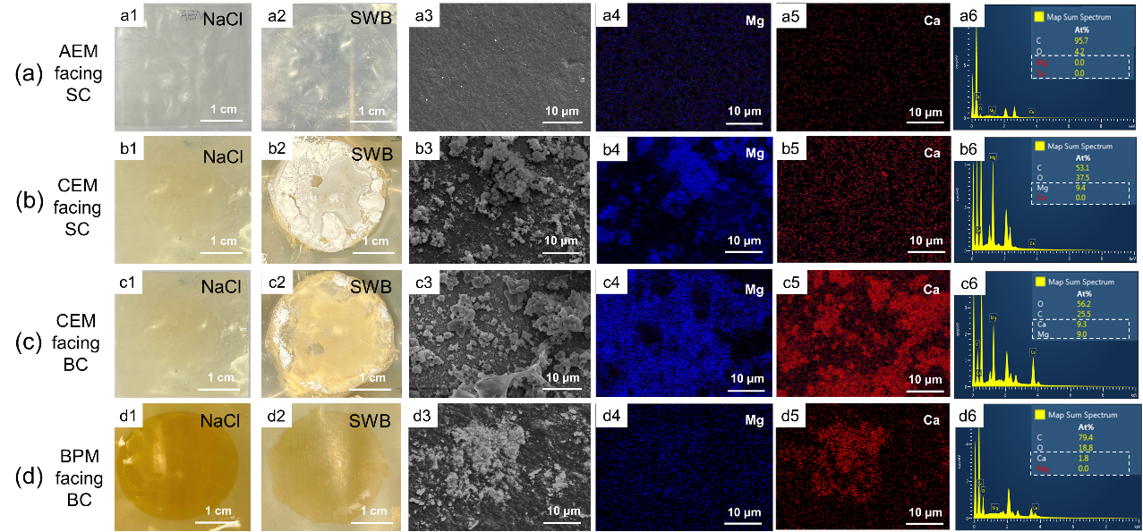

Figure 3-1 FE-SEM images and EDX elemental analysis of membrane surfaces. (a) AEM facing SC: Photograph after tests in (a1) NaCl and (a2) SWB; (a3) SEM diagram; EDX elemental mapping image of (a4) Mg and (a5) Ca; (a6) EDX map spectrum. (b) CEM facing SC: Photograph after tests in (b1) NaCl and (b2) SWB; (b3) SEM diagram; EDX elemental mapping image of (b4) Mg and (b5) Ca; (b6) EDX map spectrum. (c) CEM facing BC: Photograph after tests in (c1) NaCl and (c2) SWB; (c3) SEM diagram; EDX elemental mapping image of (c4) Mg and (c5) Ca; (c6) EDX map spectrum. (d) BPM facing BC: Photograph after tests in (d1) NaCl and (d2) SWB; (d3) SEM diagram; EDX elemental mapping image of (d4) Mg and (d5) Ca; (d6) EDX map spectrum. (AC: acid chamber; SC: salt chamber; BC: base chamber; SWB, seawater brine).

Precipitates on IEMs were collected for XRD analysis to identify the type of scaling (**Figure A7**). The appeared peaks showed the presence of Mg(OH)2 in the form of brucite crystals, Ca(OH)2 in the form of portlandite, and CaCO3 in the form of calcite. The formation of Mg(OH)2 and Ca(OH)2 was due to the reaction of divalent ions and the produced OH- (Ksp = 1.8 × 10-11 for Mg(OH)2 and Ksp = 6 × 10-6 for Ca(OH)2 at 25 ℃) (Fan, Chen et al. 2006, Cao and Harris 2008, Andreeva, Gil et al. 2017). As there was NaHCO3 in SWB, it reacted with OH- and transferred to CO32- in SC, which further reacted with Ca2+ to form CaCO3 (Ksp = 4.7 × 10-9 for CaCO3). The above XRD results were consistent with the EDX results which showed an increase in the Mg and Ca element on membrane surfaces with scaling. To gain a deeper understanding of the observed scaling behavior, the subsequent section will delve into the potential mechanisms of scaling formation and evolution within the BMED stack when treating SWB.

* + 1. **Mechanisms of Ion Transport Dependent Scaling in BMED**
       1. **Transport of Scaling Precursor Ions in BMED Stack**

During the testing of SWB, the concentrations of scaling precursor ions (i.e., Ca2+ and Mg2+) and pH in different chambers were measured at different times to monitor their transport behaviors and gain an in-depth understanding of scaling mechanisms.

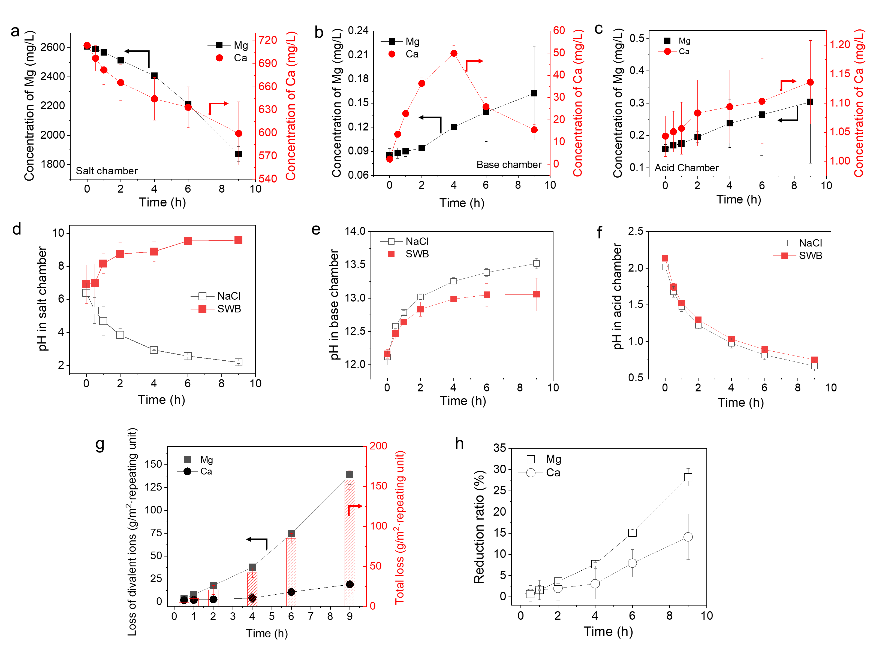

Figure 3-2 The concentration changes of Mg2+ and Ca2+ in (a) SC, (b) BC and (c) AC, and pH changes in (d) SC, (e) BC and (f) AC. (g) The loss of divalent ions and the total loss with time; (h) The reduction ratio of Mg2+ and Ca2+ with time. (AC, acid chamber; BC, base chamber; SC, salt chamber)

Under the applied electric field, cations migrated toward the cathode, crossing the CEM from the SC to the BC, as evidenced by the continuous decrease in Ca2+ and Mg2+ concentrations in the SC **(Figure 3-2 a**). Upon entering the BC, these ions accumulated over time (**Figure 3-2 b**). Although AEMs were designed to block cation transport, minor leakage was observed as indicated by the detectable presence Ca2+ and Mg2+ in AC (**Figure 3-2 c**). Concurrently, the applied current initiated water dissociation at the BPMs to generate H+ and OH-. OH- accumulated in the BC (**Figure 3-2 e**), while H+ accumulated in the AC (**Figure 3-2 f**). Due to the higher mobility of H+ relative to OH-, a portion of H+ leaked from AC to SC, contributing to the pH decline in SC (**Figure 3-2 d**). However, when treating SWB, the pH in SC increased, indicating the additional generation or accumulation of OH- (**Figure 3-2 d**).

To better quantify scaling, the element loss of scaling precursors was calculated (**Figure 3-2 g and Figure A8**). After tests, the loss of Ca gradually increased to 19 g/m2 per repeating unit **(Figure 3-2 g**), corresponding to 14.15% reduction ratio (**Figure 3-2 h**). Similarly, the loss of Mg started as soon as the experiment began and reached 139 g/m2 per repeating unit and reduction ratio of 28.23% at the end (**Figure 3-2 g, h**). Finally, the total scaling formed on membranes and in solutions increased to 158 g/m2 per repeating unit (**Figure 3-2 g**). The loss can be explained by the following reactions:

$$\begin{aligned}{Mg}^{2+}+2{OH}^{-}→Mg{\left(OH\right)}_{2}↓\#\left(3-5\right)\end{aligned}$$

$$\begin{aligned}{Ca}^{2+}+2{OH}^{-}→Ca{\left(OH\right)}_{2}↓\#\left(3-6\right)\end{aligned}$$

$$\begin{aligned}{Ca}^{2+}+{HCO_{3}}^{-}+{OH}^{-}→CaCO_{3}↓\#\left(3-7\right)\end{aligned}$$

The acidic condition (**Figure 3-2 f**) caused by water dissociation on BPM was the main reason why AEM surface was clean (**Figure 3-1 a2-a6**). Although there was slight leakage of divalent cations from SC to AC (**Figure 3-2 c**), it did not result in scaling on AEMs or in the AC. In the BC, the concentration of OH- remained high (**Figure 3-2 e**) due to water dissociation on BPM Moreover, the concentration of divalent ion gradually increase because they transported from SC to BC (**Figure 3-2 b**). The concentration of Mg2+ in the BC kept in relatively low range due to **Eq. 3-5**. However, the concentration of Ca2+ initially increased to 49.95 ppm in 4 hours and then decreased to 15.53 ppm at the end, suggesting more severe scaling of Ca(OH)2 through **Eq. 3-6**. Similarly, **Eq. 3-5, 3-6 and 3-7** occurred in the SC because of the high concentration of divalent cations (**Figure 3-2 a**) and gradually increased pH (**Figure 3-2 d**). The pH of SWB reached 9 at 4 hours (**Figure 3-2 d**), and the concentration of Mg exhibited a steeper decrease at the same time (**Figure 3-2 a**). Scaling in different parts of the stack will be discussed in detail in the following sections.

* + - 1. **Heterogeneous Scaling on Both Sides of CEM Surface**

According to the membrane morphology detection, scaling would take place on both sides of the CEM. Each region demonstrated unique scaling behaviors influenced by local ion transport, OH⁻ generation and leakage.

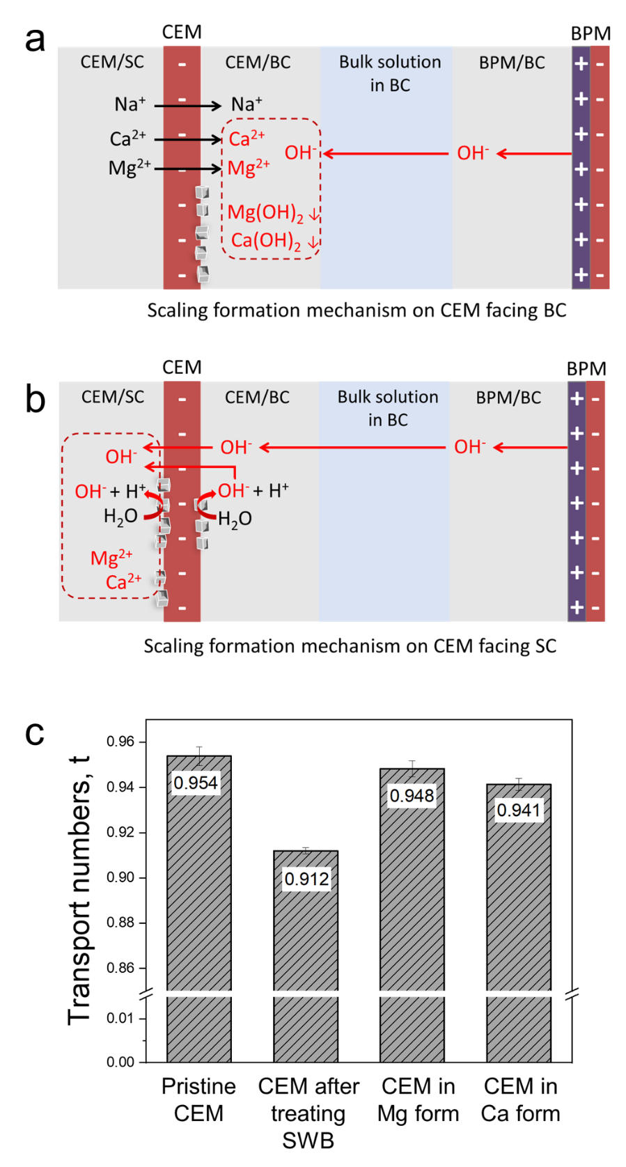

Figure 3-3 Scaling mechanism on (a) CEM facing BC and (b) CEM facing SC (The black arrow represents the transport of cations, the red arrow represents the generation and transport of OH-; the red dotted box represents precipitation occurs). (c) The transport number of different CEMs. (CEM in Mg or Ca form means the fixed charge group within the CEMs were combined with Mg or Ca, representatively).

As shown in **Figure 3-3 a** once the test began, cations (i.e., Na+, Ca2+ and Mg2+) transported across the CEM from SC to BC under the electric field. At the same time, the OH- ions generated from the BPM transported to the interface of CEM/BC. Some uneven areas on the membrane surface, which characterized by ridge-and-valley structures, provided abundant active nucleation sites (Rolf, Cao et al. 2022). The concave points hindered the diffusion of Ca2+ and Mg2+ to the bulk solution, promoting the localized supersaturation conditions on membrane surface. Mg2+ was more susceptible to this local supersaturation condition because of a lower solubility product, so it prone to form Mg2+-based crystal nuclei on membrane surface rather than accumulated in the bulk solution (**Figure 3-2 b**). For Ca2+, it was more likely to leave the CEM/BC and reached the bulk solution with a higher solubility product (**Figure 3-2 b**). The primary crystal nuclei progressively enlarged and developed into micro-scale crystalline particles and ultimately aggravated into visible inorganic deposits (Rolf, Cao et al. 2022). In that case, CEM facing BC became partially covered with precipitates (**Figure 3-1 c2**), which reduced the effective membrane area available for transport. Under the constant current mode, the ion flux through the uncovered membrane region must increase to sustain the ionic current, so the local current density on the uncovered area increased (Asraf-Snir, Gilron et al. 2018, Liu and She 2024). When the local current density exceeded the limiting current density, water splitting occurred at the interface of CEM/BC (Asraf-Snir, Gilron et al. 2018, Liu and She 2024). The occurrence of water splitting generated H+ and OH- to carry current (Liu and She 2024). The phenomenon was evidenced by the contrasting pH trends in the SC (**Figure 3-2 d**). When treating SWB, the pH in SC consistently increased over time, indicating that additional OH- was generated. Once OH- generated by water splitting crossed the CEM and accumulated at the interface of CEM/SC, it reacted with abundant divalent ion in the SC. The localized supersaturation happened on the concave point on CEM facing SC as well and form nuclei, which gradually grew to visible deposits (Rolf, Cao et al. 2022). With the experiment proceeded, the scaling further decreased the effective membrane area, thereby inducing water splitting on CEM facing SC as well (Belashova, Mikhaylin et al. 2017, Liu and She 2024). Then OH- generated further enhanced the supersaturation on membrane surface and aggravated the heterogeneous scaling. Eventually, a large amount of scaling was formed on CEM surface facing SC (**Figure 3-1 b2**), which was consistent with the scaling-enhanced scaling mechanism in previous research (Liu and She 2024). Besides water splitting, the leakage of OH- across the CEM from BC to SC was also a potential reason. The leakage of OH- through CEM was reflected by the transport number (measure by setup in **Figure A9** in **Appendix A 10**). The counterion transport number of the pristine CEM was 0.95 (**Figure 3-3 c**), indicating the leakage of OH- existed throughout the experiment. Additionally, the transport number of counter-ions of scaled CEM decreased to 0.91, indicating scaling also enhanced OH- leakage. The increase of leakage might result from the deformation of CEM, since there was no gasket covering the entire membrane. Moreover, the decreased Donan exclusion might also increase the leakage. Gou, Zhao et al. (2025) found that the high binding energy between Ca2+ and fixed charge group of CEM (RSO3-) enabled part of Ca2+ retained in the membrane channel. It was consistent with the result in **Figure 3-3 c** that the transport number of CEM (Ca2+ type) and CEM (Mg2+ type) were a little lower than that of pristine CEM (Na+ type). When divalent ions were retained in membrane channel, the fixed charges were occupied and the Donnan exclusion was weakened and allowed the transport of co-ion (OH-) more easily.

* + - 1. **Heterogeneous Scaling on the AEL Surface of BPM**

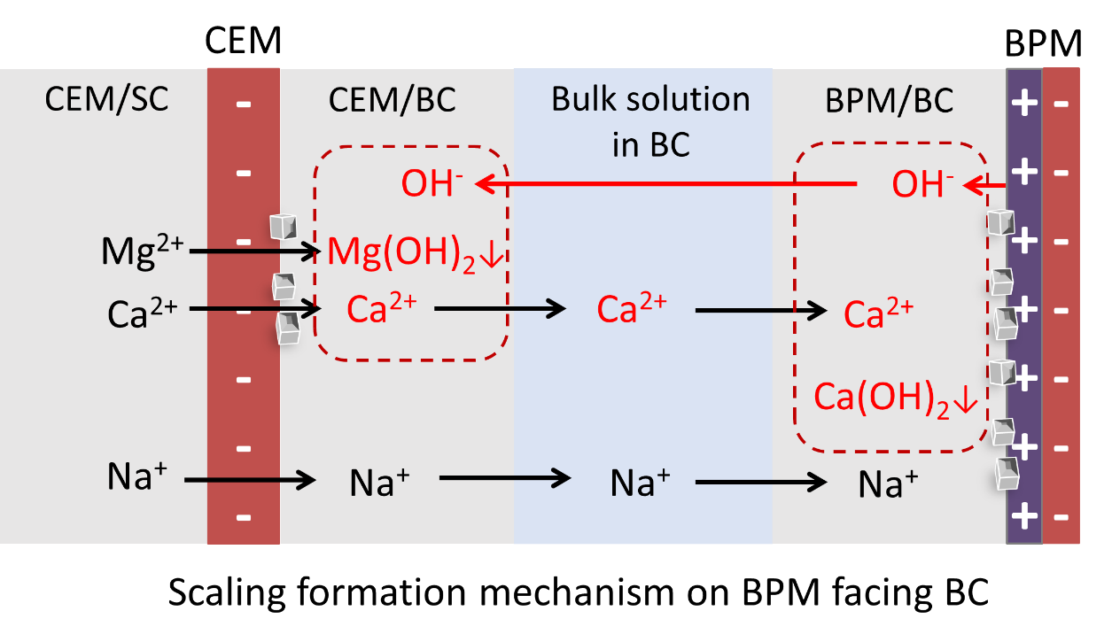

Figure 3-4 Schematic diagram of scaling formation on BPM facing BC (The black arrow represents the transport of cations; the red arrow represents the transport of OH-; the red dotted box represents precipitation occurs).

**Figure 3-4** shows the scaling mechanism on the AEL side of BPM. Under the electric field, cations firstly transported through CEM from BC to SC. When Mg2+ reached the interface of CEM/BC, most of Mg2+ precipitated directly on CEM because of the relatively low solubility product (Ksp = 1.8 × 10-11) (Andreeva, Gil et al. 2017). It was difficult to continue to transport in the BC and reached the interface of BPM/BC, which could also be reflected by the low concentration of Mg2+ in the BC (**Figure 3-2 b**). Thus, Mg-based precipitates was not found on BPM surface (**Figure 3-1 d4, d6**). However, the initial increase of the concentration of Ca2+ in BC (**Figure 3-2 b**) shows the accumulation of Ca2+ in BC, indicating that Ca2+ can reach the BC/BPM interface under electric field. Once the divalent cations reached the interface of BPM/BC, they tended to aggregate at the concave points and encountered excess OH- generated by water dissociation at BPM (León, López et al. 2022). Within the concave points on BPM surface, the diffusion of OH- from the interface of BPM/BC to the bulk solution was restricted. Therefore, it was easy to reach localized supersaturation at the concave points, where crystal nuclei grew and gradually formed larger-scale deposits (**Figure 3-1 d5**).

* + - 1. **Bulk Crystallization in Salt Solution and Base Solution**

The homogeneous scaling referred to the direct crystallization within the bulk solution. When the concentration of scaling ions (Ca2+, Mg2+, OH- and CO32-) exceeded their solubility limits, scaling formed in the bulk solution.

During BMED, cations transported from the SC to the BC, resulting in the increase of cations with time (**Figure 3-2 b**). Simultaneously, the concentration of OH- continuously increased due to water dissociation (**Figure 3-2 e**). The accumulation of divalent ions and OH- collaboratively promoted homogeneous scaling. As shown in **Figure 3-2 b**, the concentration of Mg2+ remained below 0.23 ppm because of the high concentration of OH- and low solubility products. The concentration of Mg2+ needed to less than 4.32 ppb in the BC to avoid precipitating (Ksp = 1.8 × 10-11 for Mg(OH)2 at 25 ℃) (Andreeva, Gil et al. 2017, Andreeva, Gil et al. 2018), so Mg2+ in the BC was prone to form homogeneous precipitates. Similarly, the concentration of Ca2+ exhibited a rise followed by a decline. After 4 hours, the concentration of Ca2+ reached 1.24 mM and that of OH- reached 0.098 M, so the solubility product exceeded the solubility product constant (Ksp = 6 × 10-6 for Ca(OH)2 at 25 ℃) (Andreeva, Gil et al. 2017, Andreeva, Gil et al. 2018). The sharp decrease of Ca2+ also proved that Ca-based precipitates continuously generated in the solution.

In the SC, the leakage of OH- and OH- from water splitting on CEM resulted in the increasing concentration of OH- (**Figure 3-2 d**). It facilitated the reaction of OH- with abundant divalent ions in the SC (**Figure 3-2 a**). In the SC, the concentration of OH- increased with time and the pH reached 9 at 4 hours (**Figure 3-2 d**), accompanied by the sharper decrease in the concentration of Mg2+ (**Figure 3-2 a**). After 4 hours, the concentration of Mg2+ reached 2.406 g/L and that of OH- reached 0.038 mM. The solubility product exceeded the Ksp, illustrating the abundant deposit formation after 4 hours.

Another scaling mechanism involved scaling that initially formed on the surface of IEMs and then detached into the bulk solution (Andreeva, Gil et al. 2018, Asraf-Snir, Gilron et al. 2018). Deposits heterogeneously nucleated on the membrane surface might detach from the membrane surface, which could be reflected by the decrease of voltage (**Figure A10**). Once the scaling shredded from surface to the bulk solution, these particles not only contributed to visible turbidity but can also act as nucleation seeds, accelerating further crystallization in the solution (Wang, Li et al. 2022).

* + 1. **Scaling Significantly Reduces BMED Performance**

**3.3.3.1 Scaling Reduces Produced Acid-Base Concentration and Purity**

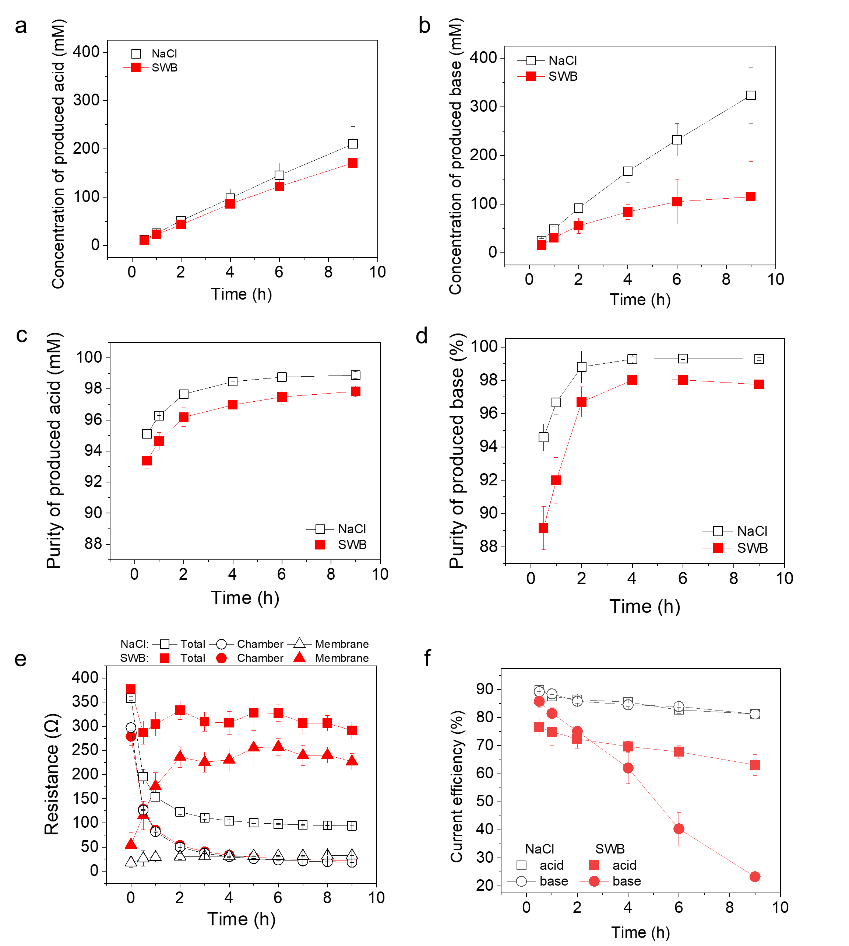

Figure 3-5 BMED performance change during treating NaCl and seawater brine (SWB). (a) Concentration of produced acid; (b) Concentration of produced base; (c) Purity of produced acid; (d) Purity of produced base; (e) Variation of stack resistance, chamber resistance and membrane resistance during BMED treating different solutions; (f) Current efficiency for acid and base production when treating different solutions.

Scaling significantly decreased BMED performance, including the concentration and purity of acid and base products (**Figure 3-5 a, b, c, d**), the system resistance (**Figure 3-5 e**), current efficiency (**Figure 3-5 f**) and energy consumption (**Figure A11**). As shown in **Figure 3-5 a,** the concentration of produced acid decreased when BMED treated SWB. This decline was more significant in base production (**Figure 3-5 b**). While the produced base concentration during baseline testing increased nearly linearly with the operating time, the base concentration during treating SWB seemingly reached a plateau after 6 hours (**Figure 3-5 b**). The concentration of produced acid was lower than that of base for NaCl, while the trend is reversed for SWB. The decayed acid-base production performance and different trends during testing with NaCl and SWB are due to multiple reasons associated with scaling. During BMED using NaCl, no scaling occurred. Due to the mobility difference (Strathmann 2004), H+ leakage was higher than OH- leakage, thereby resulting in the higher concentration of base (~324 mM base > ~210 mM acid). On the contrary, scaling during BMED using SWB consumed generated OH-, which decreased the concentration of base. Thus, the concentration of acid (~170 mM) was higher than that of base for SWB (~115 mM). Although no visible scaling was observed on the AEM and the acid chamber (**Figure 3-1 a and Figure A5 b2**), the concentration of acid during SWB treatment was slightly lower than baseline. This reduction attributed to both declined H+ production and the leakage of OH- from SC to AC. Scaling on BPMs (**Figure 3-1 d**) reduced the transport of water to the bipolar junction, which can decrease water dissociation (Luo, Liu et al. 2022). A decrease in water dissociation led directly to a decline in acid production. Moreover, the high OH- in SC (**Figure 3-2 d**) indicated that it might leak to the AC to neutralize H+. The effect of scaling on base production was more severe. In addition to consuming OH-, scaling also reduced base production by decreasing water dissociation at the BPMs and cation transport across the CEMs. Scaling on CEMs reduced the transport of cations. The conductivity of SC solution also agreed the difference between the final concentration for NaCl and SWB. As shown in **Figure A12 a**, conductivity decreased by 16.65 % and 19.02% in 9 hours for SWB and NaCl, respectively. This can be attributed to the decrease in the effective membrane area on the CEM surface as discussed above. When scaling formed on the CEM surface, the transport of ions from SC was partially blocked by scaling, and water splitting occurred to form the H+ and OH- ions to carry current, compensating the decreased transport of ions from SC to BC.

The purity of acid and base gradually increased during the BMED process (**Figure 3-5 c, d**). In the early stage of BMED process, the leakage of cations and anions from the SC resulted in the low purity of acid (**Figure 3-5 c**) and base (**Figure 3-5 d**). As operation proceeded, H+ and OH- accumulated in the AC and BC respectively and the proportion of impurities in the total equivalent decreased, which increased the purity significantly. Moreover, the purity of acid and base when treating NaCl was higher than that when treating SWB. Unlike NaCl feed solution that contained only Na+ and Cl-, SWB contained divalent cations and anions that leaked to acid and base to decrease purities. Scaling in the BMED stack might reduce the selectivity of co-ions and counter-ions (**Figure 3-3 c**) that will increase the leakage of impurities as well.

Scaling also increased the system resistance (**Figure 3-5 e**). As shown in **Figure 3-5 e** and **Figure A10**, the stack resistance and voltage for SWB was higher than that for NaCl throughout the BMED tests. They were extremely high at the beginning of each test and subsequently decreased to a plateau for both NaCl and SWB. The high values at the beginning can be attributed to the low conductivities of initial solutions in AC and BC (**Figure A12 b**), which resulted in extremely high chamber resistance (**Figure 3-5 e**). As BMED progressed, the increase in acid and base conductivities (**Figure A12 b**) resulted in a sharp decrease in chamber resistance. Although chamber resistance decreased at the same rate over time for both NaCl and SWB, the membrane resistance exhibited different rates of increase. The membrane resistance for SWB increased to 226.71 Ω at the end, which was six times higher than that treating NaCl (~32.36 Ω) (**Figure 3-5 e**). The large gap between them can be attributed to the accumulation of precipitates on the membrane surface.

Accordingly, current efficiency (**Figure 3-5 f**) and energy consumption (**Figure A11**) were influenced by the scaling significantly. With the presence of scaling, a higher fraction of the applied current was consumed by side reactions (e.g., water splitting) instead of transporting target ions, which result in the decreased current efficiency for acid production. In addition, the current efficiency of base was more seriously reduced because the produced base was consumed. Energy consumption increased with the decreased production of acid and base and increased stack resistance. As shown in **Figure A11**, the specific energy consumption of BMED using SWB was higher than that using NaCl, i.e., 90.25 % higher for acid and 5.18 times higher for base.

**3.3.3.2 Scaling Posed Irreversible Loss of BMED Performance**

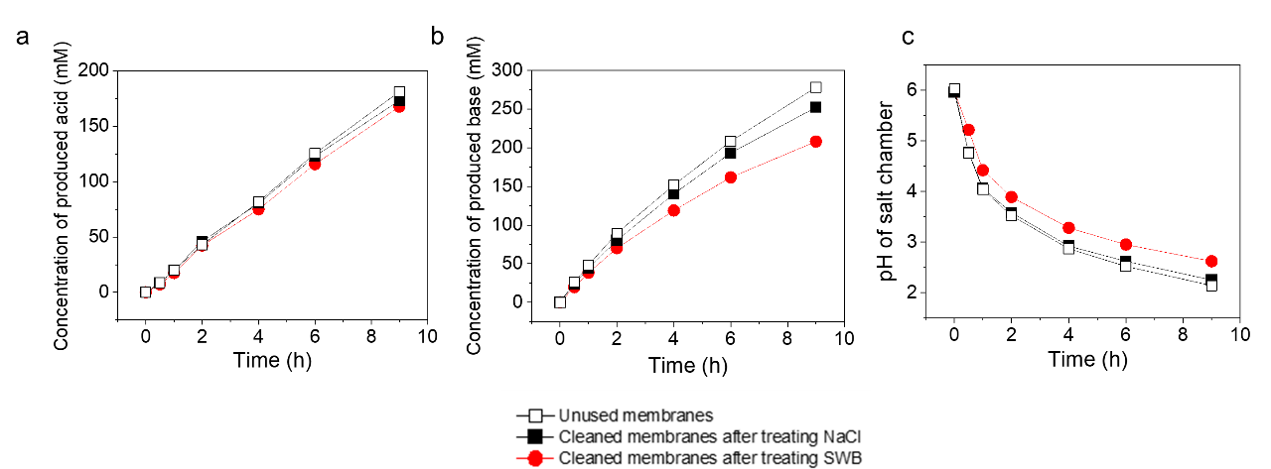

Figure 3-6 The cyclic tests of BMED with unused membranes, cleaned membrane after treating NaCl and cleaned membrane after treating SWB. (a) The concentration of produced acid; (b) The concentration of produced base; (c) pH change in the SC.

Scaling decrease the efficiency and lifespan of membranes and increase the requirement of cleaning frequency and maintenance (Dufton, Mikhaylin et al. 2018, Barros, Martí-Calatayud et al. 2020, Merino-Garcia and Velizarov 2021). Even after physical cleaning, membranes previously exposed to scaling showed a decline in performance (Figure 6). As shown in **Figure 3-6**, the acid and base production decreased and the pH decrease ratio in SC declined with cleaned membranes after treating SWB. The final acid concentration was 167.59 mM (180.99 mM and 173.06 mM for unused membranes and membranes after treating NaCl, respectively), and the final base concentration decreased to 208.02 mM (i.e., 32.2 % lower compared to unused membranes) (**Figure 3-6 a, b**). The change of pH in SC (decreased to 2.14 for unused membranes, 2.25 for cleaned membranes after treating NaCl, and 2.62 for cleaned membranes after treating SWB at the end) (**Figure 3-6 c**). Scaling directly affected the ion transport in the BMED process, especially aggravating the OH- leakage. With increasing OH- transport from the BC to SC, the pH decrease in SC would be diminished (**Figure 3-6 c**) and the base concentration would decrease as well (**Figure 3-6 b**). Scaling irreversibly altered the membrane structure, changing the properties of channels or the matrix. These findings underscore scaling not only reduced ion transport efficiency but also shortened membrane lifespan.

**3.3.4 Selective Cation Exchange Membrane Reduced Scaling**

The transport of divalent ions from BC to SC through CEM was a dominant reason to result in scaling on membranes and in chambers. The limitation of divalent ion transport could be seen as a method to reduce scaling in BMED. SIEMs are synthesized to preferentially transport monovalent ions (e.g., Na+, Li+) while effectively restricting the transport of multivalent ions (e.g., Ca2+, Mg2+). The selectivity is achieved by adjusting the pore size or adding a surface layer with adverse charge to the membrane. The former one takes advantage of size difference to sieve ions, while the latter one exclude the multivalent ions through stronger electrostatic repulsion. In BMED, selective CEM (SCEM), which is a kind of SIEM, can replace CEM to limit the migration of scaling precursor ion (i.e., Ca2+, Mg2+). In that case, scaling can be reduced to some extent through slowing down the time to reach supersaturation. As a result, the accumulation of divalent ions decreases in the BC, and the scaling in BC and CEM facing BC will be reduced. Water splitting on CEM facing BC might not be triggered to aggravate scaling on CEM facing SC and in the SC.

In this part, SCEM replaced the traditional CEM in BMED stack to test whether it could reduce scaling to some extent. The current density, flow rate and solution composition were the same as the previous section (current density = 15 mA/cm2, flow rate = 200 mL/min). Each experiment run lasted for 9 hours and was repeated at least three times to ensure reproducibility.

**3.3.4.1 Reduced Scaling Evidenced by Membrane Morphology**

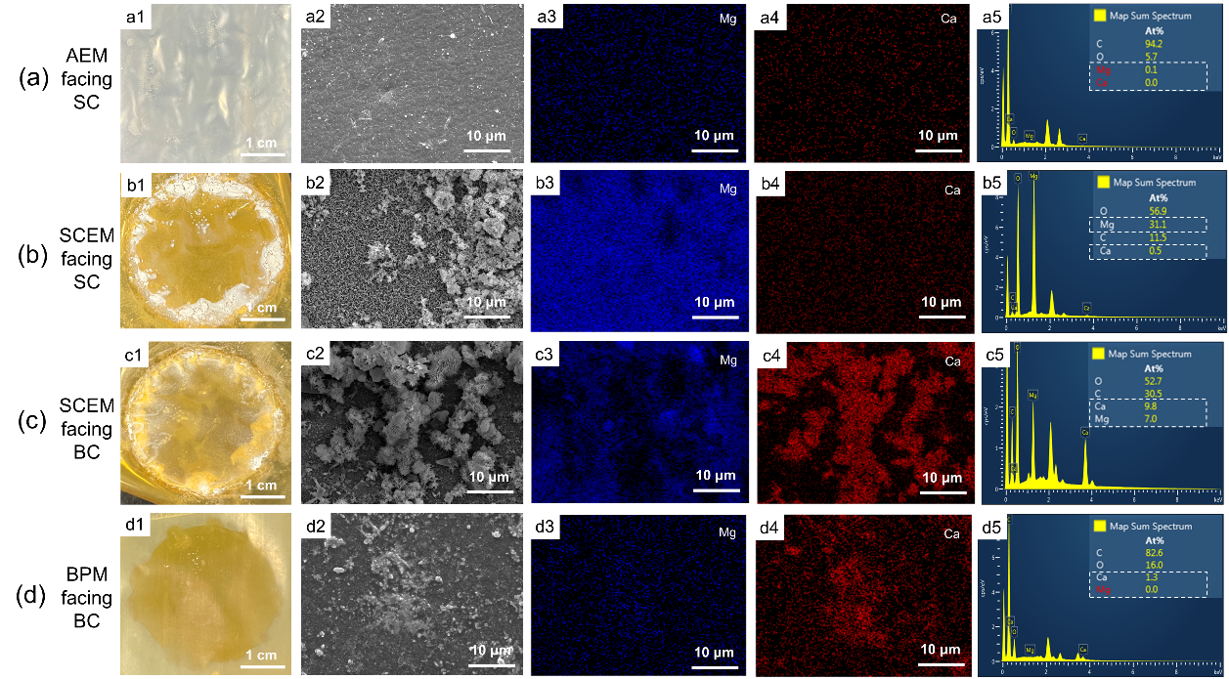

Figure 3-7 SEM images and EDX elemental analysis of membrane surfaces. (a) AEM facing SC: Photograph after tests in (a1) SWB; (a2) SEM diagram; EDX elemental mapping image of (a3) Mg and (a4) Ca; (a5) EDX map spectrum. (b) SCEM facing SC: Photograph after tests in (b1) SWB; (b2) SEM diagram; EDX elemental mapping image of (b3) Mg and (b4) Ca; (b5) EDX map spectrum. (c) SCEM facing BC: Photograph after tests in (c1) SWB; (c2) SEM diagram; EDX elemental mapping image of (c3) Mg and (c4) Ca; (c5) EDX map spectrum. (d) BPM facing BC: Photograph after tests in (d1) SWB; (d2) SEM diagram; EDX elemental mapping image of (d3) Mg and (d4) Ca; (d5) EDX map spectrum. (AC: acid chamber; SC: salt chamber; BC: base chamber; SWB, seawater brine).

After tests, IEMs were characterized by FESEM to analyze the scaling formation and chemical composition. **Figure 3-7 (a)** exhibited that no deposits formed on AEM surface (**Figure 3-7 a1**), which showed a smooth surface (**Figure 3-7 a2**) and the composition of Mg2+ and Ca2+ was near 0 (**Figure 3-7 a3-a5**). Deposits could be observed on both sides of SCEM (**Figure 3-7 b1, c1**). Compared to CEM after treating SWB (**Figure 3-1 b2, c2**), the scaling on SCEM was reduced, especially on the SCEM facing SC (**Figure 3-7 b1**, **Figure 3-1 b2**). The deposits appeared as thin and layered flakes (**Figure 3-7 b2**), which was the classical morphology of Mg(OH)2. The scaling on SCEM facing SC was mainly composed of Mg-based deposits (**Figure 3-7 b3, b4**), which was the same as that on CEM, and the composition of Mg2+ was 31.1 % and that of Ca2+ was only 0.5 % (**Figure 3-7 b5**). The scaling on SCEM facing BC was the mixture of Mg-based (7 %) and Ca-based (9.8 %) deposits (**Figure 3-7 c5**). From EDX elemental mapping images, the precipitation on the membrane surface was mainly Mg-based deposits (**Figure 3-7 c3**), and the aggregated convex precipitation was mainly Ca-deposits, with a small amount of Mg2+ (**Figure 3-7 c4**). The morphological image of BPM was the same as the BPM in traditional BMED (**Figure 3-7 d1, d2**). The EDS elemental mapping image showed the composition of deposit was mainly composed of Ca2+ rather than Mg2+ (**Figure 3-7 d3-d5**).

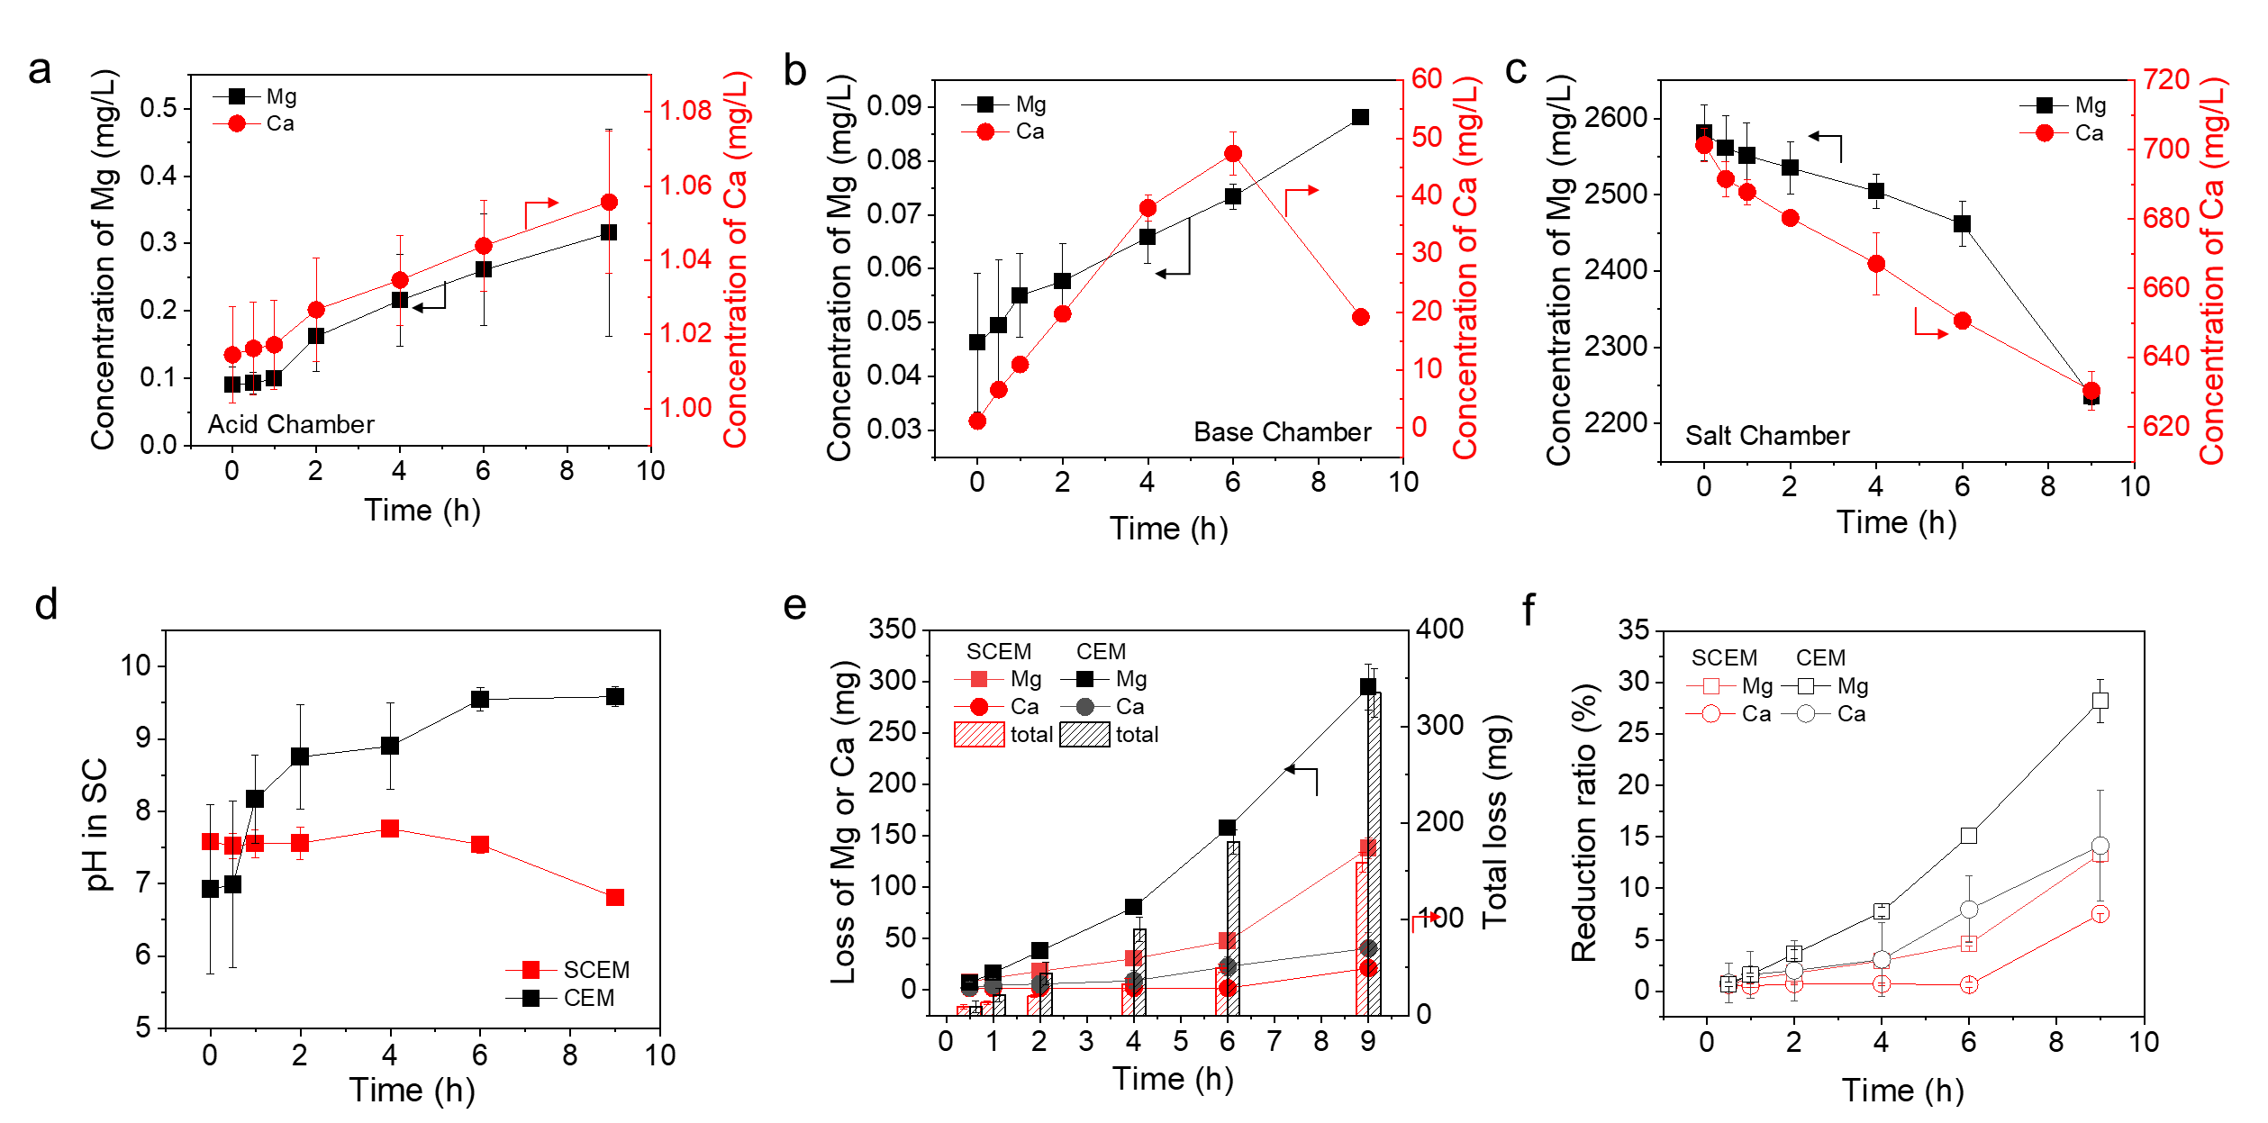

Figure 3-8 The concentration changes of Mg2+ and Ca2+ in (a) AC, (b) BC and (c) SC. (d) pH changes in SC. (e) The loss of Mg or Ca and the total loss with time. (f) The reduction ratio change of Mg and Ca with time (AC, acid chamber; BC, base chamber; SC, salt chamber).

The concentration of divalent ions in the AC of BMED with SCEM and CEM was quite low because AEM prevented the transport of cations from SC to the AC (Figure 2 a, Figure x). In the AC of BMED with SCEM, the concentration of Ca2+ and Mg2+ was below 1.2 ppm and 0.3 ppm, respectively (**Figure 3-8 a**). Since SCEM did not directly affect anion transport, its influence on acid could be neglected. However, it had a significant effect on cation transport. In the BC of BMED with SCEM (**Figure 3-8 b),** the concentration of Mg2+ remained low and reached ~0.09 ppm after 9 hours, which was 40 % lower than that in BC of BMED with CEM (**Figure 3-2 b**). The concentration change of Ca2+ showed the same trend as that in BC of BMED with CEM. However, the turning point appeared at different times. When using SCEM, the concentration of Ca2+ gradually increased and reached near 50 ppm in 6 hours (**Figure 3-8 b)**, while it took only 4 hours to reach the same concentration when using CEM (**Figure 3-2 b**). This illustrated that SCEM retarded the transport of divalent ions from SC to BC. The lower concentration of Mg2+ and delayed turning point proved that SCEM was effective in reducing divalent ion transport. However, the decrease in Ca2+ concentration after 6 hours reflected that deposits were formed in the BC or on the CEM facing BC (**Figure 3-8 c**).

The concentration change in the SC also reflected the transport difference under different membranes. The concentration of Mg2+ decreased by 14.67 % and 36.84 % when using SCEM and CEM, respectively. The concentration of Ca2+ decreased by 11.1 % and 20 % when using SCEM and CEM, respectively. The decreased decline indicated that the removal rate of divalent ions from SC decreased. The sharp decrease of Mg2+ after 6 hours reflected that deposits were generated and consumed large amount of Mg2+. The formation of deposits in the SC might result from water splitting on CEM. The pH change in SC showed that the pH was stable around 7.5 in the first 6 hours and finally slightly decreased to 7 (**Figure 3-8 d**). Compared to the pH change when using CEM (gradually increased to 9.5), the pH was relatively stable. However, it did not decreased significantly like BMED treating NaCl. It indicated that scaling existed on membrane surface and triggered water splitting. Water splitting generated OH-, which prevented the pH from dropping and neutralized H+ leaked from AC. pH difference in SC reflected that the degree of water splitting was no as drastic as that with CEM. In that case, scaling on SCEM facing SC was not as much as that on CEM (**Figure 3-7 b1, Figure 3-1 b2**).

Figure 2 e, f showed the reduction of Mg and Ca as scaling in the BMED stack. When using SCEM, the loss of Mg was 137 mg and that of Ca was 21 mg **(Figure 3-8 e)**, with a reduction ratio of 13 % and 7.5 % for Mg and Ca respectively **(Figure 3-8 f)**. The loss of Mg was significantly lower than that in BMED using CEM (294 mg). The loss of Ca was close, as the loss of Ca in BMED using CEM was 40 mg. The total loss decreased by 110 % when using SCEM. The significant reduction in lost ions positively reflected the significant reduction in scaling in BMED.

SCEM could reduce scaling in BMED. SCEM reduced the transport of divalent ions (i.e., Ca2+ and Mg2+) from the SC to BC. Although SCEM could not completely prevent their transmission, it can reduce the rate of their accumulation in the BC. In that case, the accumulation of deposits on SCEM facing BC was postponed as well, which slowed down the water splitting. Since water splitting occurred for a short time, the impact on the adjacent chamber was small: the concentration of OH- accumulated in the SC was low to reach the concentration that generated a large amount of deposits. Therefore, the scaling accumulation on the SCEM facing SC was also less than CEM facing SC, and further water splitting may not occur. Therefore, the pH did not rise further but gradually decreased (**Figure 3-8 d**).

**3.3.4.2 BMED Performance Was Improved with SCEM**

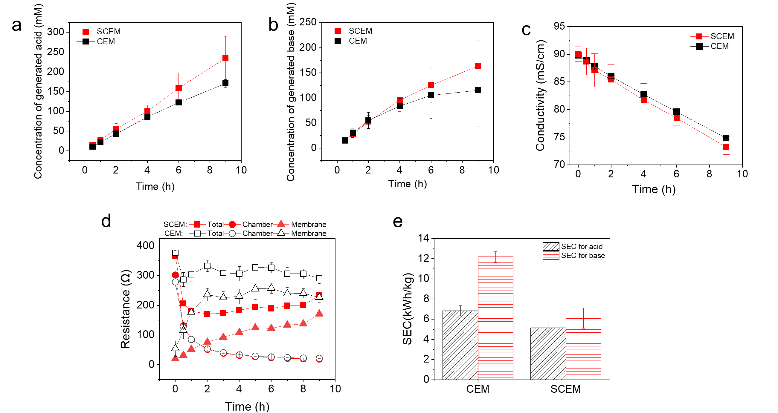

Figure 3-9 BMED performance change when using CEM and SCEM. (a) Concentration of produced acid; (b) Concentration of produced base; (c) Conductivity change in the SC. (d) Variation of stack resistance, chamber resistance and membrane resistance during BMED using CEM and SCEM. (e) Specific energy consumption of produced acid and base with CEM and SCEM.

With less scaling, BMED performance was improved with SCEM, reflected by a higher acid and base concentration (**Figure 3-9 a, b**), a higher desalination ratio (**Figure 3-9 c**) and lower resistance (**Figure 3-9 d**). As shown in **Figure 3-9 a**, the concentration of acid reached 234 mM and was 37.6 % higher than that when using CEM. The concentration of base raised to 163 mM and was 41.7 % higher than that when using CEM (**Figure 3-9 b**). Unlike the baseline test (**Figure 3-5 a, b**), the concentration of acid was higher than that of base, which was similar as the result when using CEM. It indicated that OH- in the BC was consumed and precipitated with divalent ions. However, the higher concentration of produced acid and base indicated that SCEM effectively reduced the scaling. With less divalent ions in the BC, less OH- was consumed by these ions to precipitate, increasing the concentration of base. Moreover, less scaling on membrane surface increased the desalination ratio, and the conductivity change in SC agreed the difference when using CEM and SCEM (**Figure 3-9 c**). conductivity decreased by 23 % and 20 % in 9 hours when using SCEM and CEM, respectively. When using SCEM, the scaling covered less area of the membrane, the ion transmission was less affected, and more ions could be transmitted from SC to adjacent chambers.

With SCEM, the resistance was reduced as well (**Figure 3-9 d**). The chamber resistance difference was not significant because the conductivity of acid, base and salt solutions in two stacks was similar. The difference was more significant in stack resistance and membrane resistance. The stack resistance with SCEM decreased from 365 Ω to 180 Ω in the first hour and was stable around 180 to 200 Ω. The stack resistance with CEM was much higher, which remained above 300 Ω. With similar chamber resistance, the increase of stack resistance was attributed to the increase of membrane resistance. The membrane resistance of CEM was much higher than that of SCEM in BMED process due to more scaling attached on membrane surface. With SCEM, less deposits was formed on the membrane surface, which decreased the membrane resistance.

Accordingly, energy consumption decreased significantly with the increased production of acid and base and lower stack resistance. As shown in **Figure 3-9 e**, the specific energy consumption for acid was 5.12 kWh/kg and that for base was 6.09 kWh/kg with SCEM, which was 32.8 % and 99.8 % lower than that with CEM.

**3.3.5 Reduce Current Density to Further Limit Ion Transport-Dependent Scaling**

In the scaling mechanism discussed in the previous section, the divalent ion transport and water splitting are two essential reason for scaling generation in the BMED process. These two elements are closely related to the current density. Firstly, the current density is proportional to the ion transport rate. At higher current density, the migration of Mg2+ and Ca2+ from SC to BC is intensified and more divalent ions will react with excess OH- in the BC to initiate the scaling formation. Secondly, when scaling covers the membrane surface, the local current density increases due to a decreased effective membrane area. When the local current density is higher than the applied current density, water splitting occurred to generate OH-, which leaked to the adjacent BC and aggravate scaling. In that case, decreasing the current density will relatively reduce the local current density on the uncovered area of a partially scaled membrane. It can help prevent it from exceeding the limiting current density, thereby reducing water splitting and prevent aggravated scaling in SC.

In this part, different current densities (15, 12, 9 mA/c2) were applied in BMED stack to investigate whether it was practical to reduce scaling. SCEM was used and the flow rate and solution composition were the same as the previous section. Each experiment run lasted for 9 hours and was repeated at least three times to ensure reproducibility.

**3.3.5.1 Decreasing Current Density Reduced Scaling**

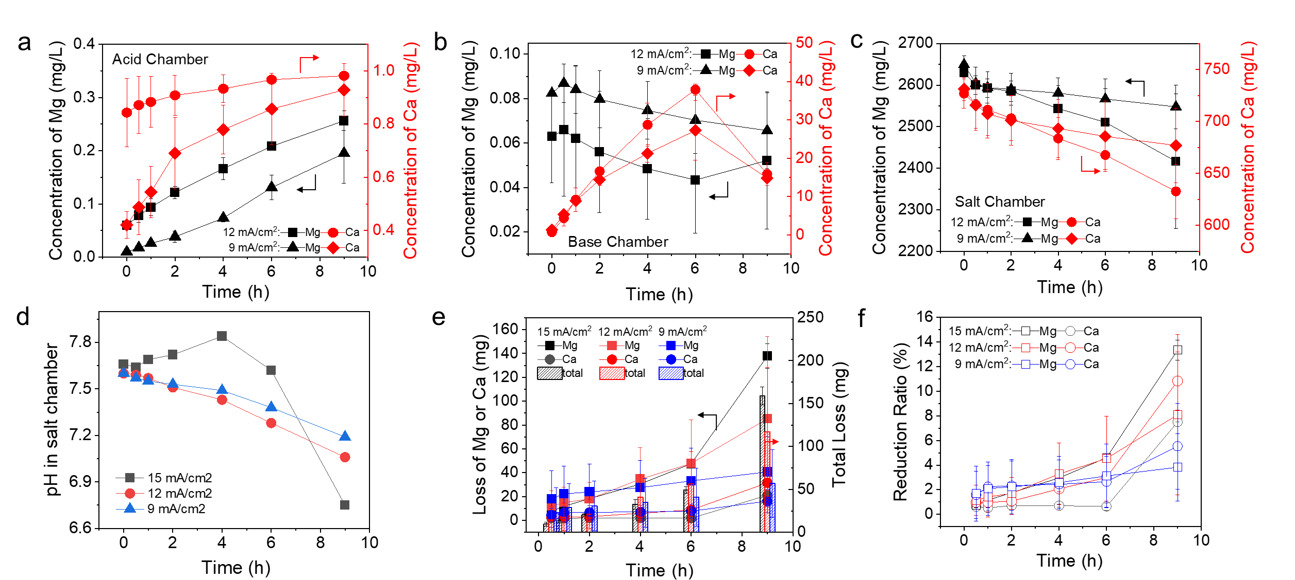

Figure 3-10 The concentration changes of Mg2+ and Ca2+ in (a) AC, (b) BC and (c) SC. (d) pH changes in SC. (e) The loss of Mg or Ca and the total loss with time. (f) The reduction ratio change of Mg and Ca with time (AC, acid chamber; BC, base chamber; SC, salt chamber) under different current density.

**Figure 3-10 a-c** showed the concentration of scaling precursor ions in acid, base and salt solution. In the AC (**Figure 3-10 a**), the concentration of Ca2+ and Mg2+ gradually increased due to slight leakage, but the concentration decreased with decreasing current density. With a lower current density, the ion mitigation rate was reduced. In the BC (**Figure 3-10 b**), the concentration of Mg under 12 mA/cm2 and 9 mA/cm2 showed a slight increase in the first half hour and gradually decreased, while that under 15 mA/cm2 was continuously increasing. Finally, the concentration of Mg under 15, 12, 9 mA/cm2 was around 0.09 ppm, 0.05 ppm and 0.07 ppm, respectively. Under a low current density, ion transport was slow. When Mg2+ reached BC, it was directly consumed to form deposits, which was not enough to accumulate in the BC. However, when the current density was higher, more Mg2+ could accumulate in the solution. The concentration change of Ca2+ showed the same trend under three current densities. However, it did not reflect that the Ca-based deposits were formed at the same time. At 6 hour, the concentration of Ca2+ was 50 pm, 40 ppm and 28 ppm and the concentration of OH- was 0.08, 0.06, 0.015 mM under 15, 12, 9 mA/cm2, respectively (**Figure 3-8 b, 3-10 b**). For 12 and 9 mA/cm2, the solubility product (3.9 × 10-6 and 1.5 × 10-6) was lower than the solubility product constant (Ksp = 6 × 10-6 for Ca(OH)2 at 25 ℃) (Andreeva, Gil et al. 2017, Andreeva, Gil et al. 2018). In that case, Ca-based deposits was formed within 6 and 9 hours. The lower accumulation of divalent ions also reflected that current density limited the ion transport. This was also shown in the concentration change in SC (**Figure 3-10 c**). The concentration of Mg2+ decreased from 2630 ppm to 2250 ppm, 2430 ppm and 2550 ppm under 15, 12, 9 mA/cm2. The concentration of Ca2+ decreased from 720 ppm to 630, 640 and 670 ppm. The decreasing current density declined the divalent ion transport from SC, which reduced the scaling in BC and SCEM facing BC. The pH in SC (**Figure 3-10 d**) also showed that the degree of water splitting on SCEM was lower under low current density, in which pH gradually decreased.

**Figure 3-10 e, f** reflected the scaling formation in BMED under different current densities. The loss of Mg was closely related to the current density. The loss of Mg was 138, 85 and 41 mg under 15, 12, 9 mA/cm2. The loss of Ca was close (21, 31, 16 mg under 15, 12, 9 mA/cm2). The total loss was 159, 116 and 57 mg. The lower loss of Mg could be reflected by the lower reduction in SC (**Figure 3-10 c**) and low accumulation in BC (**Figure 3-10 b**). **Figure 3-10 f** showed that the reduction ratio increased significantly after 6 hour from 4 % to 13 % under 15 mA/cm2, indicating that large amount of Mg-based deposits was formed in bulk solution due to supersaturation, which was not found under 12 and 9 mA/cm2.

Current density was a dominant element related to ion transport dependent scaling, which directly control the divalent ion transport and water splitting. Under a lower current density, the divalent ion transport was limited to reach the BC to initial scaling in the first stage. Simultaneously, water splitting was more difficult to be triggered under low current density, which avoided the severe scaling on SCEM facing SC and in SC.

**3.3.5.2 Current Density Might Decrease Acid-base Production**

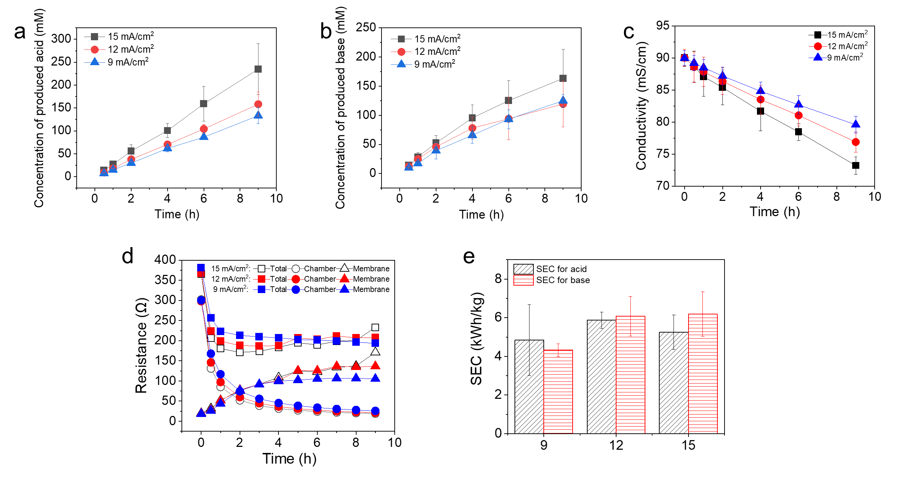

Figure 3-11 BMED performance change under different current densities. (a) Concentration of produced acid; (b) Concentration of produced base; (c) Conductivity change in the SC. (d) Variation of stack resistance, chamber resistance and membrane resistance during BMED. (e) Specific energy consumption of produced acid and base.

The current density directly related to ion transport, which can be reflected by the concentration of produced acid and base (**Figure 3-11 a, b**) and the conductivity in SC (**Figure 3-11 c**). The concentration of produced acid was around 234, 158 and 133 mM under 15, 12, 9 mA/cm2. The decrease of acid was due to decreased water dissociation on BPM under lower current density. However, the acid concentration was still higher than base concentration. The concentration of the produced base was around 163, 119 and 124 mM under 15, 12, 9 mA/cm2. It indicated that scaling in BC consumed part of OH-. The conductivity in SC showed that current density was proportional to the desalination ratio. The download trend of conductivity was weakened with decreasing current density because the ion transport through membranes was slowed down. In that case, it needed longer time to reach the target desalination ratio and concentration of acid and base. With less scaling in the stack, the resistance decreased with current densities (**Figure 3-11 d**). The stack resistance was 233, 207 and 193 Ω under 15, 12, 9 mA/cm2. The slight difference resulted from the membrane resistance. It decreased with decreasing current densities. Since there was less precipitation at low current density (**Figure 3-10 e**), the membrane resistance was lower. The difference in energy consumption among three current densities was not significant (**Figure 3-11 e**). In general, SEC decreased gradually as the current decreased. At 15 and 12 mA/cm2, the SEC for base was higher than that for acid because the concentration of produced base was lower than acid.

The current density could reduce the scaling to some extent, but it will also reduce the performance of BMED especially the acid and base production. In that case, the determination of current density based on scaling and acid-base production is very important in future work.

* 1. **Implication**

This study provides critical insights into the mechanisms of scaling formation, particularly the strong dependance of scaling on ion transport in BMED. Scaling was identified across the whole BMED stack, including in the bulk solution and on IEMs surface (particularly both sides of the CEM and the surface CEL layer of BPM). Scaling significantly reduced the acid-base concentration and purity and caused an irreversible decline in the performance. The identification of localized supersaturation zones near membrane surfaces, driven by divalent ion transport and water splitting, highlights the need for more targeted strategies to mitigate scaling during acid and base production from SWB.

The findings suggest several actionable directions. First, since the transport of divalent ions through CEMs initiates scaling processes, incorporating upstream pretreatment to limit Ca2+ and Mg2+ concentrations is crucial. Second, water splitting caused by scaling further aggravates scaling, so managing operational parameters is essential to avoid the occurrence of water splitting. Additionally, the accumulation of deposits near membrane surfaces underscores the need for periodic removal of precipitates to preserve membrane integrity and prevent further performance decline.

All in all, this study emphasizes the importance of membrane surface conditions, ion migration pathways, and local electrochemical environments in scaling behavior—factors that should guide future membrane material development and process optimization. Continued research is necessary to develop comprehensive anti-scaling strategies, especially for BMED systems treating high-divalent-ion waters, where long-term stability and energy efficiency are critical for scaling mitigation and sustainable operation.

Chapter 4 Determination of Critical Ca2+ and Mg2+ Concentrations for Scaling Prevention in BMED

**4.1 Introduction**

BMED is widely used separation technology to converse salt solutions into acid and base solutions. Under the applied current density, the ions in the salt chamber transport to adjacent chambers (i.e., acid and base chambers). Simultaneously, BPM catalyzes water dissociation at its interface, generating H+ and OH-, which accumulate in the acid and base chamber, respectively. This approach enables the production of acids and bases from salt solutions, providing an efficient and environmentally sustainable alternative to conventional chemical processes. BMED has been applied in various biological and chemical industries (Lameloise and Lewandowski 2012, Reig, Valderrama et al. 2016, Zhao, Zhou et al. 2018, Shi, Xiao et al. 2020). Many studies have shown that BMED has the potential to produce high-purity acids (e.g., HF (Erkmen, Yapıcı et al. 2016), HCl (Qiu, Yao et al. 2019), H2SO4 (Kishida, Harato et al. 2017), H3PO4 (Trivedi, Shah et al. 1999), acetic acid (Trivedi, Shah et al. 1997), citric acid (Tongwen and Weihua 2002)) and bases (e.g., NaOH (Trivedi, Shah et al. 1999, Wei, Li et al. 2012), LiOH (Qiu, Yao et al. 2019)) from salt solutions.

The presence of divalent ions such as Ca2+ and Mg2+ in salt solution will result in the formation of scaling in BMED, which poses a significant challenge to the stability and performance of BMED systems. The scaling was always observed on CEMs facing the base chamber (Ren, Wang et al. 2008, Shee, Angers et al. 2008, Wang, Yang et al. 2011). This results from the reaction of divalent ions transported from salt solution and excess OH- in the BC. The deposits are composed of Ca-based and Mg-based salts (e.g., Ca(OH)2, CaCO3 and Mg(OH)2) (Ren, Wang et al. 2008, Shee, Angers et al. 2008, Wang, Yang et al. 2011). As the presence of scaling reduces the BMED performance, pretreatment of the salt solution to reduce the concentration of Ca2+ and Mg2+ has been applied. In the research of Hábová, Melzoch et al. (2004), the concentration of metal ions (i.e., Ca2+, Mg2+ and Fe3+) decreased to 1 mg/L. Yang, Gao et al. (2014) reduced the concentration of Mg2+ in the salt solution from 2 g/L to 0 ppm and that of Ca2+ from 0.7 mg/L to 1.1 ppm by adding chemicals before the salt solution was treated in BMED. Similarly, the concentration of Mg2+ and Ca2+ in the salt solution was 9.3 and 16.6 ppm in the research of Reig, Casas et al. (2016). In these research, they claimed that the concentration was low enough to avoid scaling. However, there is no evidence to prove that deposits were not found on the membrane.

Although previous studies have reported that scaling risk was reduced when the salt solution contained low concentrations of Ca2+ and Mg2+, these studies lacked direct evidence confirming the complete absence of deposits on membranes. Moreover, no systematic evaluation has been conducted to identify the critical concentration limits of Ca2+ and Mg2+ in BMED below which the performance degradation occurred. Therefore, it is essential to determine the maximum allowable concentration of Ca2+ and Mg2+ that do not induce scaling or performance decline. It will provide a scientific basis for pretreatment targets and support the development of BMED in treating SWB.

**4.2 Material and methods**

**4.2.1 BMED Experimental Process**

The commercial membranes used in this chapter were BPMs (from Kejia Polymer Materials Technology Co., China), SCEMs (from ASTOM Co., Japan) and AEMs (from ASTOM Co., Japan). Each membrane has an effective membrane area of 7.065 cm2. The BMED setup was the same as that in Chapter 3 (details in Chapter 4.2.1). The stack was assembled according to BPM, AEM and SCEM as a repeating unit. There were three repeating units in total, with a separate BPM at the end.

Each chamber contained 400 mL of solution. The AC and BC were filled with 10 mM HCl and 10 mM NaOH. The EC was filled with 0.3 M Na2SO4. Model solutions consisted of a fixed concentration of NaCl, Na2SO4 and NaHCO3 to replicate the salinity of typical SWB (**Table B1**). To investigate the divalent ions on scaling behavior, different concentrations of MgCl2·6H2O and CaCl2·2H2O were added accordingly to reach the target Mg2+ or Ca2+ concentration as shown in Table S1. To compare whether the BMED performance declined, a NaCl solution and a SWB were also prepared.

The flow rate of each solution was 200 mL/min. A constant current density of 12 mA/cm2 was applied. Each experiment run 6 hours for short term tests, and it run 48 hours for long-term tests.

**4.2.2 BMED Performance Analysis**

During the BMED process, the pH in the AC, BC and SC were measured by portable pH meters (Seven2Go pH/Ion Meter S8, Mettler Toledo, Singapore). The concentration of produced acid and base was calculated from the measured pH values. The voltage across the BMED was monitored by Power DC software. The conductivities of solutions in AC, BC and SC were recorded by conductivity meters (Orion Star A212, Thermo Scientific, USA). The membrane resistance was calculated from the voltage, current and conductivities according to the methods in **Section 3.2.3.2**.

**4.3 Results and Discussion**

**4.3.1 Influence of Ca2+ on Acid-Base Production and System Performance**

In order to determine the critical concentration of Ca2+ in SWB that would not cause performance decline in BMED, different salt solutions with according Ca2+ were used. The concentration of Ca2+ in the salt solution varied from 0.01 ppm to 50 ppm (i.e., 0.01 ppm, 0.1 ppm, 1 ppm, 10 ppm and 50 ppm). Each test run 6 hours and was repeated at least three times to ensure reproducibility.

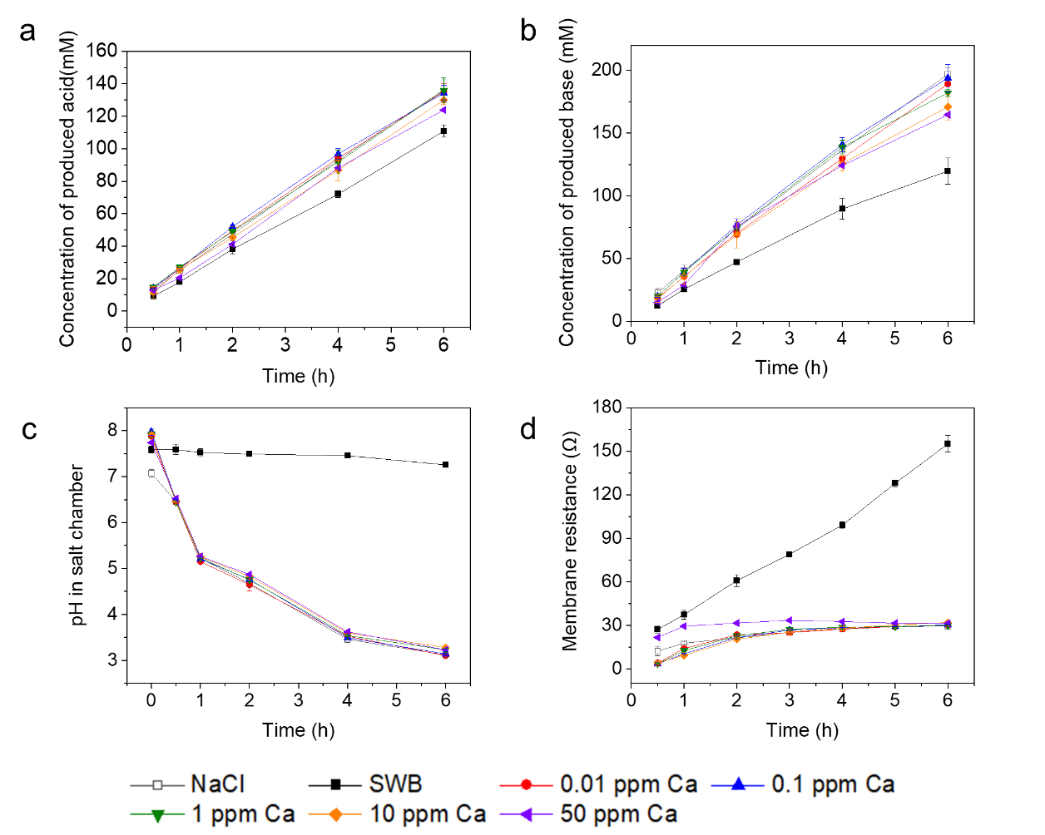

Figure 4-1 The BMED performance changes with different concentrations of Ca2+. The concentration of produced (a) acid and (b) base. (c) The pH change in the salt chamber. (d) The membrane resistance changes with time.

Figure 4-1 showed the effect of Ca2+ concentration on acid and base concentration (**Figure 4-1 a, b**), pH change in the SC (**Figure 4-1 c**) and the membrane resistance changes (**Figure 4-1 d**). For all of the tests, the final concentration of base was higher than that of acid because of the leakage of H+. The mobility of H+ was much higher than OH-, so H+ leaked from AC to SC, resulting in a decreased concentration of produced acid (Strathmann 2004). There was a slight decline in acid concentration. The acid concentration when treating NaCl could reach 136 mM, and that when treating solutions with 0.01 ppm Ca2+, 0.1 ppm Ca2+ and 1 ppm Ca2+ was around 135 mM (**Figure 4-2 a**). However, when treating solutions with 10 ppm Ca2+, the concentration of acid decreased to 129 mM, and it further decreased to 123 mM when the solution contained 50 ppm Ca2+. The decline was more obvious for base concentration. In the baseline test, the concentration of base was 196 mM. When the salt solution contained 0.01 ppm and 0.1 ppm Ca2+, the concentration was around 190 mM, which did not deviate from the baseline significantly. However, the base concentration decreased by 15.3 % when there existed 10 ppm Ca2+ in the solution, and it decreased by 19.5 % (**Figure 4-2 b**). When treating solution containing more than 10 ppm Ca2+, the acid-base production gradually decreased. The pH in salt chamber showed a decline from around 7.5 to 3.2 when treating NaCl and solution with Ca2+, while the pH in SC was stable around 7.5 when treating SC (**Figure 4-1 c**) . It indicated that the Ca2+ in SWB was high enough to form deposits on CEM and triggered water splitting. The OH- generated from water splitting neutralized the H+ leaked from AC. The pH change in SC also proved that the amount of scaling was negligible and did not further result in water splitting due to the large coverage of the CEM surface. This could also be reflected by the membrane resistance change (**Figure 4-1 d**). When treating SWB, a large number of deposits were formed on membrane surface, increasing the membrane resistance to more than 155 Ω. However, there was no significant increase in membrane resistance in other groups. The final membrane resistance was below 30 Ω for baseline tests and tests with 0.01 ppm, 0.1 ppm and 1 ppm Ca. The membrane resistance increased to 32 Ω when 10 ppm Ca existed in the salt solution, which indicated that deposits gradually grow on membrane surface. In the BC, the concentration of OH- was ~0.22 mM at 6 hours, and the concentration of Ca2+ needed to be below 4.78 ppm to avoid supersaturation (Ksp = 6 × 10-6 for Ca(OH)2 at 25 ℃) (Fan, Chen et al. 2006, Cao and Harris 2008, Andreeva, Gil et al. 2017). When there was 10 ppm in the salt solution, the concentration of Ca2+ in the BC could reach this value to form deposits with continuous transport from SC to BC. The SEM image of the SCEM surface could also illustrate that deposits were formed on membrane surface (**Figure B1**). When treating salt solution containing 1 ppm Ca2+, no obvious crystals were found on both sides of SCEM. When the solution contained 10 ppm Ca2+, the SCEM facing SC was smooth, while the presence of irregular sediments was observed on SCEM facing BC.

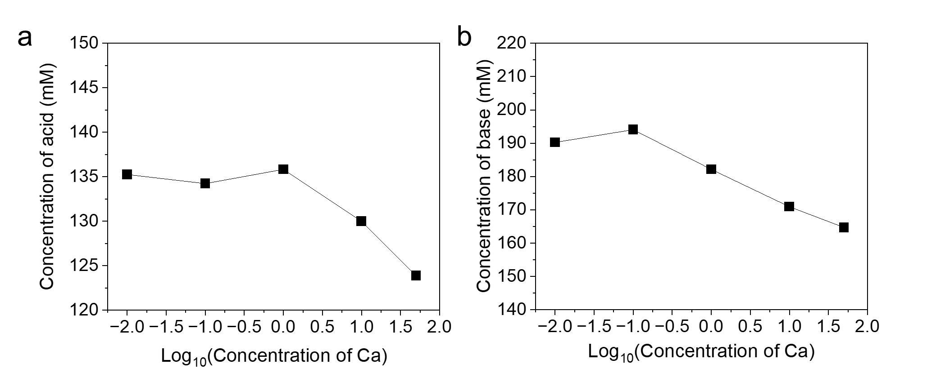

Figure 4-2 Effect of Ca2+ concentration on (a) acid and (b) base production in BMED (The x-axis represents the logarithmic concentration of Ca2+ in the feed solution (ppm)).

When the salt solution contained 10 ppm Ca2+, the performance of BMED was impaired to some extent (**Figure 4-2 a, b**). Compared to low- Ca2+ concentrations (i.e., 0.01 ppm, 0.1 ppm and 1 ppm Ca2+), the presence of 10 ppm Ca2+ led to a reduction in the acid-bas production due to slight scaling formation.

**4.3.2 Influence of Mg2+ on Acid-base Production and System Performance**

Likewise, salt solutions with varying concentrations were prepared to identify the critical concentration of Mg2+ in seawater brine (SWB). The concentration of Mg2+ in the salt solution varied from 1 ppb to 100 ppm (i.e., 1 ppb, 0.01 ppm, 0.1 ppm, 1 ppm, 10 ppm, 20 ppm, 50 ppm and 100 ppm). Each test run 6 hours and was repeated at least three times to ensure reproducibility.

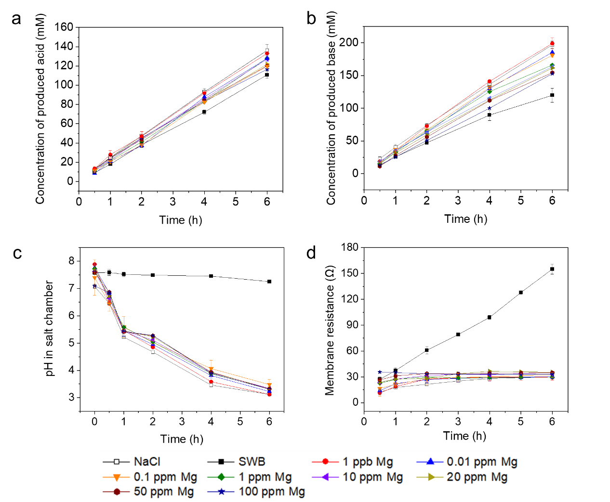

Figure 4-3 The BMED performance changes with different concentrations of Mg2+. The concentration of produced (a) acid and (b) base. (c) The pH change in the salt chamber. (d) The membrane resistance changes with time.

**Figure 4-3** showed the BMED performance change when treating salt solutions with different concentration of Mg2+. For both produced acid and base, the concentration gradually decreased with the increasing Mg2+ concentration (**Figure 4-3 a, b**). When treating solution with 1 ppb Mg, the concentration of produced acid and base was close to that treating NaCl (136 mM and 200mM for acid and base respectively). However, both acid and base gradually decreased when Mg2+ increased (from 0.01 ppm to 100 ppm) (**Figure 4-4**). The acid gradually decreased from 127 mM to 116 mM and the base decreased 185 mM to 152 mM. The production decline might result from the formation of Mg-based deposits. When dealing with the solution with 1 ppb Mg, there was no crystal on both sides of SCEM (**Figure B2 a, b)**. However, the deposits were found on the SCEM facing BC when the solution contained 0.01 ppm Mg (**Figure B2 d**), while the other side was clean (**Figure B2 c**). In the BC, the concentration of OH- was ~0.22 mM at 6 hours, and the concentration of Mg2+ needed to be below 0.0086 ppb to avoid supersaturation (Ksp = 1.8 × 10-11 for Mg(OH)2 at 25 ℃) (Fan, Chen et al. 2006, Cao and Harris 2008, Andreeva, Gil et al. 2017). It indicated that Mg-based deposits were easily formed in the stack. Although scaling was formed on membrane surface, it was not enough to trigger the water splitting, so the pH in SC for all tests except treating the SWB gradually decreased (**Figure 4-3 c**). **Figure 4-3 d** also showed that the slight scaling was formed to increase the membrane resistance.

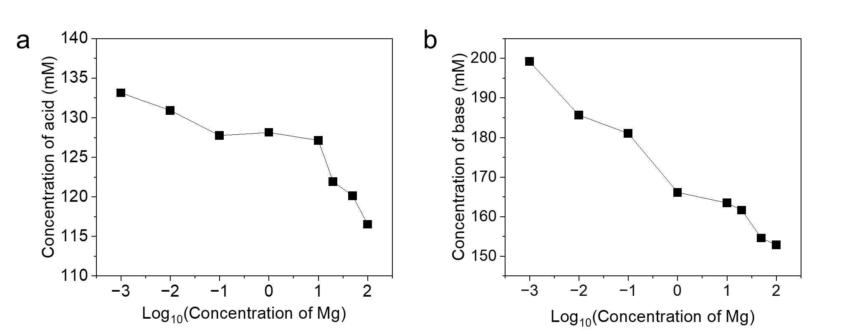

Figure 4-4 Effect of Mg2+ concentration on (a) acid and (b) base production in BMED (The x-axis represents the logarithmic concentration of Mg2+ in the feed solution (ppm)).

All in all, the BMED performance, especially the acid-base produce, decline under low-concentration Mg in the salt solution as shown in **Figure 4-4**. When the concentration of Mg was higher than 0.01 ppm, there was few undeveloped deposits on SCEM that further resulted in the performance decline.

**4.3.3 Influence of Mixed Mg2+ and Ca2+ on Acid-base Production and System Performance**

To further investigate the combined effect of Ca2+ and Mg2+ on BMED performance, mixed-ion experiments were run using two representative concentration sets based on the previously determined critical thresholds. The first group consisted of 0.01 ppm Mg2+ and 10 ppm Ca2+, which was a condition under which individual tests of both ions had already shown clear signs of performance decline. The second group, with 1 ppb Mg2+ and 1 ppm Ca2+, was selected to represent a near-baseline as neither ion at their concentrations had significantly impaired performance when tested separately. For each group, the experiment lasted 6 hours.

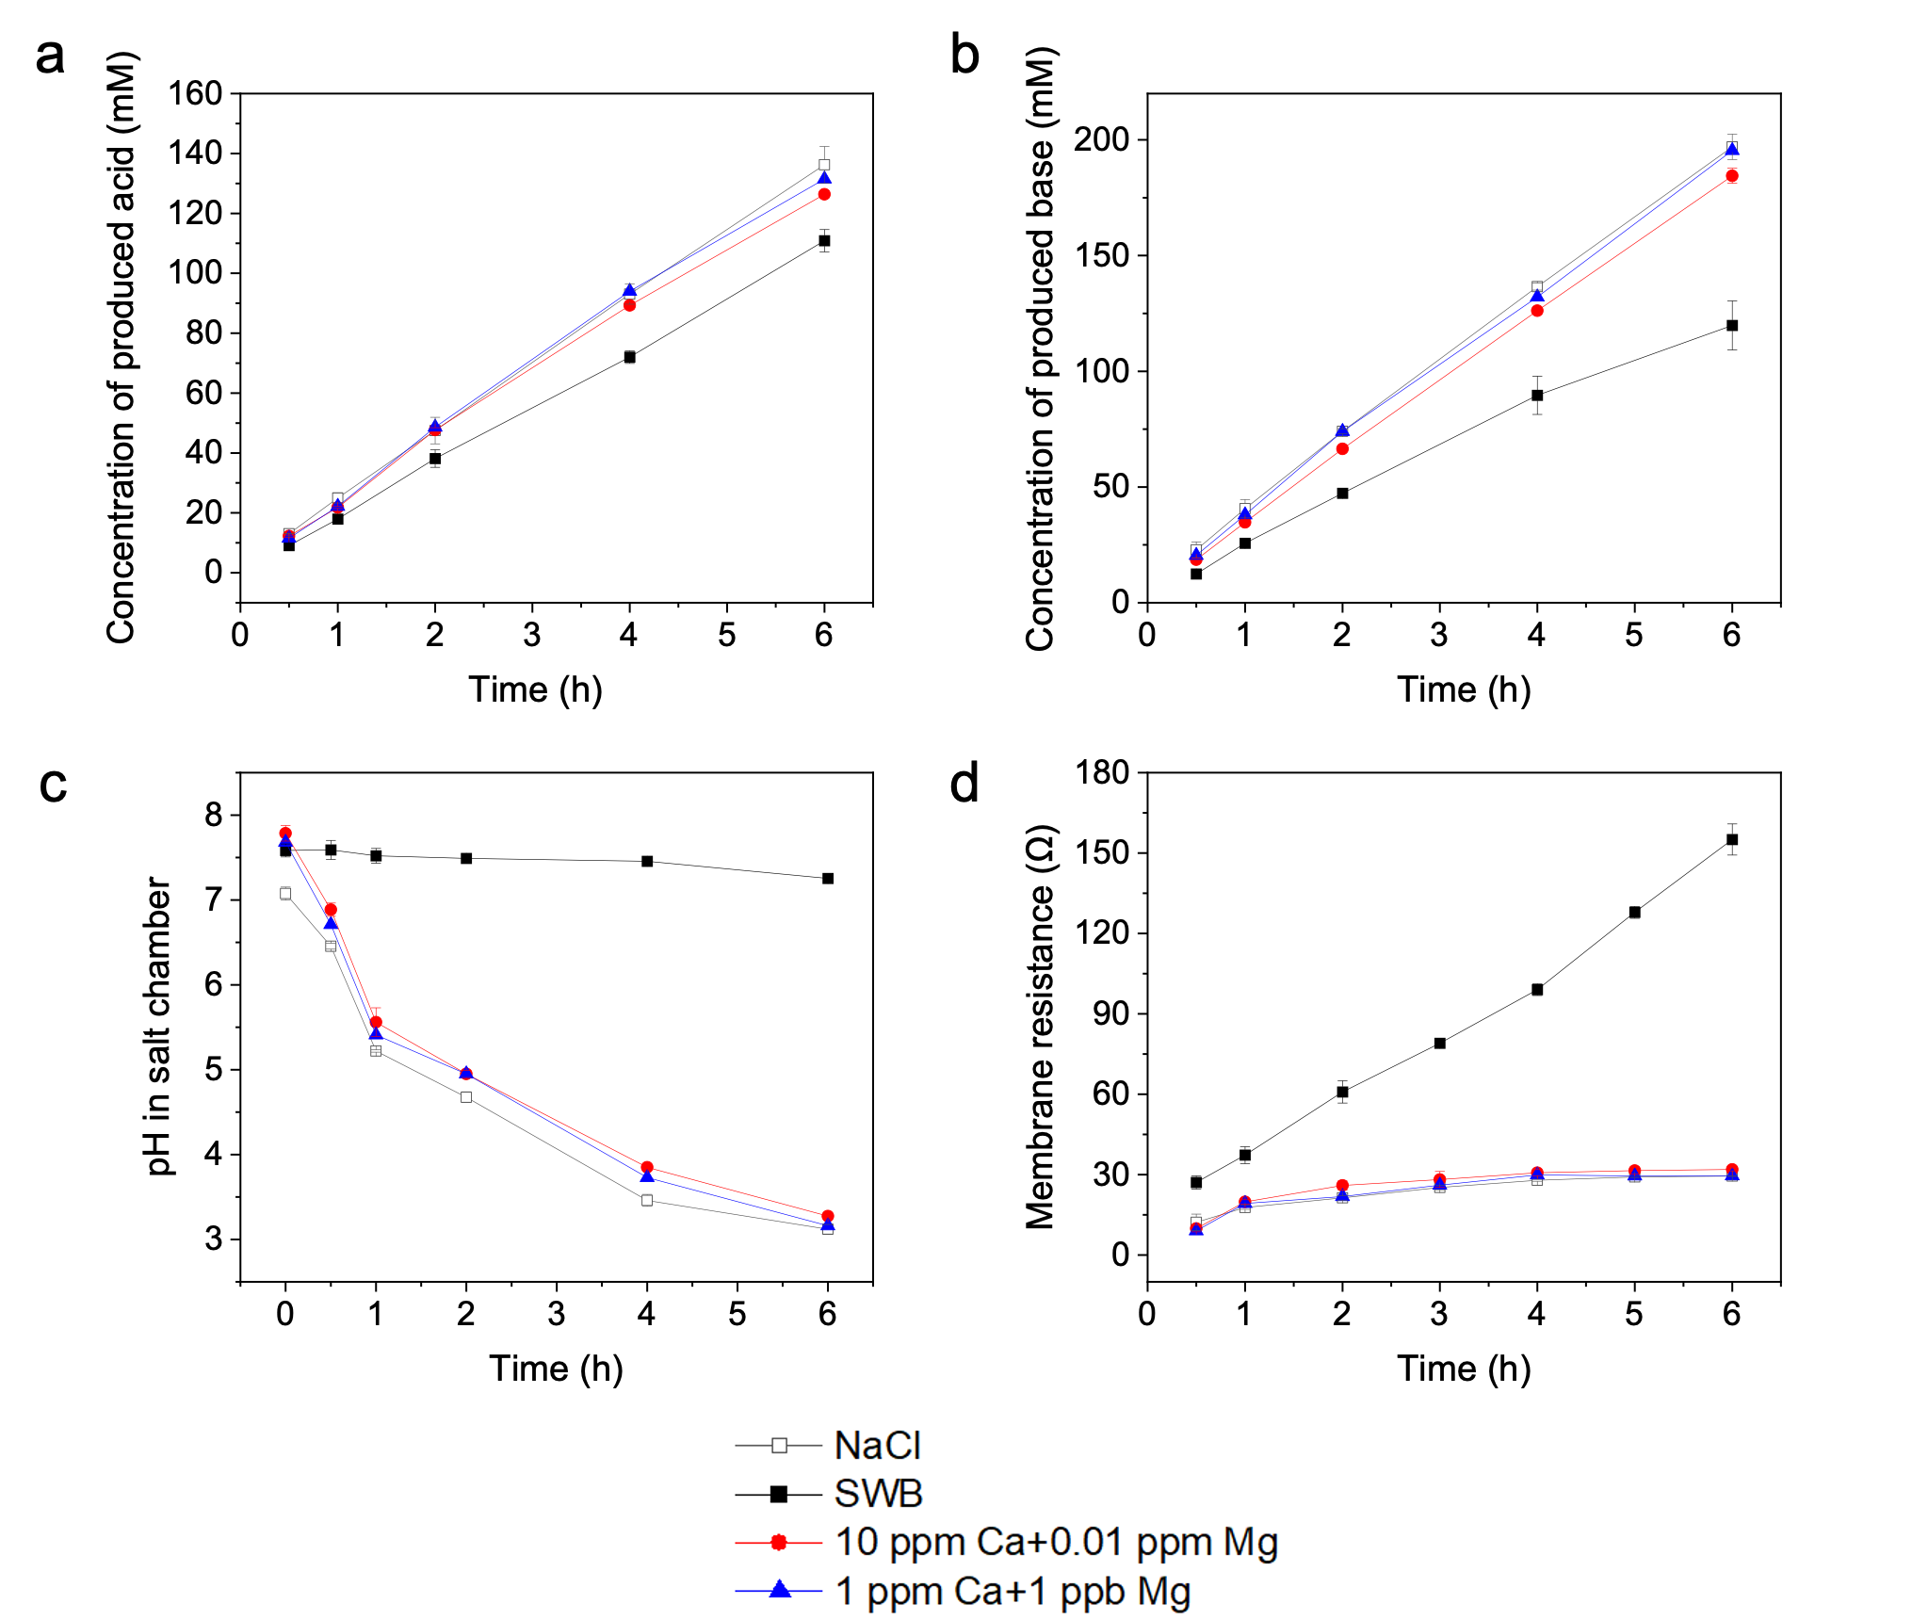

Figure 4-5 The BMED performance changes with mixed Mg2+ and Ca2+. The concentration of produced (a) acid and (b) base. (c) The pH changes in the salt chamber. (d) The membrane resistance changes with time.

**Figure 4-5** showed the performance of two mixed-ion groups, NaCl and SWB. After 6-hour test, the final concentration of acid was 131 mM and that of base was 195 mM for 1 ppb Mg2+ and 1 ppm Ca2+, which was close to the baseline (136 mM for acid and 196 mM for base) (**Figure 4-5 a, b**). When the solution contained 10 ppm Ca2+ and 0.01 ppm Mg2+, the concentration of produced acid and base dropped to 126 mM and 187 mM (**Figure 4-5 a, b**). The performance decline resulted from the scaling formation, which could be reflected by the decreased pH decline (**Figure 4-5 c**) and increased membrane resistance (**Figure 4-5 d**). **Figure B3** also showed that scaling covered the SCEM facing BC **(Figure B3 d**), while there was no obvious crystal on the SCEM when treating 1 ppm Ca2+ and 0.01 ppm Mg2+ (**Figure B3 a, b**).

**4.3.3 The BMED Performance in a Long-term Test**

To investigate the durability and operational stability of the BMED system under the critical Ca2+ and Mg2+ concentration, long-term tests were conducted. While short-term experiments were effective in identifying the scaling effect on acid-base production, they may not reflect the accumulative effected of scaling, membrane degradation over time. Therefore, a long-term test could simulate realistic operating conditions by continuously treating model SWB. Key parameters, including the concentration of produced acid and base, pH in SC, conductivity change in the SC and the voltage change across the stack, were monitored for 48 hours.

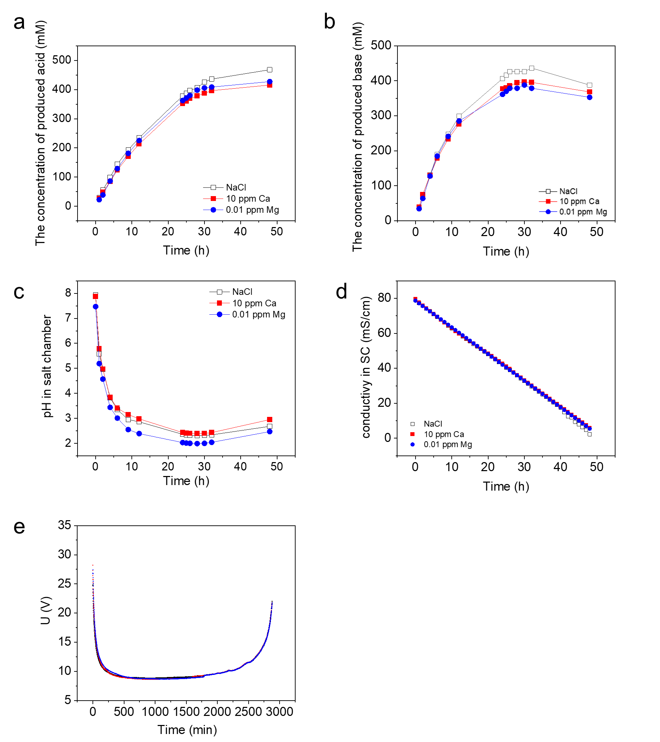

Figure 4- 6 The BMED performance changes in a long-term test. The concentration of produced (a) acid and (b) base. (c) The pH changes in the salt chamber. (d) Conductivity changes in the salt chamber with time. (e) The voltage changes across BMED stack.

**Figure 4-6 a** showed the concentration change of produced acid. In the first 6 hours, the concentration of acid increased linearly, while its increased slowed down after that. It increased to 378 mM in 24 hours and finally reached 467 mM for NaCl and ~427 mM for solution containing Ca2+ or Mg2+. The changes were similar in base production. It increased linearly in the early stage of the tests and reached a plateau from 24 hours to 32 hours (**Figure 4-6 b**). However, it gradually decreased in the final stage. The final concentration of base was 387, 368 and 352 mM for NaCl, 10 ppm Ca2+ and 0.01 ppm Mg2+. The decrease in base concentration might result from the leakage of OH- from BC to SC, which can also be reflected by the increase of pH in SC in the final stage (**Figure 4-6 c**). The pH in SC gradually decreased to 2.3 in 24 hours, but it gradually increased after 28 hours. It indicated that SCEM showed a low alkali-resistance. SCEMs were designed to selectively transport monovalent cation while restricting the passage of multivalent ions and co-ions (such as OH-). However, prolonged exposure to high alkaline environments led to chemical degradation of membrane polymer matrix and the surface layer. **Figure 4-6 d** showed the conductivity change in 48 hours. The desalination ratio of NaCl was slightly higher than that of salt solution containing Ca2+ or Mg2+. The voltage across the BMED stack showed that an immediate and sharp decrease in the initial stage of the test, which resulted from the low chamber resistance, especially acid and base chamber. With experiment processed, the voltage reached a plateau, and finally increased due to the ion depletion in the SC.

**4.4 Conclusions**

This study determined the critical concentration of divalent cations in the SWB that will not result in BMED performance decline. When the salt solution contained 10 ppm Ca2+, a moderate decline in acid and base production was observed, attributed to the formation of slight scaling on SCEM facing BC. In contrast, lower concentrations of Ca2+ (0.01-1 ppm) had minimal impact on BMED efficiency. However, Mg2+ exhibited a stronger influence on system performance. As the solubility product of Mg-based deposits was quite low, it was likely that scaling easily formed on SCEM surface. When Mg2+ exceeded 0.01 ppm, performance deterioration became evident. The mixed-ion tests and long-term tests further confirmed that the acid-base production declined when the salt solution contained 0.01 ppm Mg2+ and 10 ppm Ca2+. Moreover, in the long-term tests, the decreased base concentration and increased pH value in the SC indicated that SCEM degraded in the final stage as it was not alkali resistant.

These findings highlighted the importance of carefully controlling divalent ion concentrations in the feed solution to ensure stable BMED operation. Further efforts should focus on developing models that could monitor the critical concentration of Ca2+ and Mg2+ under different conditions, such as different repeating unit, membrane type, membrane area, current densities. With this model, the performance of BMED could be improved. Furthermore, the study suggested that although SCEM offered ion selectivity, which prevented the scaling formation to some extent, it needed further enhancement, especially in high OH- conditions. In the future, developing a more chemically robust SCEM could solve the pain point of low alkaline resistance.

Chapter 5 Conclusions and Recommendations

**5.1 Overall Conclusions**

These studies systematically investigated the scaling behavior in BMED system, including the mechanism of scaling formation and threshold conditions of scaling during the treatment of SWB. Scaling induced by divalent cations (i.e., Ca and Mg) was found to significantly result in system performance decline. Scaling on membranes reduce the effective membrane area to prevent ion migration, increase membrane resistance and diminish the purity and production of acid and base products. In order to have an understanding of scaling behavior in BMED system, the mechanism of scaling at different locations and influencing effects are investigated. The critical concentration of divalent ions in the salt solution is also determined for an improved BMED performance.

In the first research, the mechanism of scaling in BMED was thoroughly explored. Scaling was observed at multiple locations across the membrane stack, including the SC, BC, CEM facing SC, CEM facing BC and BPM facing BC. The scaling mechanism resulted from the ion transport in BMED process. Under the electric field, the divalent cations in the SC transported through CEM to the BC, where they reacted with excess OH- to form heterogeneous scaling on CEM facing BC and homogeneous scaling in the BC. When the deposits on the CEM facing BC gradually grew up from nuclei to observed crystal, the effective membrane area was reduced to increase the local current density. Once the local current density exceeded the limiting current density, water splitting occurred to generate additional OH-. OH- leaked into SC and reacted with residual divalent ions, causing further precipitation in the SC and on CEM facing SC. Scaling on CEM facing SC triggers water splitting to aggravate scaling in SC. Additionally, scaling on BPM was attributed to the interaction between divalent cations and the locally elevated OH- concentration. Overall, this finding underscores the critical influence of ion migration and local electrochemical environment conditions on scaling behavior. Based on the mechanism, the limitation of divalent ion transport and the prevention of water splitting was essential to avoid scaling formation in BMED. In that case, this research also demonstrated to use SCEM and change current density to reduce scaling in BMED. The use of SCEM could effectively mitigate scaling by limiting the transport of divalent cations from the SC to the BC. Furthermore, reducing the current density could slow down the transportation of cation and avoid water splitting, which reduced the scaling to some extent.

The second research focused on the determination of critical concentrations of Ca and Mg that lead to performance decline. It was determined that when the concentration of Ca and Mg reached 10 ppm and 0.01 ppm in the salt solution respectively, BMED performance, especially the acid and base production began to decline due to initial scaling formation. The mixed-ion tests and long-term tests also proved this. In particular, the long-term tests revealed that SCEMs suffered a degradation when they were exposed to high pH environment, as evidenced by a decline of final base concentration and increased pH in the SC.

Overall, this research provides mechanistic insight into scaling behavior. It not only offer guidance of scaling mitigation according to the scaling formation mechanism at different locations but also point out optimal operation parameter that could reduce scaling to some extent.

**5.2 Recommendations for Future Research**

In this research, some issues can be further explored or improved in future research. Future research could aim to establish a more refined operational balance between the scaling mitigation and high acid-base production in BMED. Although reducing current density could reduce scaling to some extent, it required a longer desalination time and lower acid-base production. In that case, it is essential to develop more targeted scaling mitigation methods based on the scaling mechanism in this study. The new methods could develop from the limitation of divalent ion transport, the prevention of OH- leakage, the avoidance of water splitting. Advanced mitigation strategies should be explored to reduce scaling while maintaining high production efficiency.

Limitation also exists in the application of SCEM. SCEM did help the less transport of divalent cations to the BC to initiate the scaling formation, but it shows a degradation in the long-term run. It indicates that the development of SCEM could not only focus on improving the permselectivity of monovalent ions to multivalent ions but also improve its efficiency in alkaline resistance. SCEM capable of withstanding prolonged exposure to high-pH environment without performance decline will be essential for long-term BMED process, especially when treating SWB.

In addition, the critical concentration of divalent ions in the salt solution might be changed based on the different membrane stack, parameters and membranes. In the future work, a model to predict whether scaling will be formed in BMED according to different conditions will help to improve BMED performance.

Reference

Abdul-Wahab, S. A. and M. A. Al-Weshahi (2009). "Brine management: substituting chlorine with on-site produced sodium hypochlorite for environmentally improved desalination processes." Water resources management **23**(12): 2437-2454.

Afsar, N. U., M. A. Shehzad, M. Irfan, K. Emmanuel, F. Sheng, T. Xu, X. Ren, L. Ge and T. Xu (2019). "Cation exchange membrane integrated with cationic and anionic layers for selective ion separation via electrodialysis." Desalination **458**: 25-33.

Al-Sakaji, B. A., G. A. Husseini and N. A. Darwish (2023). "Impact of ionic strength and charge density on donnan potential in the NaCl-cation exchange membrane system." Water **15**(21): 3830.

Alawad, S. M., R. B. Mansour, F. A. Al-Sulaiman and S. Rehman (2023). "Renewable energy systems for water desalination applications: A comprehensive review." Energy Conversion and Management **286**: 117035.

Andreeva, M., V. Gil, N. Pismenskaya, L. Dammak, N. Kononenko, C. Larchet, D. Grande and V. Nikonenko (2018). "Mitigation of membrane scaling in electrodialysis by electroconvection enhancement, pH adjustment and pulsed electric field application." Journal of Membrane Science **549**: 129-140.

Andreeva, M. A., V. V. Gil, N. D. Pismenskaya, L. Dammak, N. A. Kononenko, C. Larchet, D. Grande and V. V. Nikonenko (2018). "Mitigation of membrane scaling in electrodialysis by electroconvection enhancement, pH adjustment and pulsed electric field application." Journal of Membrane Science **549**: 129-140.

Andreeva, M. A., V. V. Gil, N. D. Pismenskaya, V. V. Nikonenko, L. Dammak, C. Larchet, D. Grande and N. A. Kononenko (2017). "Effect of homogenization and hydrophobization of a cation-exchange membrane surface on its scaling in the presence of calcium and magnesium chlorides during electrodialysis." Journal of Membrane Science **540**: 183-191.

Arana Juve, J.-M., F. M. S. Christensen, Y. Wang and Z. Wei (2022). "Electrodialysis for metal removal and recovery: A review." Chemical Engineering Journal **435**.

Ariono, D. and I. Wenten (2017). "Heterogeneous structure and its effect on properties and electrochemical behavior of ion-exchange membrane." Materials Research Express **4**(2): 024006.

Asraf-Snir, M., J. Gilron and Y. Oren (2016). "Gypsum scaling of anion exchange membranes in electrodialysis." Journal of Membrane Science **520**: 176-186.

Asraf-Snir, M., J. Gilron and Y. Oren (2018). "Scaling of cation exchange membranes by gypsum during Donnan exchange and electrodialysis." Journal of Membrane Science **567**: 28-38.

Aydogan Gokturk, P., R. Sujanani, J. Qian, Y. Wang, L. E. Katz, B. D. Freeman and E. J. Crumlin (2022). "The Donnan potential revealed." Nature communications **13**(1): 5880.

Barros, K. S., M. C. Martí-Calatayud, V. Pérez-Herranz and D. C. R. Espinosa (2020). "A three-stage chemical cleaning of ion-exchange membranes used in the treatment by electrodialysis of wastewaters generated in brass electroplating industries." Desalination **492**.

Bazinet, L., D. Montpetit, D. Ippersiel, J. Amiot and F. Lamarche (2001). "Identification of skim milk electroacidification fouling: a microscopic approach." Journal of colloid and interface science **237**(1): 62-69.

Belashova, E., S. Mikhaylin, N. Pismenskaya, V. Nikonenko and L. Bazinet (2017). "Impact of cation-exchange membrane scaling nature on the electrochemical characteristics of membrane system." Separation and Purification Technology **189**: 441-448.

Bunani, S., M. Arda, N. Kabay, K. Yoshizuka and S. Nishihama (2017). "Effect of process conditions on recovery of lithium and boron from water using bipolar membrane electrodialysis (BMED)." Desalination **416**: 10-15.

Bunani, S., K. Yoshizuka, S. Nishihama, M. Arda and N. Kabay (2017). "Application of bipolar membrane electrodialysis (BMED) for simultaneous separation and recovery of boron and lithium from aqueous solutions." Desalination **424**: 37-44.

Cao, X. and W. Harris (2008). "Carbonate and magnesium interactive effect on calcium phosphate precipitation." Environmental science & technology **42**(2): 436-442.

Casademont, C., M. A. Farias, G. Pourcelly and L. Bazinet (2008). "Impact of electrodialytic parameters on cation migration kinetics and fouling nature of ion-exchange membranes during treatment of solutions with different magnesium/calcium ratios." Journal of membrane Science **325**(2): 570-579.

Cassaro, C., G. Virruso, A. Culcasi, A. Cipollina, A. Tamburini and G. Micale (2023). "Electrodialysis with Bipolar Membranes for the Sustainable Production of Chemicals from Seawater Brines at Pilot Plant Scale." ACS Sustain Chem Eng **11**(7): 2989-3000.

Cassaro, C., G. Virruso, A. Culcasi, A. Cipollina, A. Tamburini and G. Micale (2023). "Electrodialysis with bipolar membranes for the sustainable production of chemicals from seawater brines at pilot plant scale." ACS Sustainable Chemistry & Engineering **11**(7): 2989-3000.

Chang, J.-H., A. V. Ellis, C.-H. Tung and W.-C. Huang (2010). "Copper cation transport and scaling of ionic exchange membranes using electrodialysis under electroconvection conditions." Journal of Membrane Science **361**(1-2): 56-62.

Chekioua, A. and R. Delimi (2015). "Purification of H2SO4 of pickling bath contaminated by Fe (II) ions using electrodialysis process." Energy Procedia **74**: 1418-1433.

Chen, B., C. Jiang, Y. Wang, R. Fu, Z. Liu and T. Xu (2018). "Selectrodialysis with bipolar membrane for the reclamation of concentrated brine from RO plant." Desalination **442**: 8-15.

Chen, Q. B., J. Wang, Y. Liu, J. Zhao, P. F. Li and Y. Xu (2021). "Sustainable disposal of seawater brine by novel hybrid electrodialysis system: Fine utilization of mixed salts." Water Res **201**: 117335.

Chen, T., J. Bi, Z. Ji, J. Yuan and Y. Zhao (2022). "Application of bipolar membrane electrodialysis for simultaneous recovery of high-value acid/alkali from saline wastewater: An in-depth review." Water Res **226**: 119274.

Chen, X., X. Ruan, S. E. Kentish, G. Li, T. Xu and G. Q. Chen (2021). "Production of lithium hydroxide by electrodialysis with bipolar membranes." Separation and Purification Technology **274**.

Cherif, A. T., J. Molenat and A. Elmidaoui (1997). "Nitric acid and sodium hydroxide generation by electrodialysis using bipolar membranes." Journal of applied electrochemistry **27**(9): 1069-1074.

Choi, K. H. and T. Y. Jeoung (2002). "Removal of zinc ions in wastewater by electrodialysis." Korean Journal of Chemical Engineering **19**: 107-113.

Culcasi, A., L. Gurreri, A. Cipollina, A. Tamburini and G. Micale (2022). "A comprehensive multi-scale model for bipolar membrane electrodialysis (BMED)." Chemical Engineering Journal **437**: 135317.

Dlugolecki, P., K. Nymeijer, S. Metz and M. Wessling (2008). "Current status of ion exchange membranes for power generation from salinity gradients." Journal of Membrane Science **319**(1-2): 214-222.

Donnan, F. G. (1924). "The theory of membrane equilibria." Chemical reviews **1**(1): 73-90.

DuChanois, R. M., C. J. Porter, C. Violet, R. Verduzco and M. Elimelech (2021). "Membrane Materials for Selective Ion Separations at the Water-Energy Nexus." Adv Mater **33**(38): e2101312.

Dufton, G., S. Mikhaylin, S. Gaaloul and L. Bazinet (2018). "How electrodialysis configuration influences acid whey deacidification and membrane scaling." J Dairy Sci **101**(9): 7833-7850.

Dunn, T. H. (2023). The effect of surface topography on crystallisation, University of Leeds.

Elimelech, M. and W. A. Phillip (2011). "The future of seawater desalination: energy, technology, and the environment." science **333**(6043): 712-717.

Erkmen, J., S. Yapıcı, M. E. Arzutuğ, Ö. Aydın, O. N. Ata and M. R. Öner (2016). "Hydrofluoric acid and sodium hydroxide production by bipolar membrane electrodialysis." Desalination and Water Treatment **57**(43): 20254-20260.

Fan, C., J. Chen, Y. Chen, J. Ji and H. H. Teng (2006). "Relationship between solubility and solubility product: The roles of crystal sizes and crystallographic directions." Geochimica et Cosmochimica Acta **70**(15): 3820-3829.

Fan, H., Y. Huang and N. Y. Yip (2022). "Advancing ion-exchange membranes to ion-selective membranes: principles, status, and opportunities." Frontiers of Environmental Science & Engineering **17**(2).

Farrokhzad, H., M. R. Moghbeli, T. Van Gerven and B. Van der Bruggen (2015). "Surface modification of composite ion exchange membranes by polyaniline." Reactive and Functional Polymers **86**: 161-167.

Fernandez-Gonzalez, C., A. Dominguez-Ramos, R. Ibañez and A. Irabien (2015). "Electrodialysis with Bipolar Membranes for Valorization of Brines." Separation & Purification Reviews **45**(4): 275-287.

Ferrer, J. S. J., S. Laborie, G. Durand and M. Rakib (2006). "Formic acid regeneration by electromembrane processes." Journal of Membrane Science **280**(1-2): 509-516.

Filingeri, A., J. Lopez, A. Culcasi, T. Leon, A. Tamburini, J. L. Cortina, G. Micale and A. Cipollina (2023). "In-depth insights on multi-ionic transport in Electrodialysis with bipolar membrane systems." Chemical Engineering Journal **468**: 143673.

Filingeri, A., J. Lopez, A. Culcasi, T. Leon, A. Tamburini, J. Luis Cortina, G. Micale and A. Cipollina (2023). "In-depth insights on multi-ionic transport in Electrodialysis with bipolar membrane systems." Chemical Engineering Journal **468**.

Fu, L., X. Gao, Y. Yang, F. Aiyong, H. Hao and C. Gao (2014). "Preparation of succinic acid using bipolar membrane electrodialysis." Separation and Purification Technology **127**: 212-218.

Gao, X., Y. Yang, L. Fu, Z. Sun, Y. Zheng and C. Gao (2014). "Regenerating spent acid produced by HZSM-5 zeolite preparation by bipolar membrane electrodialysis." Separation and Purification Technology **125**: 97-102.

Ge, L., B. Wu, Q. Li, Y. Wang, D. Yu, L. Wu, J. Pan, J. Miao and T. Xu (2016). "Electrodialysis with nanofiltration membrane (EDNF) for high-efficiency cations fractionation." Journal of Membrane Science **498**: 192-200.

Gherasim, C.-V., J. Křivčík and P. Mikulášek (2014). "Investigation of batch electrodialysis process for removal of lead ions from aqueous solutions." Chemical Engineering Journal **256**: 324-334.

Ghyselbrecht, K., A. Silva, B. Van der Bruggen, K. Boussu, B. Meesschaert and L. Pinoy (2014). "Desalination feasibility study of an industrial NaCl stream by bipolar membrane electrodialysis." J Environ Manage **140**: 69-75.

Giesbrecht, P. K. and M. S. Freund (2020). "Recent advances in bipolar membrane design and applications." Chemistry of Materials **32**(19): 8060-8090.

Glueckauf, E. and R. Watts (1962). "The Donnan law and its application to ion exchanger polymers." Proceedings of the Royal Society of London. Series A. Mathematical and Physical Sciences **268**(1334): 339-349.

Gonzalez, A., M. Grageda, A. Quispe, S. Ushak, P. Sistat and M. Cretin (2021). "Application and Analysis of Bipolar Membrane Electrodialysis for LiOH Production at High Electrolyte Concentrations: Current Scope and Challenges." Membranes (Basel) **11**(8).

Gou, M., Y. Zhao, B. Li, Y. Li, Z. Li and M. Wang (2025). "Scaling behavior of cation exchange membrane induced by Ca2+ during the electrodialysis for enriching lithium-containing solutions." Journal of Membrane Science **713**.

Guo, H. and Y. Kim (2021). "Membrane Scaling in Electrodialysis Fed with High-Strength Wastewater." Environmental Engineering Science **38**(9): 832-840.

Gurreri, L., A. Tamburini, A. Cipollina and G. Micale (2020). "Electrodialysis Applications in Wastewater Treatment for Environmental Protection and Resources Recovery: A Systematic Review on Progress and Perspectives." Membranes (Basel) **10**(7).

Hábová, V., K. Melzoch and M. Rychtera (2004). "Modern method of lactic acid recovery from fermentation broth." Czech journal of food sciences **22**(3): 87.

Herrero-Gonzalez, M., N. Admon, A. Dominguez-Ramos, R. Ibañez, A. Wolfson and A. Irabien (2020). "Environmental sustainability assessment of seawater reverse osmosis brine valorization by means of electrodialysis with bipolar membranes." Environmental Science and Pollution Research **27**: 1256-1266.

Herrero-Gonzalez, M., P. Diaz-Guridi, A. Dominguez-Ramos, A. Irabien and R. Ibañez (2020). "Highly concentrated HCl and NaOH from brines using electrodialysis with bipolar membranes." Separation and Purification Technology **242**.

Huang, C. and T. Xu (2006). "Electrodialysis with bipolar membranes for sustainable development." Environmental science & technology **40**(17): 5233-5243.

Hughes, M., A. Raubenheimer and A. Viljoen (1992). "Electrodialysis reversal at Tutuka Power Station, RSA-seven years' design and operating experience." Water Science and Technology **25**(10): 277-289.

Hülber-Beyer, É., K. Bélafi-Bakó and N. Nemestóthy (2021). "Low-waste fermentation-derived organic acid production by bipolar membrane electrodialysis—an overview." Chemical Papers **75**(10): 5223-5234.

Ibáñez, R., A. Pérez-González, P. Gómez, A. M. Urtiaga and I. Ortiz (2013). "Acid and base recovery from softened reverse osmosis (RO) brines. Experimental assessment using model concentrates." Desalination **309**: 165-170.

Jarma, Y. A., E. Çermikli, D. İpekçi, E. Altıok and N. Kabay (2021). "Comparison of two electrodialysis stacks having different ion exchange and bipolar membranes for simultaneous separation of boron and lithium from aqueous solution." Desalination **500**.

Jiang, C., Y. Wang, Z. Zhang and T. Xu (2014). "Electrodialysis of concentrated brine from RO plant to produce coarse salt and freshwater." Journal of Membrane Science **450**: 323-330.

Jiang, S., H. Sun, H. Wang, B. P. Ladewig and Z. Yao (2021). "A comprehensive review on the synthesis and applications of ion exchange membranes." Chemosphere **282**: 130817.

Johnston, J. (1915). "THE SOLUBILITY-PRODUCT CONSTANT OF CALCIUM AND

MAGNESIUM CARBONATES." Journal of the American Chemical Society **37**(9).

Jones, E., M. Qadir, M. T. H. van Vliet, V. Smakhtin and S. M. Kang (2019). "The state of desalination and brine production: A global outlook." Sci Total Environ **657**: 1343-1356.

Kang, M.-S., Y.-J. Choi, I.-J. Choi, T.-H. Yoon and S.-H. Moon (2003). "Electrochemical characterization of sulfonated poly (arylene ether sulfone)(S-PES) cation-exchange membranes." Journal of Membrane Science **216**(1-2): 39-53.

Kim, J., S. Yoon, M. Choi, K. J. Min, K. Y. Park, K. Chon and S. Bae (2022). "Metal ion recovery from electrodialysis-concentrated plating wastewater via pilot-scale sequential electrowinning/chemical precipitation." Journal of Cleaner Production **330**: 129879.

Kishida, M., T. Harato, C. Tokoro and S. Owada (2017). "In situ remediation of bauxite residue by sulfuric acid leaching and bipolar-membrane electrodialysis." Hydrometallurgy **170**: 58-67.

Klaysom, C., B. P. Ladewig, G. M. Lu and L. Wang (2011). "Preparation and characterization of sulfonated polyethersulfone for cation-exchange membranes." Journal of Membrane Science **368**(1-2): 48-53.

Kroupa, J., J. Kinčl and J. Cakl (2015). "Recovery of H2SO4 and NaOH from Na2SO4 by electrodialysis with heterogeneous bipolar membrane." Desalination and Water Treatment **56**(12): 3238-3246.

Kumar, A., K. R. Phillips, J. Cai, U. Schröder and J. H. Lienhard (2019). "Integrated valorization of desalination brine through NaOH recovery: opportunities and challenges." Angewandte Chemie International Edition **58**(20): 6502-6511.

Lameloise, M.-L. and R. Lewandowski (2012). "Recovering l-malic acid from a beverage industry waste water: Experimental study of the conversion stage using bipolar membrane electrodialysis." Journal of Membrane Science **403-404**: 196-202.

Lattemann, S. and T. Höpner (2008). "Environmental impact and impact assessment of seawater desalination." Desalination **220**(1-3): 1-15.

Lei, C., Z. Li, Q. Gao, R. Fu, W. Wang, Q. Li and Z. Liu (2020). "Comparative study on the production of gluconic acid by electrodialysis and bipolar membrane electrodialysis: Effects of cell configurations." Journal of Membrane Science **608**: 118192.

Leon, T., S. Abdullah Shah, J. Lopez, A. Culcasi, L. Jofre, A. Cipollina, J. L. Cortina, A. Tamburini and G. Micale (2022). "Electrodialysis with Bipolar Membranes for the Generation of NaOH and HCl Solutions from Brines: An Inter-Laboratory Evaluation of Thin and Ultrathin Non-Woven Cloth-Based Ion-Exchange Membranes." Membranes (Basel) **12**(12).

León, T., J. López, R. Torres, J. Grau, L. Jofre and J.-L. Cortina (2022). "Describing ion transport and water splitting in an electrodialysis stack with bipolar membranes by a 2-D model: Experimental validation." Journal of Membrane Science **660**: 120835.

Liu, H., Y. Jiang, J. Ding, W. Shi, J. Pan, C. Gao, J. Shen and B. van der Bruggen (2017). "Surface layer modification of AEMs by infiltration and photo‐cross‐linking to induce monovalent selectivity." AIChE Journal **64**(3): 993-1000.

Liu, H., H. Ruan, Y. Zhao, J. Pan, A. Sotto, C. Gao, B. Van der Bruggen and J. Shen (2017). "A facile avenue to modify polyelectrolyte multilayers on anion exchange membranes to enhance monovalent selectivity and durability simultaneously." Journal of Membrane Science **543**: 310-318.

Liu, H. and Q. She (2024). "Scaling-Enhanced Scaling during Electrodialysis Desalination." ACS ES&T Engineering **4**(5): 1063-1072.

Liu, Y., L. Dai, X. Ke, J. Ding, X. Wu, R. Chen, R. Ding and B. Van der Bruggen (2022). "Arsenic and cation metal removal from copper slag using a bipolar membrane electrodialysis system." Journal of Cleaner Production **338**.

Liu, Y., X. Ke, H. Zhu, R. Chen, X. Chen, X. Zheng, Y. Jin and B. Van der Bruggen (2020). "Treatment of raffinate generated via copper ore hydrometallurgical processing using a bipolar membrane electrodialysis system." Chemical Engineering Journal **382**.

Liu, Y., H. Zhu, M. Zhang, R. Chen, X. Chen, X. Zheng and Y. Jin (2018). "Cr(VI) recovery from chromite ore processing residual using an enhanced electrokinetic process by bipolar membranes." Journal of Membrane Science **566**: 190-196.

Luo, H., X. Cheng, G. Liu, Y. Zhou, Y. Lu, R. Zhang, X. Li and W. Teng (2017). "Citric acid production using a biological electrodialysis with bipolar membrane." Journal of Membrane Science **523**: 122-128.

Luo, T., S. Abdu and M. Wessling (2018). "Selectivity of ion exchange membranes: A review." Journal of Membrane Science **555**: 429-454.

Luo, Y., Y. Liu, J. Shen and B. Van der Bruggen (2022). "Application of Bipolar Membrane Electrodialysis in Environmental Protection and Resource Recovery: A Review." Membranes (Basel) **12**(9).

Ma, C., C. Yi, F. Li, C. Shen, Z. Wang, W. Sand and Y. Liu (2020). "Mitigation of membrane fouling using an electroactive polyether sulfone membrane." Membranes **10**(2): 21.

MacAdam, J. and S. A. Parsons (2004). "Calcium carbonate scale formation and control." Re/Views in Environmental Science & Bio/Technology **3**(2): 159-169.

Marder, L., G. O. Sulzbach, A. M. Bernardes and J. Z. Ferreira (2003). "Removal of cadmium and cyanide from aqueous solutions through electrodialysis." Journal of the Brazilian Chemical Society **14**: 610-615.

Matos, C. T., S. Velizarov, J. G. Crespo and M. A. Reis (2006). "Simultaneous removal of perchlorate and nitrate from drinking water using the ion exchange membrane bioreactor concept." Water Res **40**(2): 231-240.

Mavrov, V., H. Chmiel, B. Heitele and F. Rögener (1999). "Desalination of surface water to industrial water with lower impact on the environment: Part 4: Treatment of effluents from water desalination stages for reuse and balance of the new technological concept for water desalination." Desalination **124**(1-3): 205-216.

Mavukkandy, M. O., C. M. Chabib, I. Mustafa, A. Al Ghaferi and F. AlMarzooqi (2019). "Brine management in desalination industry: From waste to resources generation." Desalination **472**: 114187.

Mazrou, S., H. Kerdjoudj, A. CHE´ RIF and J. MOLE´ NAT (1997). "Sodium hydroxide and hydrochloric acid generation from sodium chloride and rock salt by electro-electrodialysis." Journal of Applied Electrochemistry **27**(5): 558-567.

McGovern, R. K. and S. M. Zubair (2014). "The cost effectiveness of electrodialysis for diverse salinity applications." Desalination **348**: 57-65.

Mehran Aliaskari, H. H., Florencia Saravia (2025). "Real Time Monitoring of Scaling Behavior in Bipolar Membrane Electrodialysis." Journal of Membrane Science.

Melnikov, S. S., O. A. Mugtamov and V. I. Zabolotsky (2020). "Study of electrodialysis concentration process of inorganic acids and salts for the two-stage conversion of salts into acids utilizing bipolar electrodialysis." Separation and Purification Technology **235**.

Merino-Garcia, I. and S. Velizarov (2021). "New insights into the definition of membrane cleaning strategies to diminish the fouling impact in ion exchange membrane separation processes." Separation and Purification Technology **277**.

Mikhaylin, S. and L. Bazinet (2016). "Fouling on ion-exchange membranes: Classification, characterization and strategies of prevention and control." Adv Colloid Interface Sci **229**: 34-56.

Mulyati, S., R. Takagi, A. Fujii, Y. Ohmukai and H. Matsuyama (2013). "Simultaneous improvement of the monovalent anion selectivity and antifouling properties of an anion exchange membrane in an electrodialysis process, using polyelectrolyte multilayer deposition." Journal of membrane science **431**: 113-120.

Nagarale, R., G. Gohil, V. K. Shahi and R. Rangarajan (2004). "Preparation and electrochemical characterizations of cation-exchange membranes with different functional groups." Colloids and Surfaces A: Physicochemical and Engineering Aspects **251**(1-3): 133-140.

Nagarale, R. K., G. S. Gohil and V. K. Shahi (2006). "Recent developments on ion-exchange membranes and electro-membrane processes." Adv Colloid Interface Sci **119**(2-3): 97-130.

Oener, S. Z., M. J. Foster and S. W. Boettcher (2020). "Accelerating water dissociation in bipolar membranes and for electrocatalysis." Science **369**(6507): 1099-1103.

Öğütveren, Ü. B., S. Koparal and E. Özel (1997). "Electrodialysis for the removal of copper ions from wastewater." Journal of Environmental Science & Health Part A **32**(3): 749-761.

Öner, M. R., O. N. Ata, A. B. Yavuz and H. E. Sayğın (2023). "Investigation of the effect of impurity concentration in the simulated industrial saline water on the scaling phenomenon on ion exchange membranes." Journal of Environmental Chemical Engineering **11**(5).

Ortiz-Albo, P., S. Torres-Ortega, M. Gonzalez Prieto, A. Urtiaga and R. Ibañez (2019). "Techno-economic feasibility analysis for minor elements valorization from desalination concentrates." Separation & Purification Reviews **48**(3): 220-241.

Paleologou, M., A. Thibault, P.-Y. Wong, R. Thompson and R. Berry (1997). "Enhancement of the current efficiency for sodium hydroxide production from sodium sulphate in a two-compartment bipolar membrane electrodialysis system." Separation and purification technology **11**(3): 159-171.

Pang, X., Y. Tao, Y. Xu, J. Pan, J. Shen and C. Gao (2020). "Enhanced monovalent selectivity of cation exchange membranes via adjustable charge density on functional layers." Journal of Membrane Science **595**.

Paquay, E., A.-M. Clarinval, A. Delvaux, M. Degrez and H. D. Hurwitz (2000). "Applications of electrodialysis for acid pickling wastewater treatment." Chemical Engineering Journal **79**(3): 197-201.

Pärnamäe, R., S. Mareev, V. Nikonenko, S. Melnikov, N. Sheldeshov, V. Zabolotskii, H. V. M. Hamelers and M. Tedesco (2021). "Bipolar membranes: A review on principles, latest developments, and applications." Journal of Membrane Science **617**.

Peltier, C. R., W. You, D. Fackovic Volcanjk, Q. Li, A. J. Macbeth, H. D. Abruna and G. W. Coates (2023). "Quaternary ammonium-functionalized polyethylene-based anion exchange membranes: Balancing performance and stability." ACS Energy Letters **8**(5): 2365-2372.

Pramanik, B. K., L. Shu and V. Jegatheesan (2017). "A review of the management and treatment of brine solutions." Environmental science: water research & technology **3**(4): 625-658.

Qian, M. and J. Ma (2012). "The characteristics of heterogeneous nucleation on concave surfaces and implications for directed nucleation or surface activity by surface nanopatterning." Journal of crystal growth **355**(1): 73-77.

Qiu, Y., L. Yao, C. Tang, Y. Zhao, J. Zhu and J. Shen (2019). "Integration of selectrodialysis and selectrodialysis with bipolar membrane to salt lake treatment for the production of lithium hydroxide." Desalination **465**: 1-12.

Ran, J., L. Wu, Y. He, Z. Yang, Y. Wang, C. Jiang, L. Ge, E. Bakangura and T. Xu (2017). "Ion exchange membranes: New developments and applications." Journal of Membrane Science **522**: 267-291.

Reig, M., S. Casas, C. Aladjem, C. Valderrama, O. Gibert, F. Valero, C. M. Centeno, E. Larrotcha and J. L. Cortina (2014). "Concentration of NaCl from seawater reverse osmosis brines for the chlor-alkali industry by electrodialysis." Desalination **342**: 107-117.

Reig, M., S. Casas, O. Gibert, C. Valderrama and J. L. Cortina (2016). "Integration of nanofiltration and bipolar electrodialysis for valorization of seawater desalination brines: Production of drinking and waste water treatment chemicals." Desalination **382**: 13-20.

Reig, M., S. Casas, C. Valderrama, O. Gibert and J. L. Cortina (2016). "Integration of monopolar and bipolar electrodialysis for valorization of seawater reverse osmosis desalination brines: Production of strong acid and base." Desalination **398**: 87-97.

Reig, M., C. Valderrama, O. Gibert and J. L. Cortina (2016). "Selectrodialysis and bipolar membrane electrodialysis combination for industrial process brines treatment: Monovalent-divalent ions separation and acid and base production." Desalination **399**: 88-95.

Ren, H., Q. Wang, X. Zhang, R. Kang, S. Shi and W. Cong (2008). "Membrane fouling caused by amino acid and calcium during bipolar membrane electrodialysis." Journal of Chemical Technology & Biotechnology **83**(11): 1551-1557.

Ribeiro, J. M., D. Renfrew, E. Nika, V. Vasilaki and E. Katsou (2025). "Towards circular desalination: A new methodology for measuring and assessing resource flows and circular actions." Water Res **274**: 123126.

Rolf, J., T. Cao, X. Huang, C. Boo, Q. Li and M. Elimelech (2022). "Inorganic Scaling in Membrane Desalination: Models, Mechanisms, and Characterization Methods." Environ Sci Technol **56**(12): 7484-7511.

Saleh, T. A. and V. K. Gupta (2016). An Overview of Membrane Science and Technology. Nanomaterial and Polymer Membranes**:** 1-23.

Sata, T. (2007). Ion exchange membranes: preparation, characterization, modification and application, Royal Society of chemistry.

Sata, T., T. Sata and W. Yang (2002). "Studies on cation-exchange membranes having permselectivity between cations in electrodialysis." Journal of Membrane Science **206**(1-2): 31-60.

Sedighi, M., M. M. Behvand Usefi, A. F. Ismail and M. Ghasemi (2023). "Environmental sustainability and ions removal through electrodialysis desalination: Operating conditions and process parameters." Desalination **549**.

Shabib, A., B. Tatan, Y. Elbaz, A. A. Hassan, M. A. Hamouda and M. A. Maraqa (2024). "Advancements in reverse osmosis desalination: Technology, environment, economy, and bibliometric insights." Desalination: 118413.

Sharifian, R., L. Boer, R. M. Wagterveld and D. A. Vermaas (2022). "Oceanic carbon capture through electrochemically induced in situ carbonate mineralization using bipolar membrane." Chemical Engineering Journal **438**.

Sharifian, R., H. C. van der Wal, R. M. Wagterveld and D. A. Vermaas (2023). "Fouling management in oceanic carbon capture via in-situ electrochemical bipolar membrane electrodialysis." Chemical Engineering Journal **458**.

Shee, F. L. T., P. Angers and L. Bazinet (2008). "Microscopic approach for the identification of cationic membrane fouling during cheddar cheese whey electroacidification." Journal of colloid and interface science **322**(2): 551-557.

Shemer, H., S. Wald and R. Semiat (2023). "Challenges and solutions for global water scarcity." Membranes **13**(6): 612.

Shi, L., L. Xiao, Z. Hu and X. Zhan (2020). "Nutrient recovery from animal manure using bipolar membrane electrodialysis: Study on product purity and energy efficiency." Water Cycle **1**: 54-62.

Shi, Q., Y. Su, W. Chen, J. Peng, L. Nie, L. Zhang and Z. Jiang (2011). "Grafting short-chain amino acids onto membrane surfaces to resist protein fouling." Journal of membrane science **366**(1-2): 398-404.

Song, Y., T. Sun, L. Cang, S. Wu and D. Zhou (2019). "Migration and transformation of Cu(II)-EDTA during electrodialysis accompanied by an electrochemical process with different compartment designs." Electrochimica Acta **295**: 605-614.

Strathmann, H. (2004). Ion-exchange membrane separation processes, Elsevier.

Strathmann, H. (2010). "Electrodialysis, a mature technology with a multitude of new applications." Desalination **264**(3): 268-288.

Tas, S., B. Zoetebier, M. A. Hempenius, G. J. Vancso and K. Nijmeijer (2016). "Monovalent cation selective crown ether containing poly(arylene ether ketone)/SPEEK blend membranes." RSC Advances **6**(60): 55635-55642.

Tekinalp, O., P. Zimmermann, S. Holdcroft, O. S. Burheim and L. Deng (2023). "Cation Exchange Membranes and Process Optimizations in Electrodialysis for Selective Metal Separation: A Review." Membranes (Basel) **13**(6).

Tong, T., A. F. Wallace, S. Zhao and Z. Wang (2019). "Mineral scaling in membrane desalination: Mechanisms, mitigation strategies, and feasibility of scaling-resistant membranes." Journal of Membrane Science **579**: 52-69.

Tongwen, X. and Y. Weihua (2002). "Citric acid production by electrodialysis with bipolar membranes." Chemical Engineering and Processing: Process Intensification **41**(6): 519-524.

Trivedi, G., B. Shah, S. Adhikary, V. Indusekhar and R. Rangarajan (1997). "Studies on bipolar membranes. Part II—Conversion of sodium acetate to acetic acid and sodium hydroxide." Reactive and Functional Polymers **32**(2): 209-215.

Trivedi, G., B. Shah, S. Adhikary and R. Rangarajan (1999). "Studies on bipolar membranes: Part III: Conversion of sodium phosphate to phosphoric acid and sodium hydroxide." Reactive and Functional Polymers **39**(1): 91-97.

Tu, W. H., Y. Zhao, W. P. Chan and G. Lisak (2024). "Reclaimed seawater discharge–desalination brine treatment and resource recovery system." Water research **251**: 121096.

Valero, F., A. Barceló and R. Arbós (2011). "Electrodialysis technology: theory and applications." Desalination, trends and technologies **28**: 3-20.

Virruso, G., C. Cassaro, F. Vassallo, A. Filingeri, A. Pellegrino, A. Tamburini, A. Cipollina and G. D. Micale (2025). "A pilot plant investigation on a real seawater brine valorisation via electrodialysis with bipolar membranes." Journal of Water Process Engineering **69**: 106741.

Vöge, A., V. Deimede and J. K. Kallitsis (2014). "Synthesis and properties of alkaline stable pyridinium containing anion exchange membranes." RSC Advances **4**(85): 45040-45049.

Wang, Q., P. Yang and W. Cong (2011). "Cation-exchange membrane fouling and cleaning in bipolar membrane electrodialysis of industrial glutamate production wastewater." Separation and Purification Technology **79**(1): 103-113.

Wang, X., K. Li, X. Qin, M. Li, Y. Liu, Y. An, W. Yang, M. Chen, J. Ouyang and J. Gong (2022). "Research on Mesoscale Nucleation and Growth Processes in Solution Crystallization: A Review." Crystals **12**(9).

Wei, Y., C. Li, Y. Wang, X. Zhang, Q. Li and T. Xu (2012). "Regenerating sodium hydroxide from the spent caustic by bipolar membrane electrodialysis (BMED)." Separation and Purification Technology **86**: 49-54.

Wu, X., H. Zhu, Y. Liu, R. Chen, Q. Qian and B. Van der Bruggen (2020). "Cr(III) recovery in form of Na2CrO4 from aqueous solution using improved bipolar membrane electrodialysis." Journal of Membrane Science **604**.

Xu, T. (2005). "Ion exchange membranes: State of their development and perspective." Journal of Membrane Science **263**(1-2): 1-29.

Yaminsky, V. V. and E. A. Vogler (2001). "Hydrophobic hydration." Current opinion in colloid & interface science **6**(4): 342-349.

Yan, H., W. Li, Y. Zhou, M. Irfan, Y. Wang, C. Jiang and T. Xu (2020). "In-Situ Combination of Bipolar Membrane Electrodialysis with Monovalent Selective Anion-Exchange Membrane for the Valorization of Mixed Salts into Relatively High-Purity Monoprotic and Diprotic Acids." Membranes (Basel) **10**(6).

Yang, Y., X. Gao, A. Fan, L. Fu and C. Gao (2014). "An innovative beneficial reuse of seawater concentrate using bipolar membrane electrodialysis." Journal of Membrane Science **449**: 119-126.

Yang, Y., S. Qiao, M. Zheng, J. Zhou and X. Quan (2019). "Enhanced permeability, contaminants removal and antifouling ability of CNTs-based hollow fiber membranes under electrochemical assistance." Journal of Membrane Science **582**: 335-341.

Zhang, F., H. Zhang and C. Qu (2011). "Imidazolium functionalized polysulfone anion exchange membrane for fuel cell application." Journal of Materials Chemistry **21**(34): 12744-12752.

Zhang, X., W. Lu, H. Ren and W. Cong (2008). "Sulfuric acid and ammonia generation by bipolar membranes electrodialysis: Transport rate model for ion and water through anion exchange membrane." Chemical and Biochemical Engineering Quarterly **22**(1): 1-8.

Zhang, X., W. Zhao, Y. Zhang and V. Jegatheesan (2021). "A review of resource recovery from seawater desalination brine." Reviews in Environmental Science and Bio/Technology **20**: 333-361.

Zhang, Y., K. Ghyselbrecht, R. Vanherpe, B. Meesschaert, L. Pinoy and B. Van der Bruggen (2012). "RO concentrate minimization by electrodialysis: techno-economic analysis and environmental concerns." J Environ Manage **107**: 28-36.

Zhang, Y., S. Paepen, L. Pinoy, B. Meesschaert and B. Van der Bruggen (2012). "Selectrodialysis: Fractionation of divalent ions from monovalent ions in a novel electrodialysis stack." Separation and Purification Technology **88**: 191-201.

Zhao, J., Q. Chen, L. Ren and J. Wang (2021). "Fabrication of hydrophilic cation exchange membrane with improved stability for electrodialysis: An excellent anti-scaling performance." Journal of Membrane Science **617**.

Zhao, W.-Y., M. Zhou, B. Yan, X. Sun, Y. Liu, Y. Wang, T. Xu and Y. Zhang (2018). "Waste conversion and resource recovery from wastewater by ion exchange membranes: state-of-the-art and perspective." Industrial & Engineering Chemistry Research **57**(18): 6025-6039.

Zhou, Y., H. Yan, X. Wang, Y. Wang and T. Xu (2016). "A closed loop production of water insoluble organic acid using bipolar membranes electrodialysis (BMED)." Journal of Membrane Science **520**: 345-353.

Zhu, J., A. Asadi, D. Kang, J. Chung-Yen Jung, P.-Y. Abel Chuang and P.-C. Sui (2025). "Bipolar membranes electrodialysis of lithium sulfate solutions from hydrometallurgical recycling of spent lithium-ion batteries." Separation and Purification Technology **354**.

Appendix A Supporting Information for Impact of Ion Transport on Membrane Scaling in Bipolar Membrane Electrodialysis

**Section A1. Bipolar membrane electrodialysis (BMED) setup**

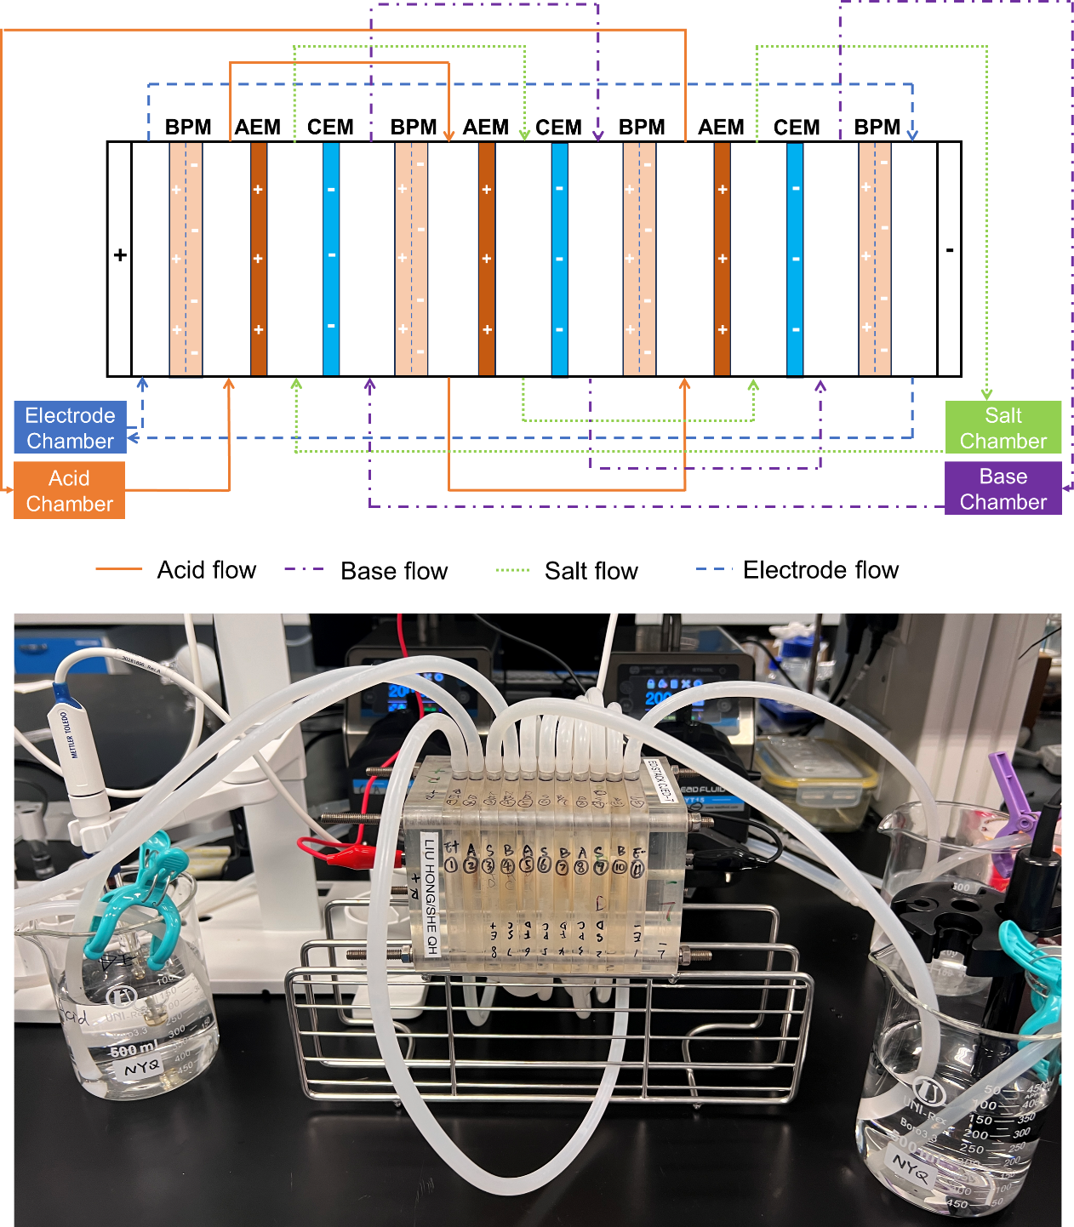

Figure A 1 The configuration of lab-scale experimental BMED stack.

**Section A2. The composition of model seawater brine**

Sodium chloride (NaCl), magnesium chloride hexahydrate (MgCl2·6H2O), calcium chloride dihydrate (CaCl2·2H2O), sodium sulfate (Na2SO4) and sodium bicarbonate (NaHCO3) were purchased from Sigma-Aldrich. The concentration of ions in SWB was twice as much as seawater.(Liu and She 2024) The detailed composition of the SWB is provided in **Table A1**. The solution was prepared by dissolving the chemicals in Milli-Q DI water.

Table A 1 The composition of model SWB in BMED system

|  |  |
| --- | --- |
| Chemicals | Concentration [g/L] |
| NaCl | 49.06 |
| MgCl2 | 10.4 |
| CaCl2 | 2.32 |
| Na2SO4 | 8.18 |
| NaHCO3 | 0.402 |

**Section A3. The quantification of scaling in BMED**

According to mass balance principles, the change in the number of moles of Ca²⁺ and Mg²⁺ in each solutions was equal to the amount of scaling. The loss of Ca and Mg (mg) can be calculated as follows:

$$\begin{aligned}Loss of Ca or Mg= C_{0,S}^{i}V_{0,S}-C_{t,S}^{i}V_{t,S}\#\left(1\right)\end{aligned}$$

where $C_{0,S}^{i}$ and $C_{t,S}^{i}$ were the concentration of (i.e., Ca2+ and Mg2+) (mg/L) at time 0 and $t$ in each chamber (i.e., AC, BC, SWBC and EC), repectively. $V_{0,S}$ and $V_{t,S}$ were the volume (L) of each chambers at time 0 and $t$. The concentration in EC was almost zero and can be ignored.

The areal divalent ions loss per repeating unit (g/m2·repeating unit) was calcualted from Eq.1:

$$\begin{aligned}Loss of divalent ions= \frac{C_{0,S}^{i}V_{0,S}-C_{t,S}^{i}V_{t,S}}{N*A}\#\left(2\right)\end{aligned}$$

where $N$ was the number of repeating unit in the stack and $A$ was the membrane area (m2).

The reduction ratio of divalent ions can be calculated as follows:

$$\begin{aligned}R_{Ca}=\frac{C_{0,S}^{Ca}V_{0,S}-C_{t,S}^{Ca}V_{t,S}}{C_{0,S}^{Ca}V_{0,S}}\#\left(3\right)\end{aligned}$$

$$\begin{aligned}R_{Mg}=\frac{C_{0,S}^{Mg}V_{0,S}-C_{t,S}^{Mg}V_{t,S}}{C_{0,S}^{Mg}V_{0,S}}\#\left(4\right)\end{aligned}$$

**Section A4. Stack resistance calculation**

The resistance of BMED stack can be defined as the sum of the resistance of individual part as shown in **Eq. 5** (Dlugolecki, Nymeijer et al. 2008, Liu and She 2024).

$$\begin{aligned}R_{stack}=\frac{N}{A}\left(R_{AEM}+R_{CEM}+R_{BPM}+\frac{d_{AC}}{σ_{AC}}+\frac{d_{BC}}{σ_{BC}}+\frac{d_{SC}}{σ_{SC}}\right)+R_{ele}\#\left(5\right)\end{aligned}$$

where $N$ is the number of repeating units, $A$ is the effective membrane area (m2), is the anion exchange membrane resistance (Ωm2), is the cation exchange membrane resistance (Ωm2), is the bipolar membrane resistance (Ωm2)., , were the thickness of AC, BC and SC (m), $σ_{AC}$, $σ_{BC}$ and $σ_{SC}$ is the conductivity of AC, BC and SC (S/m), and $R_{ele}$ is the electrode resistance (Ω).

The stack designed for testing $R_{ele}$ consisted of two electrode chambers, one serving as the anode compartment and the other as the cathode compartment, with a BPM positioned between them. The electrodes were titanium-coated with ruthenium. The setup was shown in **Figure A2**.

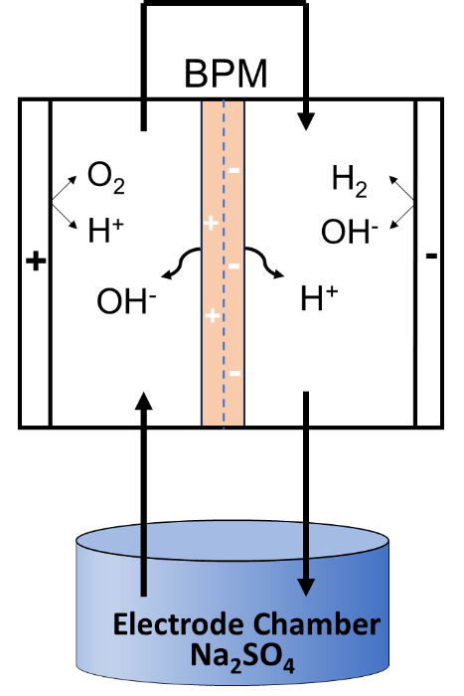

Figure A 2 Schematic experimental setup for determining the electrode resistance. (Conditions: electrode solution = 0.3 M Na2SO4, current density = 5~20 mA/cm2)

For the measurement of electrode resistance in the BMED system, direct current is applied to the stack, and the corresponding voltage is monitored using the Power DC software. The current density was systematically varied from 5 to 20 mA/cm2, incrementing by 1 mA/cm2 at each step. At each current density, the system stabilized before the voltage was recorded to ensure accurate data**. Fig. A3** showed the voltage of the electrode chambers as a function of direct current. According to **Eq. 6**, $R_{ele}$ can be calculated according to Ohm’s Law. When the current density was 15 mA/cm2, Rele was 43.11 Ω.

$$\begin{aligned}R_{ele}=\frac{U_{ele}}{I_{ele}}\#\left(6\right)\end{aligned}$$

Where $U_{ele}$ and $I_{ele}$ is the voltage and current.

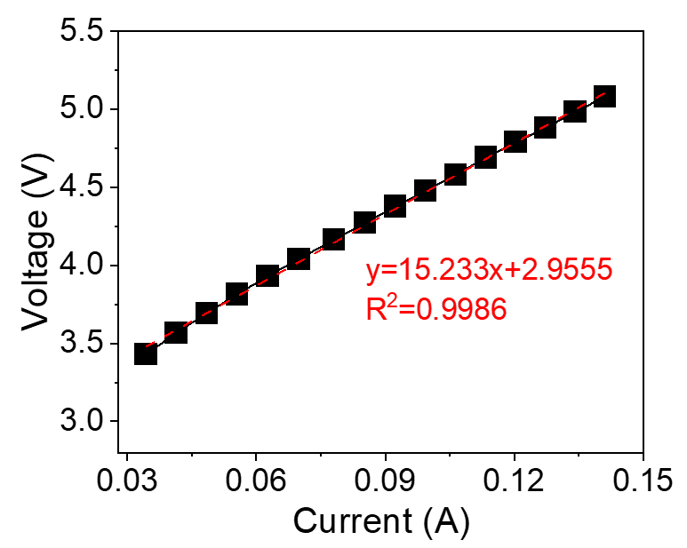

Figure A 3 Voltage drop of the electrode compartments as a function of direct current.

The membrane resistance can be calculated by the conversion of **Eq. 5**:

$$\begin{aligned}R_{membrane}=\frac{N}{A}\left(R_{AEM}+R_{CEM}+R_{BPM}\right)=R_{stack}-R_{chamber}-R_{ele}\#\left(7\right)\end{aligned}$$

**Section A5. Characterization of IEMs after NaCl tests**

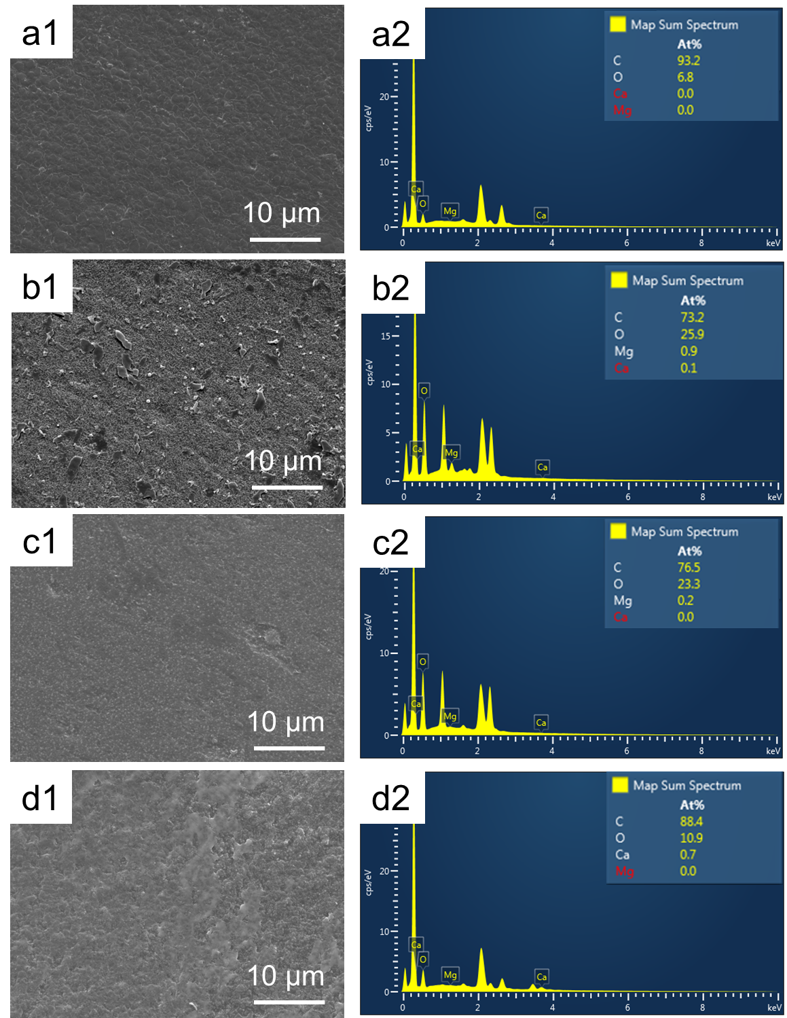

Figure A 4 Characterization of IEMs after BMED tests treating NaCl. AEM facing SWBC: (a1) SEM image; (a2) EDS map spectrum. CEM facing SWBC: (b1) SEM image; (b2) EDS map spectrum. CEM facing BC: (c1) SEM image; (c2) EDS map spectrum. BPM facing BC: (d1) SEM image

**Section A6 Scaling formation in chambers**

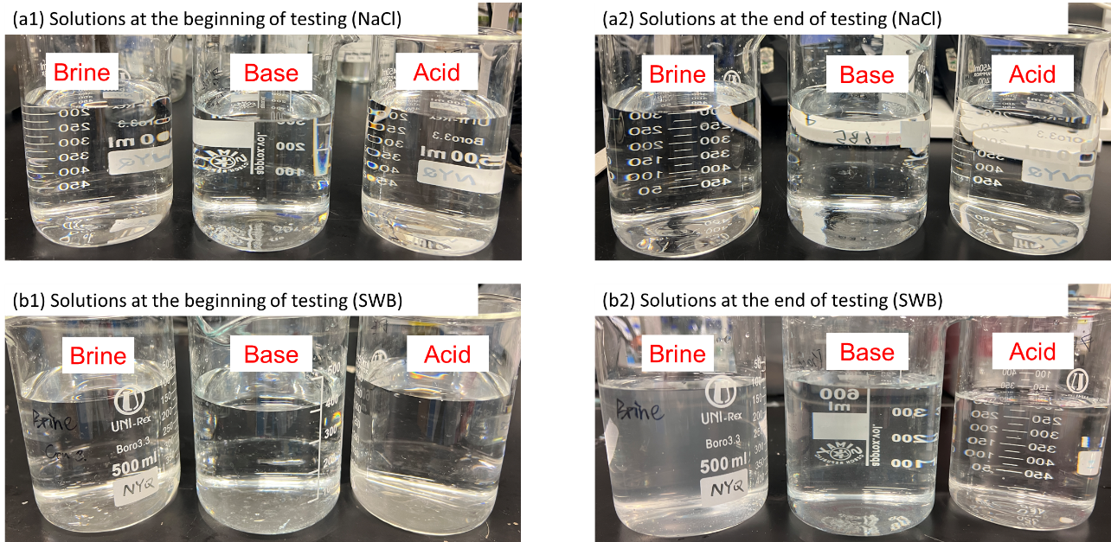

Figure A 5 Photos of solution at the (a1) beginning and end (a2) of BMED treating NaCl. Photos of solution at the (a1) beginning and end (a2) of BMED treating SWB.

Table A 2 The turbidity [NTU] of solution in SWB and base chamber

|  |  |  |  |  |
| --- | --- | --- | --- | --- |
|  | BMED treating NaCl | | BMED treating SWB | |
|  | Base chamber | SWB chamber | Base chamber | SWB chamber |
| Initial | 0.11±0.01 | 0.23±0.01 | 0.11±0.01 | 0.14±0.02 |
| Final | 0.20±0.04 | 0.38±0.03 | 29.40±0.92 | 45.23±0.12 |

**Section A7. Characterization of Pristine IEMs**

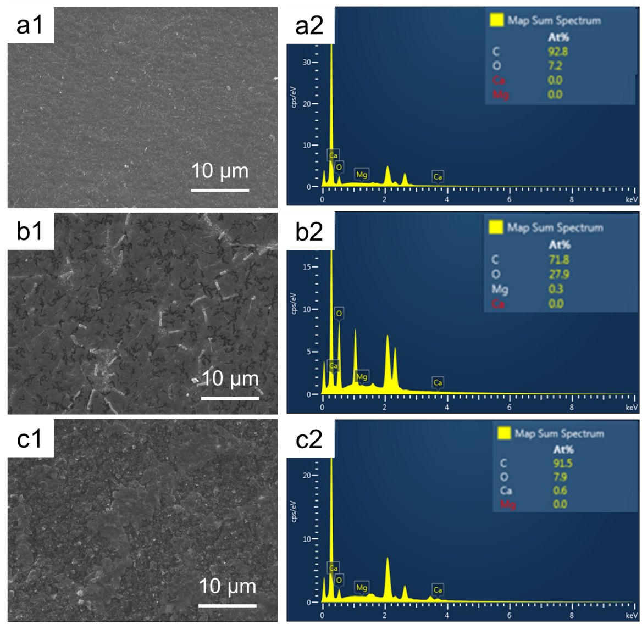

Figure A 6 Characterization of pristine IEMs. AEM: (a1) SEM image; (a2) EDS map spectrum. CEM: (b1) SEM image; (b2) EDS map spectrum. BPM (AEL): (c1) SEM image; (c2) EDS map spectrum

**Section A8. The composition of scaling**

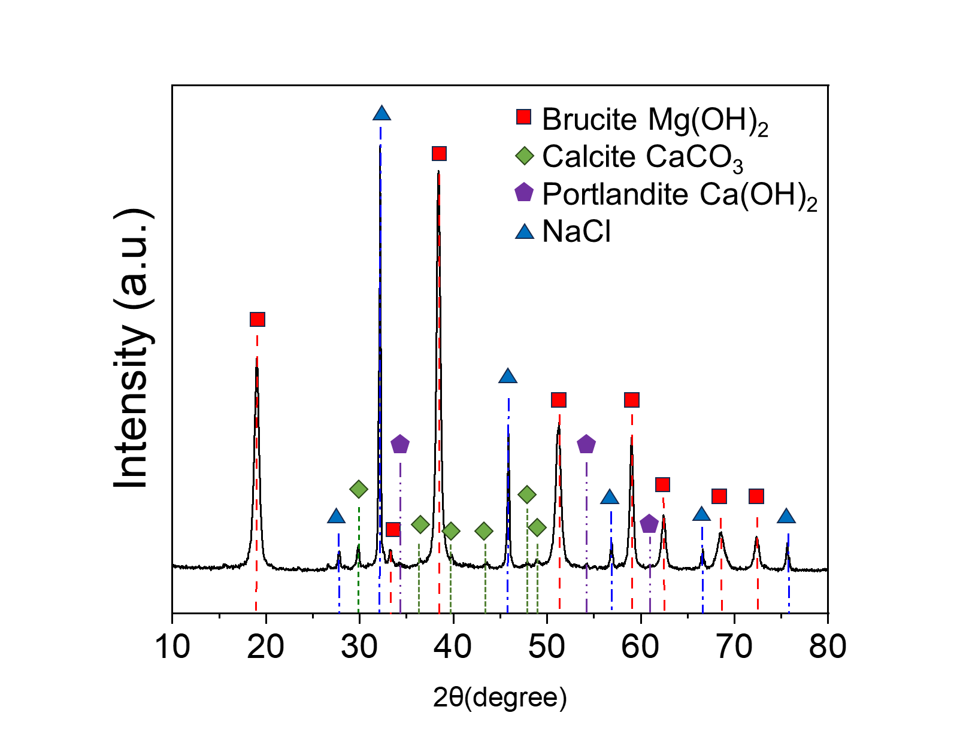

Figure A 7 X-ray diffraction spectra for the precipitates collected in the stack.

**Section A9 The quantification of scaling**

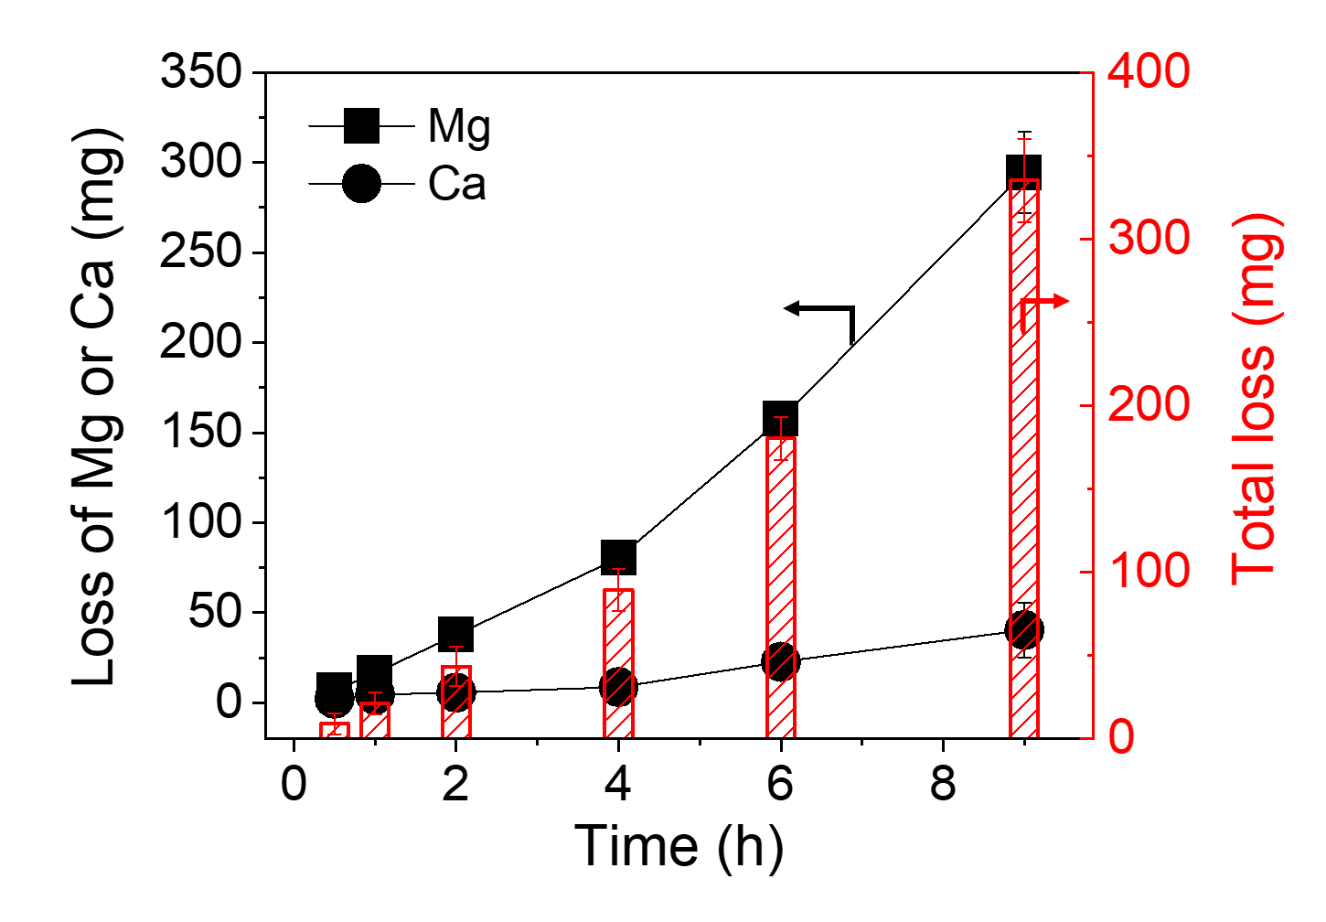

Figure A 8 The loss of Mg or Ca and the total loss in the BMED stack

**Section A10. The calculation of transport numbers**

To evaluate the transport number and assess OH- leakage through the membrane, a two-compartment electrochemical cell was assembled as shown in **Figure A9** **(Liu, Ruan et al. 2017)**. The setup consists of two chambers separated by an ion-exchange membrane, with each compartment equipped with an electrode connected to a voltmeter for potential measurement. The left compartment was filled with 0.2 M NaOH, while the right compartment contained 0.1 M NaOH. The concentration gradient drives ion transport across the membrane. By monitoring the voltage difference between the two solutions over time and analyzing the resulting electrochemical potential, the counter-ion transport number can be determined (**Eq. 11**). As the sum of transport number of counter-ion and co-ion is 1 (**Eq. 9**), the transport number of counter-ion can also reflect the leakage of co-ion.

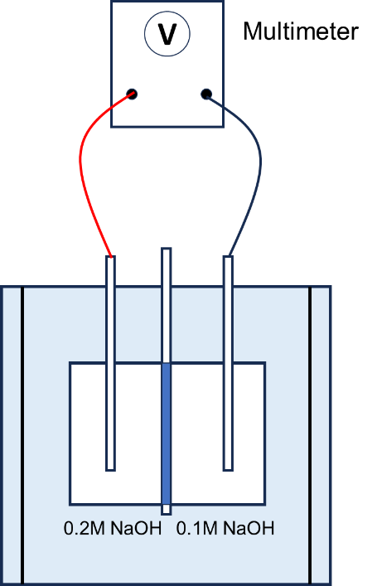

Figure A 9 The schematic diagram of a two-cell mode measurement module for transport number

The membrane potential is evaluated by the Nernst equation **Eq. 8 (Liu, Ruan et al. 2017)**:

$$\begin{aligned}E_{m}=\left(\overline{t_{+}}-\overline{t_{-}}\right)\frac{RT}{zF}\ln\left(\frac{a1}{a2}\right)\#\left(8\right)\end{aligned}$$

where Em is the membrane potential (mV); $\overline{t_{+}}$ and $\overline{t_{-}}$ is the cations and anions transport numbers of the membrane, respectively; $a1$ and $a2$ is the activity of the of electrolytic solutions; z is the valence of the electrolyte; F is the Faraday constant.

In this research, the electrolyte is NaOH, so z =1. Meanwhile,

$$\begin{aligned}\overline{t_{+}}+\overline{t_{-}}=1\#\left(9\right)\end{aligned}$$

So **Eq. 8** can be written as:

$$\begin{aligned}E_{m}=\left(2\overline{t_{+}}-1\right)\frac{RT}{F}\ln\left(\frac{a1}{a2}\right)\#\left(10\right)\end{aligned}$$

In that case, the transport number of counter-ion:

$$\begin{aligned}\overline{t_{+}}=\frac{E_{m}F}{RTln\left(\frac{a1}{a2}\right)}\#\left(11\right)\end{aligned}$$

**Section A11 The voltage change across the BMED stack**

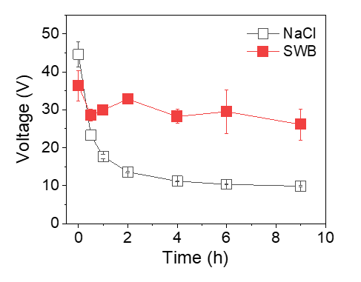

Figure A 10 The voltage change across the BMED system.

**Section A12. Specific energy consumption during BMED tests**

Specific Energy consumption of produced acid and base (SEC, kWh/kg) was calculated as follows(Cassaro, Virruso et al. 2023):

$$\begin{aligned}{SEC}^{i}=\frac{\int_{0}^{t}{U_{t}I_{t}dt}}{(C_{t}^{i}-C_{0}^{i})VM^{i}}\#\left(12\right)\end{aligned}$$

where $U_{t}$ is the voltage (V) and $I_{t}$ is the current (A) at time $t$. $C_{t}^{i}$ and $C_{0}^{i}$ were the concentration of solution $i$ (i.e., base or acid) at time $t$ and 0 (mol/L) $V$ is the volume of circulated volume of acid or base solution (L). $M^{i}$ is the molar weight of base or acid (g/mol).

When BMED treats SWB, scaling increased the resistance of the stack. Under the constant current, the voltage across the BMED system remained elevated throughout the experiment (**Fig. A10**). Since SEC was proportional to the voltage (**Eq. 12**), it naturally led to higher SEC compared to NaCl.

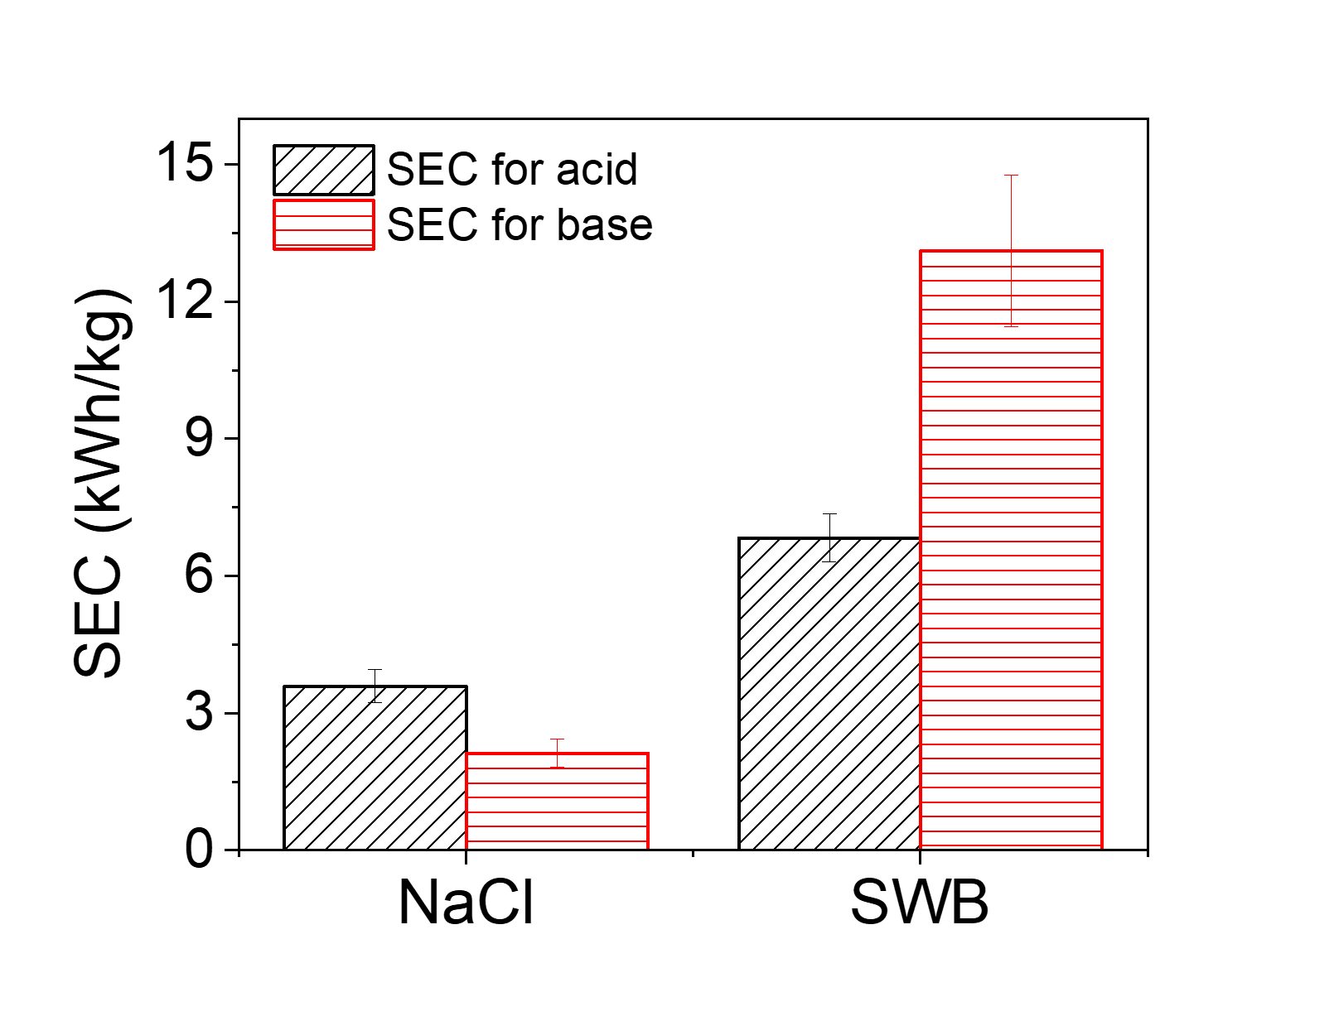

Figure A 11 The specific energy consumption (SEC) of the entire process to produce acid and base.

**Section A13. The conductivity changes in acid, base and salt chambers**

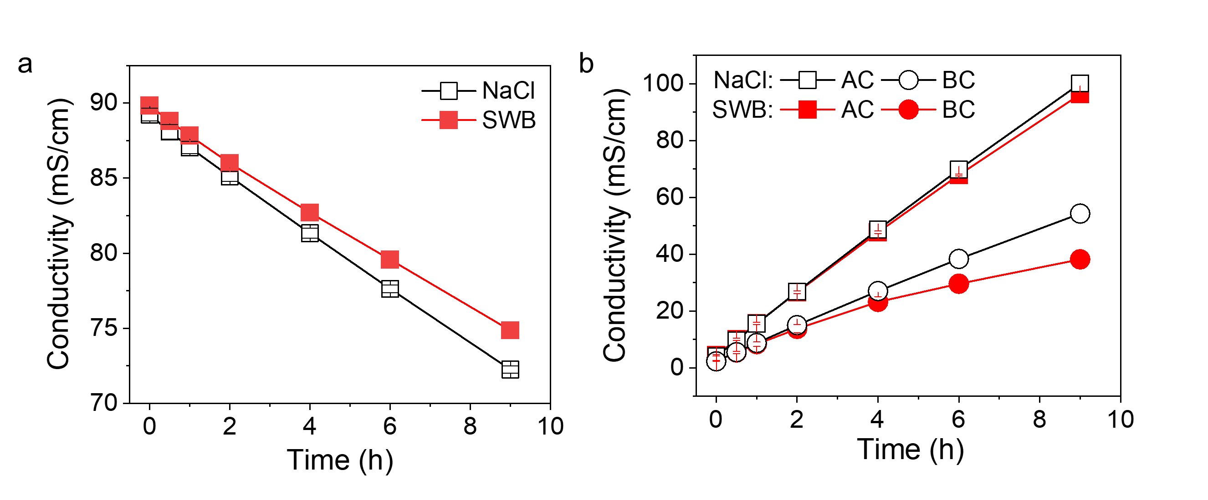

Figure A 12 The conductivity change of acid chamber and base chamber (AC: acid chamber; BC: base chamber).

**Reference**

1. Liu, H.; She, Q., Scaling-Enhanced Scaling during Electrodialysis Desalination. *ACS ES&T Engineering* **2024,** *4*, (5), 1063-1072.

2. Dlugolecki, P.; Nymeijer, K.; Metz, S.; Wessling, M., Current status of ion exchange membranes for power generation from salinity gradients. *Journal of Membrane Science* **2008,** *319*, (1-2), 214-222.

3. Liu, H.; Ruan, H.; Zhao, Y.; Pan, J.; Sotto, A.; Gao, C.; Van der Bruggen, B.; Shen, J., A facile avenue to modify polyelectrolyte multilayers on anion exchange membranes to enhance monovalent selectivity and durability simultaneously. *Journal of Membrane Science* **2017,** *543*, 310-318.

4. Cassaro, C.; Virruso, G.; Culcasi, A.; Cipollina, A.; Tamburini, A.; Micale, G., Electrodialysis with Bipolar Membranes for the Sustainable Production of Chemicals from Seawater Brines at Pilot Plant Scale. *ACS Sustain Chem Eng* **2023,** *11*, (7), 2989-3000.

Appendix B Supporting Information for Determination of Critical Ca2+ and Mg2+ Concentrations for Scaling Prevention in BMED

**Section B1 The composition of salt solutions in tests**

Sodium chloride (NaCl), magnesium chloride hexahydrate (MgCl2·6H2O), calcium chloride dihydrate (CaCl2·2H2O), sodium sulfate (Na2SO4) and sodium bicarbonate (NaHCO3) were purchased from Sigma-Aldrich. The detailed composition of the SWB is provided in **Table B1**. The solution was prepared by dissolving the chemicals in Milli-Q DI water.

Table B 1 The composition of model SWB in BMED system

|  |  |
| --- | --- |
| Chemicals | Concentration [g/L] |
| NaCl | 49.06 |
| Na2SO4 | 8.18 |
| NaHCO3 | 0.402 |
| Mg | 1 ppb, 0.01 ppm, 0.1 ppm, 1 ppm, 10 ppm, 50 ppm, 100 ppm |
| Ca | 0.01 ppm, 0.1 ppm, 1 ppm, 10 ppm and 50 ppm |

**Section B2 The characterization of SCEM**

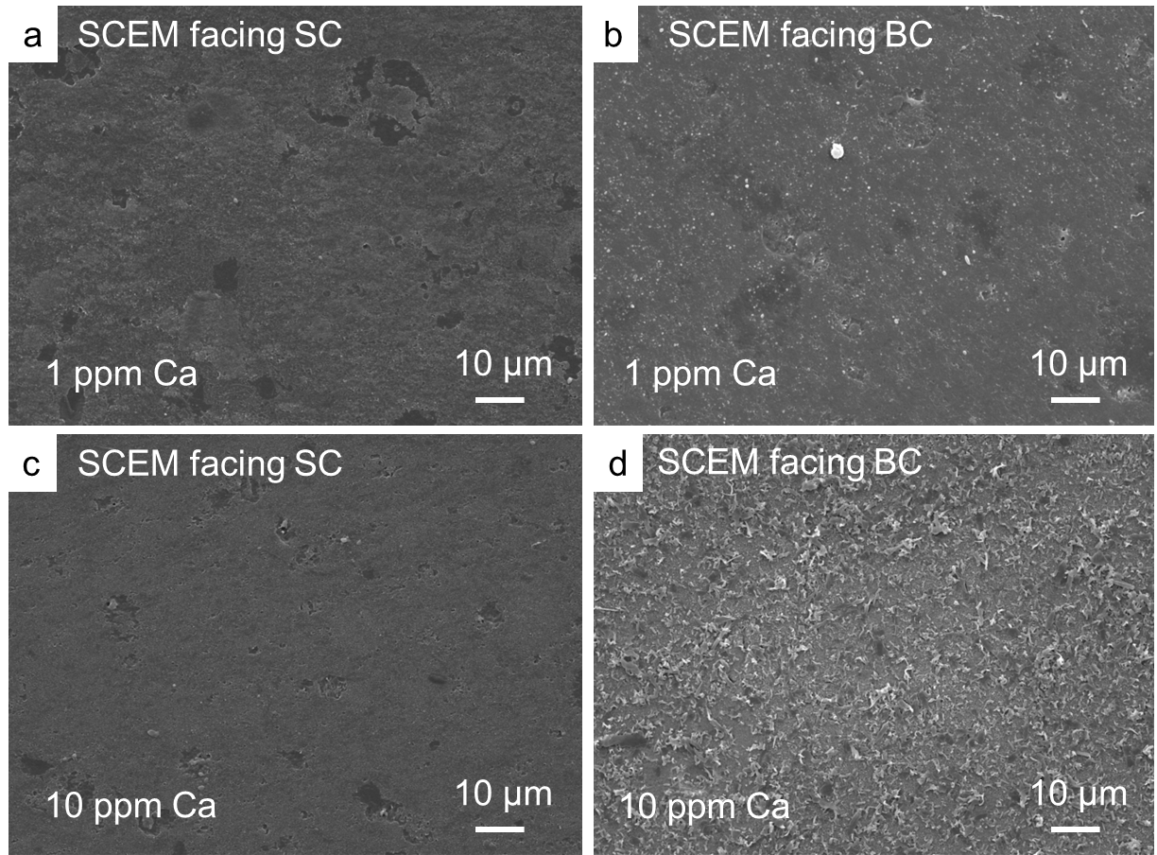

Figure B 1 The SEM diagram of SCEM after treating solution containing 1 ppm Ca: (a) SCEM facing SC; (b) SCEM facing BC. The SEM diagram of SCEM after treating solution containing 10 ppm Ca: (c) SCEM facing SC; (d) SCEM facing BC.

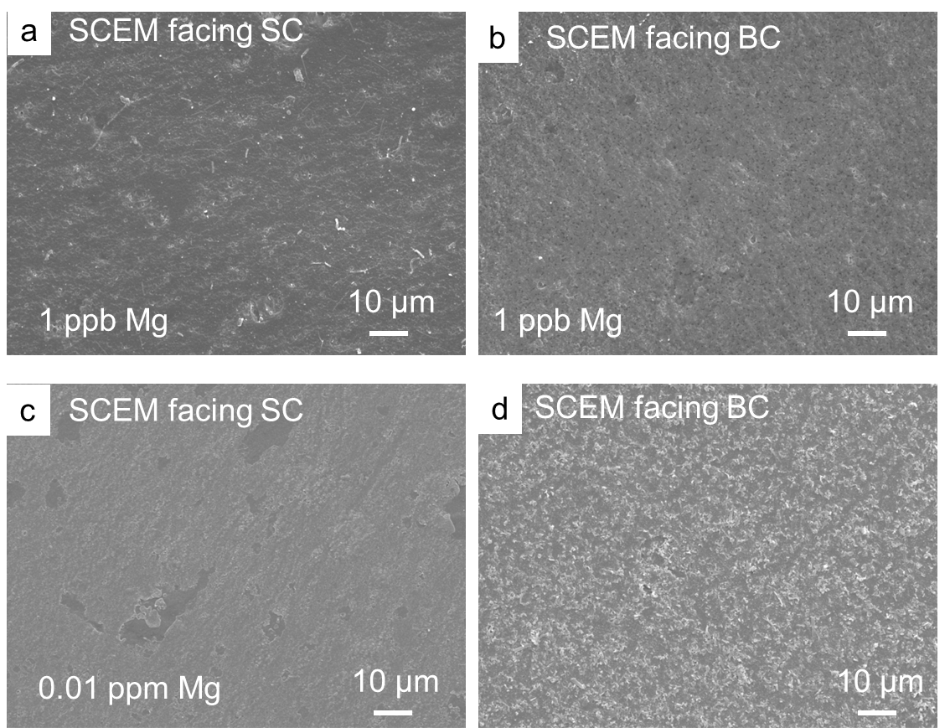

Figure B 2 The SEM diagram of SCEM after treating solution containing 1 ppb Mg: (a) SCEM facing SC; (b) SCEM facing BC. The SEM diagram of SCEM after treating solution containing 0.01 ppm Mg: (c) SCEM facing SC; (d) SCEM facing BC.

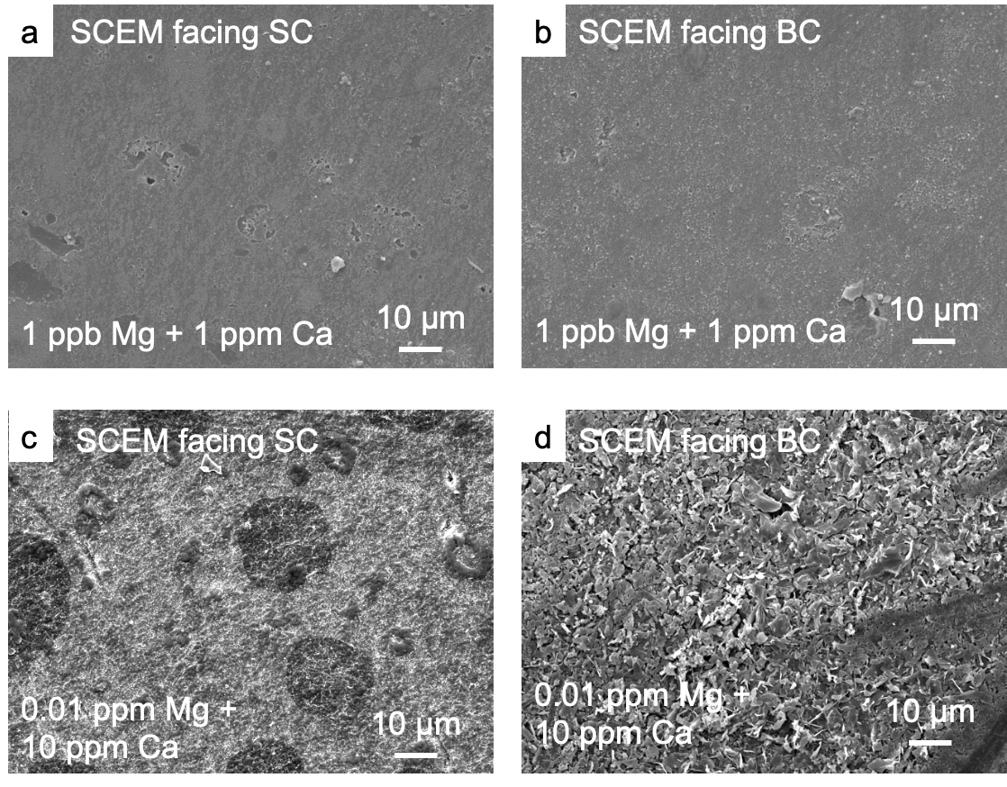

Figure B 3 The SEM diagram of SCEM after treating solution containing 1 ppb Mg and 1 ppm Ca: (a) SCEM facing SC; (b) SCEM facing BC. The SEM diagram of SCEM after treating solution containing 0.01 ppm Mg and 100 ppm Ca: (c) SCEM facing SC; (d) SCEM facing BC.